### Exercise 3.1. Carpet cost

* Assuming the carpet for the room described in the worked example costs £5.00 per square metre, amend the program to calculate and display the cost of the required amount of carpet.

Pseudocode:

Input Length as the next value inputted by user

Input Width as the next value inputted by user

Set Area to Length * Width

Set Price to Area * £5.00

Print Area and Price

import java.util.Scanner;

import java.util.InputMismatchException;

class carpetCost

{

public static void main(String[] args)

{

Scanner input = new Scanner(System.in);

//Input width and length, giving messages to let the user know what is being requested

System.out.println("Enter carpet length and width in meters.");

//define and set default doubles for input

Double length = 0.0, width = 0.0;

//try to catch InputMismatchException thrown if the input is not the correct type.

try

{

//write the start of lines to symbolise what each input is for.

System.out.print("Length: ");

length = input.nextDouble();

System.out.print("Width: ");

width = input.nextDouble();

}

catch (InputMismatchException e)

{

//tell the user their input was not decimal and exit with code 0 (normal)

System.out.println("You need to input a decimal number.");

System.exit(0);

}

//calculate area and cost of the carpet, where 5 is £5

Double area = length * width;

Double cost = area * 5;

//output results.

System.out.println("Carpet Area: " + area);

System.out.println("Carpet Cost : " + cost);

}

}

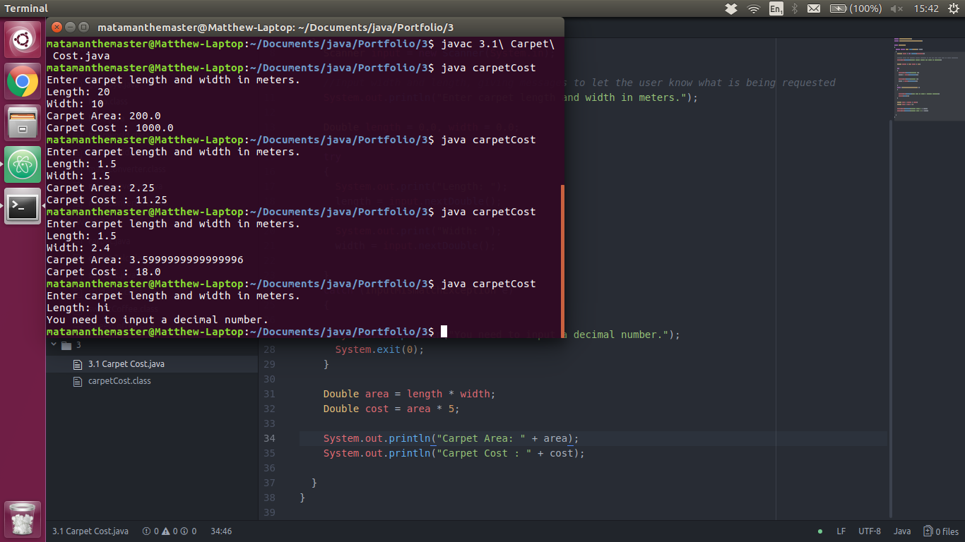

### Exercise 3.2. Age in 2050

* Design and build a program to input the year in which you were born and display the age you will be in the year 2050.

Pseudocode:

Input Birth Year

Set Age to Birth Year - 2050

Print Age

import java.util.Scanner;

import java.util.InputMismatchException;

class agein2050

{

public static void main(String[] args)

{

Scanner input = new Scanner(System.in);

int birthYear = 0;

try

{

//try to input their birth year and catch errors

System.out.println("Enter your birth year.");

System.out.print("Year: ");

birthYear = input.nextInt();

}

catch (InputMismatchException e)

{

//Catch an InputMismatchException, they inputted the wrong type. Exit the program.

System.out.println("You need to enter a birth year as a number.");

System.exit(0);

}

if (birthYear < 2050 && birthYear > -1)

{

//get age in 2050 by subtraction.

int endAge = 2050 - birthYear;

//output.

System.out.println("In 2050 you will be " + endAge);

}

else

{

//Tell the user their input was invalid, exit program.

System.out.println("You need to enter a valid year (Between 0 and 2049).");

System.exit(0);

}

}

}

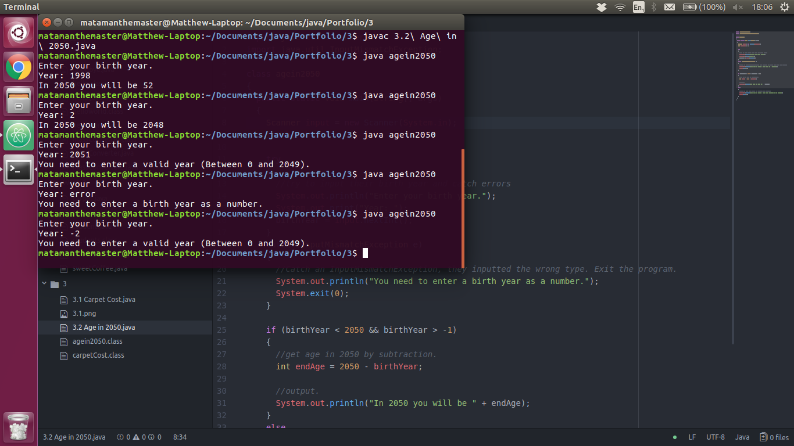

### Exercise 3.3. Average

* Design and build a program to input a set of 4 numbers and display their average (be careful with data types!)

Pseudocode:

Set i to 0

for i to 3

Set Average = Average + the next value inputted by the user

end

Set Average = Average / 4

Print Average

import java.util.Scanner;

import java.util.InputMismatchException;

class average

{

public static void main(String[] args)

{

Scanner input = new Scanner(System.in);

Double average = 0.0;

System.out.println("Please input the 4 numbers to mean.");

for (int i = 0; i < 4; i++)

{

try

{

System.out.print(i + 1 + ": ");

//increment by the input.

average += input.nextDouble();

}

catch (InputMismatchException e)

{

//catch the user supplying invalid type.

System.out.println("Value inputed was not a number.");

System.exit(0);

}

}

average = average / 4;

//output

System.out.println("The average of the 4 supplied numbers is " + average + ".");

}

}

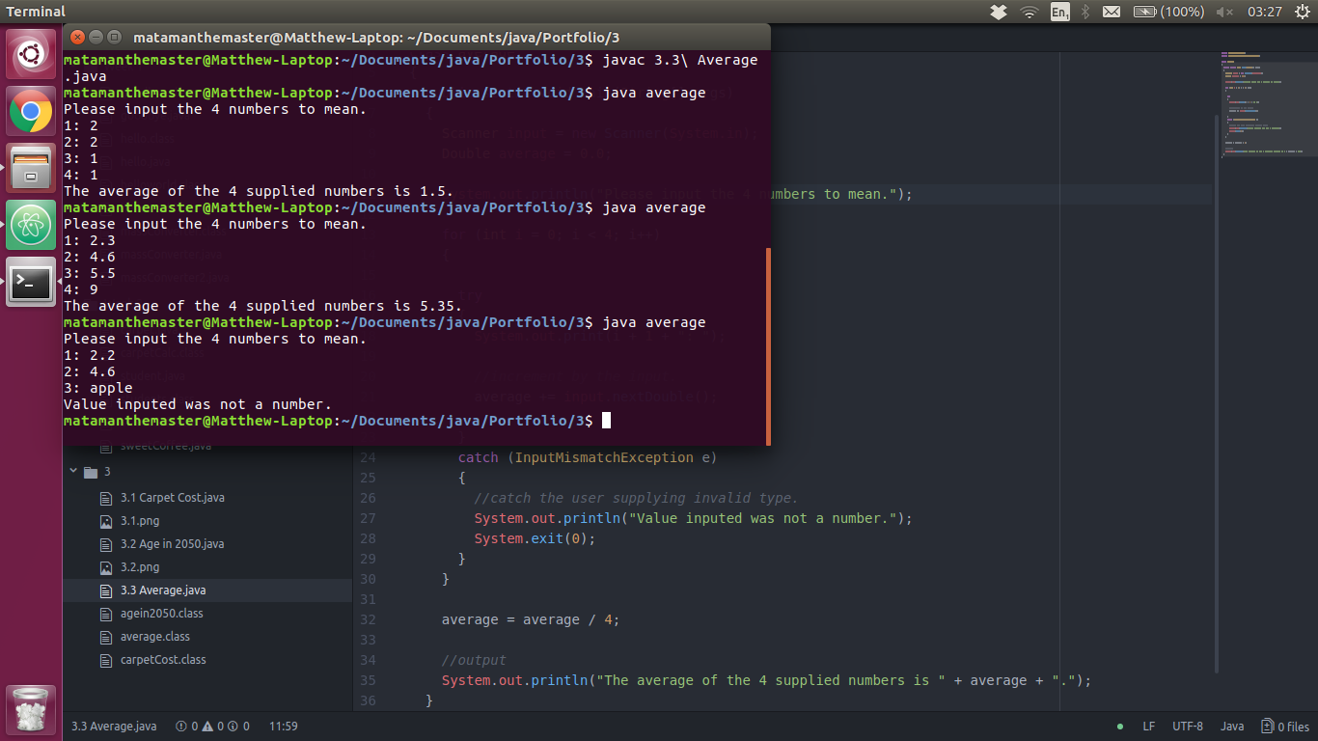

### Exercise 3.4. Money

* Design and build a program to input the number of £5, £10 and £20 notes you have, then display the total number of notes and the total amount of money.

Pseudocode:

Set noFives to the next intager inputted by the user

Set noTens to the next intager inputted by the user

Set noTwenties to the next intager inputted by the user

Set totalNotes to noFives + noTens + noTwenties

Set totalMoney to noFives * 5

Set totalMoney to totalMoney + noTens * 10

Set totalMoney to totalMoney + noTwenties * 20

Print totalNotes and totalMoney

import java.util.Scanner;

import java.util.InputMismatchException;

class money

{

public static void main(String[] args)

{

Scanner input = new Scanner(System.in);

System.out.println("Input the number of notes you have");

int noFives = 0;

int noTens = 0;

int noTwenties = 0;

try

{

//input the quantities of each notes the client has.

System.out.print("£5: ");

noFives = input.nextInt();

System.out.print("£10: ");

noTens = input.nextInt();

System.out.print("£20: ");

noTwenties = input.nextInt();

}

catch (InputMismatchException e)

{

//Invalid inputs.

System.out.println("Only whole numbers can be used to represent the quantity of each note.");

System.exit(0);

}

//validation

if (noFives < 0 || noTens < 0 || noTwenties < 0)

{

System.out.println("You cannot have negative quantities of notes.");

System.exit(0);

}

else

{

//calculate end numbers for display.

int totalNotes = noFives + noTens + noTwenties;

int totalValue = (noFives * 5) + (noTens * 10) + (noTwenties * 20);

System.out.println("For the " + totalNotes + " notes, you have a total of £" + totalValue + ".");

}

}

}

### Exercise 4.1. Capital city

* Design, write and test a program which asks the user to input the capital city of France. If they answer **Paris**, give them a congratulations message.

Pseudocode:

Set Answer to the value provided by the user

if Answer when floored = "paris"

Print "Congradulations"

else

Print "Incorrect"

end

import java.util.Scanner;

class capitalCity

{

public static void main(String[] args)

{

//Scanner for console input

Scanner input = new Scanner(System.in);

//ask the question, preformat.

System.out.println("What is the capital city of France?");

System.out.print("> ");

//set answer to the user input. Don't care about checking for an invalid value as strings can be any input.

String answer = input.next();

//changes to lower case

if (answer.toLowerCase().equals("paris"))

{

System.out.println("congratulations");

}

else

{

System.out.println("Incorrect");

}

}

}

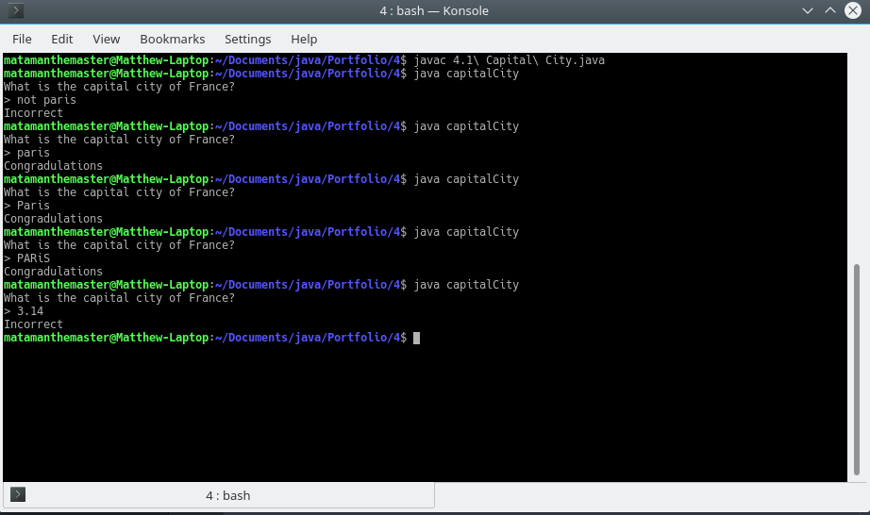

### Exercise 4.2. Income and expenditure

* Design, write and test a program which asks the user their income and expenditure, and output 'SPEND SPEND SPEND!", or "Put some money in the bank!" depending on the outcome.

Pseudocode:

Set Threshold to value entered by client

Set Income to value entered by client

Set Expenditure to value entered by client

if Income >= 0 and Expenditure >= 0

Set Total = income - Expenditure

if Total < Threshold

Print "Put some money in the bank!"

else

Print "SPEND SPEND SPEND!"

end

end

import java.util.Scanner;

import java.util.InputMismatchException;

class incomeExpenditure

{

public static void main(String[] args)

{

Scanner input = new Scanner(System.in);

//vars to be inputted by scanner and for processing.

Double threshold = 0.0;

Double income = 0.0;

Double expenditure = 0.0;

Double total = 0.0;

try

{

//input vars

System.out.print("Threshold: ");

threshold = input.nextDouble();

System.out.print("Income: ");

income = input.nextDouble();

System.out.print("Expenditure: ");

expenditure = input.nextDouble();

}

catch (InputMismatchException e)

{

//if invalid type then exit program.

System.out.println("You need to input a number (whole or decimal).");

System.exit(0);

}

//check all variables inputted are valid (>= 0)

if (income >= 0 && expenditure >= 0)

{

//calculate total money left.

total = income - expenditure;

if (total < threshold)

{

//outcome

System.out.println();//blank line to seperate inputs and outputs

System.out.println("Put some money in the bank!");

}

else

{

//outcome

System.out.println();//blank line to seperate inputs and outputs

System.out.println("SPEND SPEND SPEND!");

}

}

else

{

//if income and expenditure is < 0

System.out.println("Incomes and Expenditures must be positive.");

}

}

}

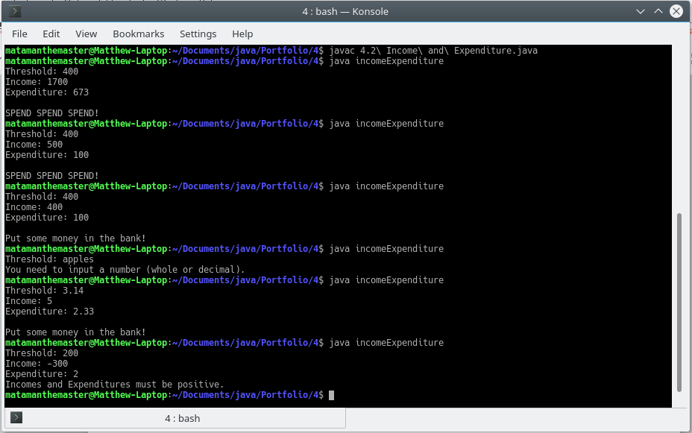

### Exercise 4.3. Meal cost

* Design, write and test a program which asks a waiter the cost of a customer's meal. If the cost is 10 pounds or more, give a 5% discount.

Pseudocode

Input MealCost

if MealCost >= 10

FivePercent = (MealCost / 100) * 5

MealCost = MealCost - FivePercent

end

Print MealCost

Code

import java.util.Scanner;

import java.util.InputMismatchException;

class mealCost

{

public static void main(String[] args)

{

Scanner input = new Scanner(System.in);

Double mealCost = 0.0;

Double fivePercent = 0.0;

try

{

System.out.println("Input a meal price.");

System.out.print("£");

mealCost = input.nextDouble();

}

catch (InputMismatchException e)

{

System.out.println("You need to input a whole or decimal number.");

System.exit(0);

}

//if positive

if (mealCost >= 0)

{

if (mealCost >= 10)

{

//take 5% of the meal cost away

fivePercent = (mealCost / 100) * 5;

mealCost -= fivePercent;

}

//outcome

System.out.println("The meal cost £" + mealCost);

}

else

{

//if mealCost is negative

System.out.println("Meal costs must be positive.");

}

}

}

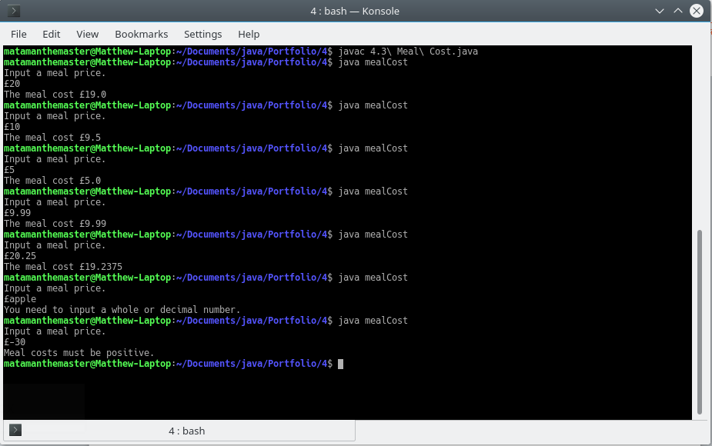

### Exercise 4.4. Logic teaser

* Below is a table. Columns 1 and 2 indicate two tests, A and B. As we know, tests always evaluate to true (T) and false (F). The rows of the table indicate combinations of the possible values for A and B. The other columns in the table show more complex tests which use A and B in various combinations along with conditional and logical operators. Fill out the rest of the table for each row, given the True/False values of A and B. To start you off, the first complex condition (A or B) has been completed.

|  |  |  |  |  |  |  |  |  |
| --- | --- | --- | --- | --- | --- | --- | --- | --- |
| **A** | **B** | **A||B** | **A&&B** | **!(A||B)** | **!(A&&B)** | **!A||B** | **!(!A&&!B)** | **A||!B** |
| **T** | **T** | T | T | F | F | T | T | T |
| **T** | **F** | T | F | F | T | F | T | T |
| **F** | **T** | T | F | F | T | T | T | F |
| **F** | **F** | F | F | F | T | T | F | T |

### Exercise 4.5. Payday

* Design, code and test a program which inputs a code for the name of a day ("Sun" for Sunday, "Wk" for other Day) together with 2 numbers representing normal hours worked and overtime hours worked. Output the day name and the pay according to the following rules:

Sunday: ordinary hours @ £15 per hour; overtime @ £20 per hour   
Other day: ordinary hours @ £8 per hour; overtime @ £12.00 per hour.

Pseudocode

Set DayCode to the lower case value inputted by user

Set NormalHours to the value inputted by the user

Set OvertimeHours to the value inputted by the user

if DayCode = "sun"

Set NormalRate to 15

Set OvertimeRate to 20

Set Day to "Sunday"

else if DayCode = "wk"

Set NormalRate to 8

Set OvertimeRate to 12

Set Day to "Other Day"

end

Set NormalPay = NormalRate * NormalHours

Set OvertimePay = OvertimeRate * OvertimeHours

Print Day

Print NormalPay

Print OvertimePay

Code:

import java.util.Scanner;

import java.util.InputMismatchException;

class payday

{

public static void main(String[] args)

{

Scanner input = new Scanner(System.in);

//inputs

String dayCode = "";

Double hoursNormal = 0.0;

Double hoursOvertime = 0.0;

//Processing & outputs

int rateNormal = 0;

int rateOvertime = 0;

String day = "";

Double payNormal = 0.0;

Double payOvertime = 0.0;

System.out.println("Input a day code (wk for other day, sun for sunday).");

try

{

//convert the next string to lower case

dayCode = input.next().toLowerCase();

System.out.print("Normal Hours: ");

hoursNormal = input.nextDouble();

System.out.print("Overtime Hours: ");

hoursOvertime = input.nextDouble();

}

catch (InputMismatchException e)

{

//InputMismatchException cannot happen on string, so user must have not entered hours correctly

System.out.println("Normal hours and overtime hours must be numbers.");

System.exit(0);

}

//if hours are >= 0 and <= 168 (number of hours in a week) and so is valid

if (hoursNormal > -1 && hoursOvertime > -1 && hoursNormal < 169 && hoursOvertime < 169)

{

if (dayCode.equals("sun"))

{

day = "sunday";

//sunday pay rates

rateNormal = 15;

rateOvertime = 20;

}

else if (dayCode.equals("wk"))

{

day = "other day";

//other day pay rates

rateNormal = 8;

rateOvertime = 12;

}

else

{

//invalid day code (not wk or sun)

System.out.println("You provided an invalid day code.");

System.exit(0);

}

//calculates the pay for the work hours done (using rates for respective day)

payNormal = rateNormal * hoursNormal;

payOvertime = rateOvertime * hoursOvertime;

//print Day, Normal Pay, Overtime Pay, Total Pay

System.out.println("Day: " + day + ", Normal Pay: " + payNormal + ", Overtime Pay: " + payOvertime + ", Total Pay: " + (payNormal + payOvertime));

}

else

{

//if the hours entered are < 0 || > 168

System.out.println("Hours must be between 0 and 168");

}

}

}

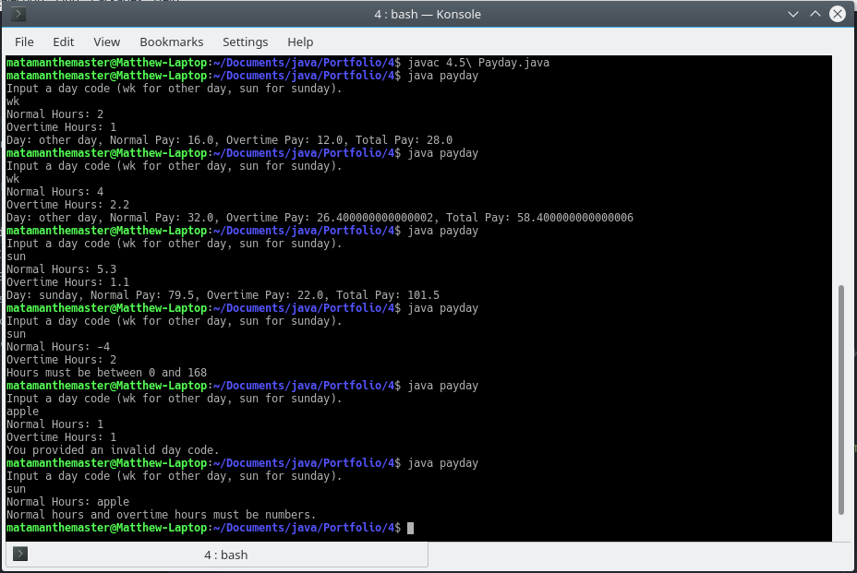

### Exercise 4.6. Insurance

* *Bike Direct* insurance offers bike insurance as follows:   
    
  basic rate = £30  
  add £10 for a mountain bike  
  add £5 for cyclists under 25.   
    
  Design, write and test a program to input the type of bike - mountain or touring, and the cyclist's age, and calculate and display the premium payable.

Pseudocode:

Set BikeType to the floored value inputted by the user

Set Age to the value inputted by the user

Set InsuranceTotal = 30

if BikeType == "mountain"

InsuranceTotal += 10

end

if Age < 25

InsuranceTotal +=5

end

Print InsuranceTotal

import java.util.Scanner;

import java.util.InputMismatchException;

class insurance

{

public static void main(String[] args)

{

Scanner input = new Scanner(System.in);

//define input variables with default (null) values

String type = null;

int age = -1;

try

{

//input variables

System.out.print("Bike Type: ");

type = input.next().toLowerCase();/*converts the next string entered into the cmd tolower case.*/

System.out.print("Your Age: ");

age = input.nextInt();

}

catch (InputMismatchException e)

{

//if the type (for input.nextInt()) is not correct, stop the program.

System.out.println("Age must be a whole number");

System.exit(0);

}

//validate age

if (age > -1 && age < 151)

{

//var stores the final result

int totalInsurance = 30;

if (type.equals("mountain"))

{

totalInsurance += 10;

}

if (age < 25)

{

totalInsurance += 5;

}

//output result and answers provided by the client.

System.out.println("For a " + age + " year old with a " + type + " bike, it will cost you " + totalInsurance + " for

insurance.");

}

else

{

//else, if age is invalid, stop program.

System.out.println("Age must be between 0 and 150");

System.exit(0);

}

}

}

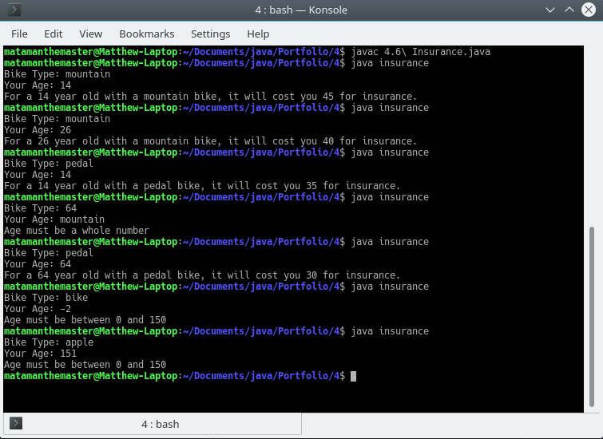

### Exercise 5.1. More coffee

* In the coffee survey program, what would happen if **nothing**, **sugar** and **sweetener** were not originally set to zero? Would the program work?

No, the compiler would think that the variable was used before a value was set, as we set the value during a for block and during a try catch block.

* Type in the coffee survey program and get it working. Test to see what happens when only one person likes a particular way of drinking coffee? Modify your program to report in correct English by stating "Only 1 person ... " rather than "1 people ...".
* Modify the coffee survey program to validate the three choices. Trap for out of range values (i.e. where the user types in a number other than 1, 2, or 3). **Make sure your program still processes 5 valid selections.**

For 5.1 I started to program GUI applications using the JavaFX library, with FXML as the template generated using a program, Gluon Scene Builder. FXML controls point to a control class and controls invoke methods on particular events occurring, all controlled by the library.

I changed how the application would run to better suit the event driven nature of JavaFX. I opted to use buttons that trigger events, calling my own methods for the user to choose their answer. For this, no loops are required for asking the user the question or getting their answer; the question can always be displayed, and the answers can always be displayed at the same time via buttons.

Design

GUI Design:

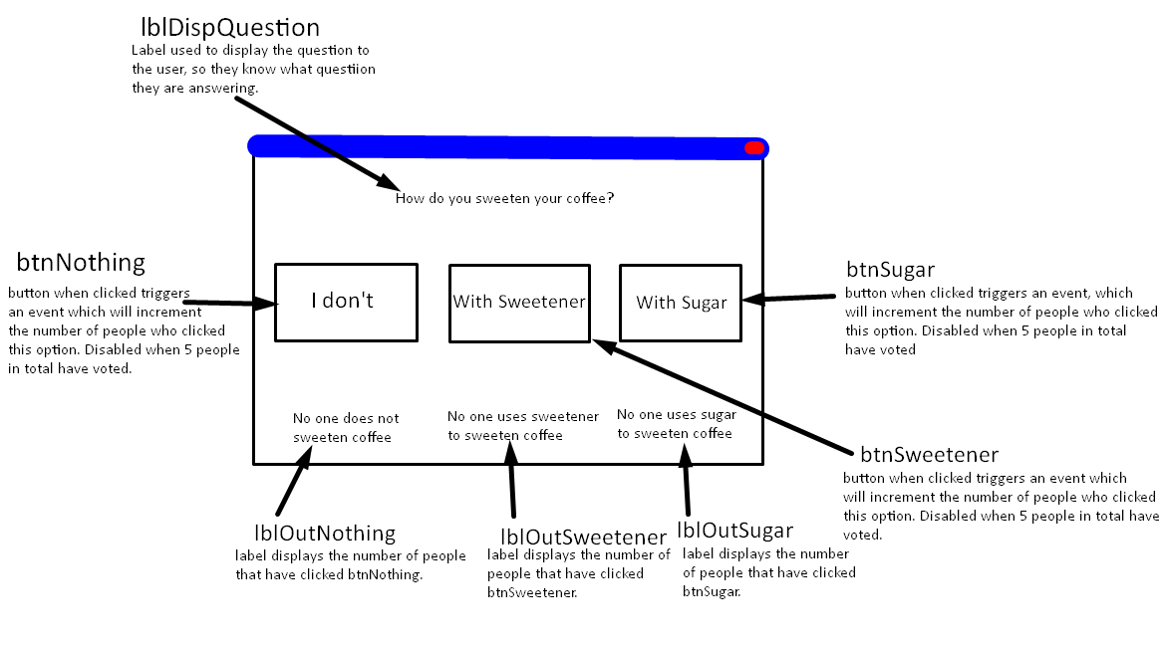

Pseudocode:

Define btnNothing, btnSugar, btnSweetener as buttons

Define lblOutNothing, lblOutSugar, lblOutSweetener, lblOutNoVotes as labels

Define noNone, noSugar, noSweetener, totalVotes as 0

On event btnNothing pressed

If noNone == 1

Set lblOutNothing’s text to “1 person does not sweeten coffee.”

Else if noNone >= 1

Set lblOutNothing’s text to noNone + “ people do not sweeten coffee.”

End

Set totalVotes as noNone + noSugar + noSweetener

If totalVotes > 4

Disable btnNothing

Disable btnSugar

Disable btnSweetener

End

End

On event btnSweetener pressed

If noSweetener == 1

Set lblOutSweetener’s text to “1 person uses sweetener.”

Else if noSweetener >= 1

Set lblOutSweetener’s text to noSweetener + “ people use sweetener.”

End

Set totalVotes as noNone + noSugar + noSweetener

If totalVotes > 4

Disable btnNothing

Disable btnSugar

Disable btnSweetener

End

End

On event btnSugar pressed

If noSugar == 1

Set lblOutSugar’s text to “1 person uses sugar.”

Else if noSugar >=

Set lblOutSugar’s text to noSugar + “ people use sugar.”

End

Set totalVotes as noNone + noSugar + noSweetener

If totalVotes > 4

Disable btnNothing

Disable btnSugar

Disable btnSweetener

End

End

Code

Main Class:

package sweetCoffee;  
  
import javafx.application.Application;  
import javafx.fxml.FXMLLoader;  
import javafx.scene.Parent;  
import javafx.scene.Scene;  
import javafx.stage.Stage;  
  
public class Main extends Application {  
  
 @Override  
 public void start(Stage stageMain) throws Exception {  
  
 //get the contents of Main.fxml to append to the scene  
 Parent root = FXMLLoader.*load*(getClass().getResource("Main.fxml"));  
  
 //set the scene with the contents of Main.fxml and default size.  
 Scene sceneMain = new Scene(root, 600, 275);  
  
 //get the css file and add it to the scene's stylesheets.  
 sceneMain.getStylesheets().add(getClass().getResource("css/style.css").toExternalForm());  
  
 //set title, scene and show the stage.  
 stageMain.setTitle("5.1 Sweet Coffee");  
 stageMain.setScene(sceneMain);  
 stageMain.show();  
 }  
  
  
 public static void main(String[] args) {  
 *launch*(args);  
 }  
}

Some code here was generated by the IDE, mainly the package and class (which I modified the package name of) and the two methods. I wrote the code inside the start method.

Controller Class:

package sweetCoffee;  
  
import javafx.fxml.FXML;  
import javafx.scene.text.Text;  
import javafx.scene.control.Button;  
  
public class Controller {  
  
 //gets instances of elements from the FXML via their fx:id.  
 @FXML private Button btnNothing;  
 @FXML private Button btnSugar;  
 @FXML private Button btnSweetener;  
 @FXML private Text lblOutNothing;  
 @FXML private Text lblOutSugar;  
 @FXML private Text lblOutSweetener;  
 @FXML private Text lblOutNoVotes;  
  
 //incremental ints.  
 private int noNone = 0;  
 private int noSugar = 0;  
 private int noSweetener = 0;  
 private int totalVotes = 0;  
  
 //called when btnNothing is pressed  
 @FXML  
 protected void btnNothingPressed()  
 {  
 noNone++;  
  
 //set the number who voted none to the none display, grammatically formatting it.  
 if (noNone == 1)  
 {  
 lblOutNothing.setText("1 person does not sweeten coffee.");  
 }  
 else if (noNone >= 1)  
 {  
 lblOutNothing.setText(noNone + " people do not sweeten coffee.");  
 }  
  
 /*runs method that should run each time a button is pressed.  
 Provides utilities such as checking visibility, counting total votes and disabling at 5 votes.*/  
 buttonPressed();  
 }  
  
 //called when btnSugar is pressed.  
 @FXML  
 protected void btnSugarPressed()  
 {  
 noSugar++;  
  
 //set the number who voted sugar to the none display, grammatically formatting it.  
 if (noSugar == 1)  
 {  
 lblOutSugar.setText("1 person uses sugar.");  
 }  
 else if (noSugar >= 1)  
 {  
 lblOutSugar.setText(noSugar + " people use sugar.");  
 }  
  
 buttonPressed();  
 }  
  
 //called when btnSweetener is pressed.  
 @FXML  
 protected void btnSweetenerPressed()  
 {  
  
 noSweetener++;  
  
 //set the number who voted sweetener to the none display, grammatically formatting it.  
 if (noSweetener == 1)  
 {  
 lblOutSweetener.setText("1 person uses sweetener.");  
 }  
 else if (noSweetener >= 1)  
 {  
 lblOutSweetener.setText(noSweetener + " people use sweetener.");  
 }  
  
 buttonPressed();  
 }  
  
 private void buttonPressed()  
 {  
 //makes sure that the outputs are visible.  
 if (!lblOutNothing.isVisible())  
 {  
 lblOutNothing.setVisible(true);  
 lblOutSugar.setVisible(true);  
 lblOutSweetener.setVisible(true);  
 }  
  
 //calculates the new total of votes.  
 totalVotes = noNone + noSugar + noSweetener;  
  
 //displays the total votes on lblNoVotes with correct grammar.  
 if (totalVotes == 1)  
 {  
 lblOutNoVotes.setText("1 person has voted.");  
 }  
 else if (totalVotes > 1)  
 {  
 lblOutNoVotes.setText(totalVotes + " people have voted.");  
 }  
  
 //ends the voting by disabling buttons when we reach the maximum votes specified in the question. This prevents additional inputs.  
 if (totalVotes > 4)  
 {  
 btnNothing.setDisable(true);  
 btnSugar.setDisable(true);  
 btnSweetener.setDisable(true);  
 }  
 }  
  
}

The package and the class were auto-generated by the IDE, everything else I wrote.

Scene Builder generated FXML:

<?xml version="1.0" encoding="UTF-8"?>  
  
<?import java.lang.String?>  
<?import javafx.scene.control.Button?>  
<?import javafx.scene.layout.ColumnConstraints?>  
<?import javafx.scene.layout.GridPane?>  
<?import javafx.scene.layout.Pane?>  
<?import javafx.scene.layout.RowConstraints?>  
<?import javafx.scene.text.Text?>  
  
<GridPane maxHeight="-Infinity" maxWidth="-Infinity" minHeight="400.0" minWidth="600.0" prefHeight="400.0" prefWidth="700.0" xmlns="http://javafx.com/javafx/9" xmlns:fx="http://javafx.com/fxml/1" fx:controller="sweetCoffee.Controller">  
 <columnConstraints>  
 <ColumnConstraints hgrow="SOMETIMES" minWidth="10.0" prefWidth="100.0" />  
 <ColumnConstraints hgrow="SOMETIMES" minWidth="10.0" prefWidth="100.0" />  
 <ColumnConstraints hgrow="SOMETIMES" minWidth="10.0" prefWidth="100.0" />  
 </columnConstraints>   
 <rowConstraints>  
 <RowConstraints minHeight="10.0" prefHeight="30.0" vgrow="SOMETIMES" />  
 <RowConstraints minHeight="10.0" prefHeight="30.0" vgrow="SOMETIMES" />  
 <RowConstraints minHeight="10.0" prefHeight="30.0" vgrow="SOMETIMES" />  
 <RowConstraints minHeight="10.0" prefHeight="30.0" vgrow="SOMETIMES" />  
 </rowConstraints>  
 <children>  
 <Pane prefHeight="200.0" prefWidth="200.0" styleClass="appHead" GridPane.columnSpan="2147483647" />  
 <Text fx:id="lblDispQuestion" strokeType="OUTSIDE" strokeWidth="0.0" text="How do you sweeten your coffee?" textAlignment="CENTER" textOrigin="CENTER" GridPane.columnIndex="1" GridPane.halignment="CENTER">  
 <styleClass>  
 <String fx:value="text" />  
 <String fx:value="question" />  
 </styleClass>  
 </Text>  
 <Button fx:id="btnNothing" mnemonicParsing="false" onAction="#btnNothingPressed" styleClass="btn" text="I don't" GridPane.halignment="CENTER" GridPane.rowIndex="1" />  
 <Button fx:id="btnSugar" mnemonicParsing="false" onAction="#btnSugarPressed" styleClass="btn" text="With Sugar" GridPane.columnIndex="1" GridPane.halignment="CENTER" GridPane.rowIndex="1" />  
 <Button fx:id="btnSweetener" mnemonicParsing="false" onAction="#btnSweetenerPressed" styleClass="btn" text="With Sweetener" GridPane.columnIndex="2" GridPane.halignment="CENTER" GridPane.rowIndex="1" />  
 <Text fx:id="lblOutNoVotes" strokeType="OUTSIDE" strokeWidth="0.0" styleClass="text" text="No one has voted yet." GridPane.columnIndex="1" GridPane.halignment="CENTER" GridPane.rowIndex="2" />  
 <Text fx:id="lblOutNothing" strokeType="OUTSIDE" strokeWidth="0.0" styleClass="text" text="No one doesn't sweeten coffee." textAlignment="CENTER" visible="false" wrappingWidth="180.0" GridPane.halignment="CENTER" GridPane.rowIndex="3" />  
 <Text fx:id="lblOutSugar" strokeType="OUTSIDE" strokeWidth="0.0" styleClass="text" text="No one uses sugar. " textAlignment="CENTER" visible="false" wrappingWidth="180.0" GridPane.columnIndex="1" GridPane.halignment="CENTER" GridPane.rowIndex="3" />  
 <Text fx:id="lblOutSweetener" strokeType="OUTSIDE" strokeWidth="0.0" styleClass="text" text="No one uses sweetener." textAlignment="CENTER" visible="false" wrappingWidth="180.0" GridPane.columnIndex="2" GridPane.halignment="CENTER" GridPane.rowIndex="3" />  
 </children>  
</GridPane>

All was generated using Gluon Scene Builder, which I designed in its GUI.

JavaFX CSS:

GridPane {  
 -fx-background-color: #676767;  
}  
  
.text {  
 -fx-wrap-text: true;  
 -fx-font-size: 14px;  
 -fx-text-fill: #cccccc;  
}  
  
.btn {  
 -fx-background-color: #444444;  
 -fx-text-fill: #bbbbbb;  
 -fx-font-size: 14px;  
 -fx-border-color: #bbbbbb;  
 -fx-border-radius: 4px;  
 -fx-width: 150px;  
}  
  
.btn:hover {  
 -fx-background-color: #555555;  
 -fx-fill: #ff0000;  
 -fx-text-fill: #ff0000 **!important**;  
}  
  
.appHead {  
 -fx-width: 100%;  
 -fx-background-color: #444444;  
}  
  
.question {  
 -fx-fill: #ff0000;  
}

All was written by me.

Output

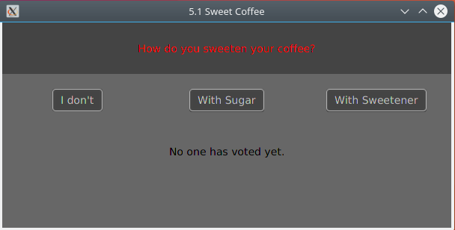

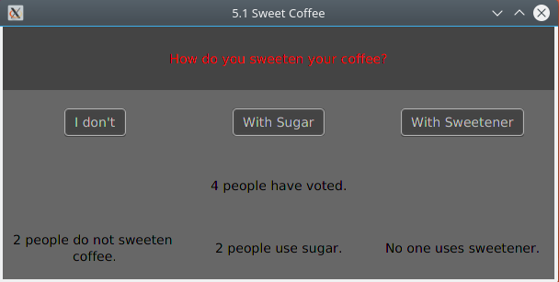

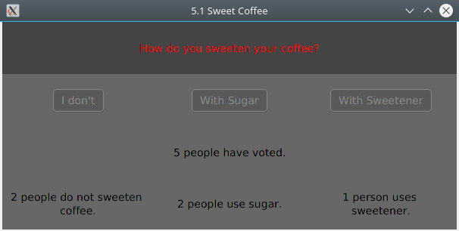

### Exercise 5.2. Square and cube

* Design, write, and test a program to input 7 integers and, for each integer, calculate and display its square and cube.

For this exercise I made both a CLI and GUI application because I was unsure of how I would keep to the specification of the question. The CLI was supposed to keep to the specification whereas the GUI was supposed to make a more usable and intuitive application.

**CLI**

Design

Pseudocode

Define ans[]

Set i to 0

For i to 6

Set exp to user inputted number

Set base to user inputted number

Set result to power(base, exp)

Set ans[i] to result

End

Set i to 0

For i to 6

Output ans[i]

End

Code

import java.util.Scanner;

import java.util.InputMismatchException;

class cliSquareAndCube

{

public static void main(String[] args)

{

//variable for gettint values from the console

Scanner input = new Scanner(System.in);

//array to hold the results.

double[] results = new double[7];

//variables to be inputted by the user.

double base = 0;

double exp = 0;

//loop 1 to calculate exponential functions from user data.

for (int i = 0; i < 7; i++)

{

try

{

//input the number base.

System.out.print("Exponential Function " + i + " Base: ");

base = input.nextDouble();

//input the exponent.

System.out.print("Exponential Function " + i + " Exponent: ");

exp = input.nextDouble();

}

catch (InputMismatchException e)

{

//when the user enters an incorrect type (not an int), and Scanner throws the InputMismatchException

//exit and tell the user why.

System.out.println("Bases and Exponents should only be numbers");

System.exit(0);

}

//after the try catch for this loop, calculate the exponent based on the user input.

results[i] = Math.pow(base, exp);

}

//create whitespace and heading in terminal

System.out.println();

System.out.println();

System.out.println();

System.out.println();

System.out.println();

System.out.println("Results:");

//loop 2 to display the results of the exponential functions

for (int i = 0; i < 7; i++)

{

System.out.println(i + " " + results[i]);

}

System.out.println("End of Results.");

}

}

Output

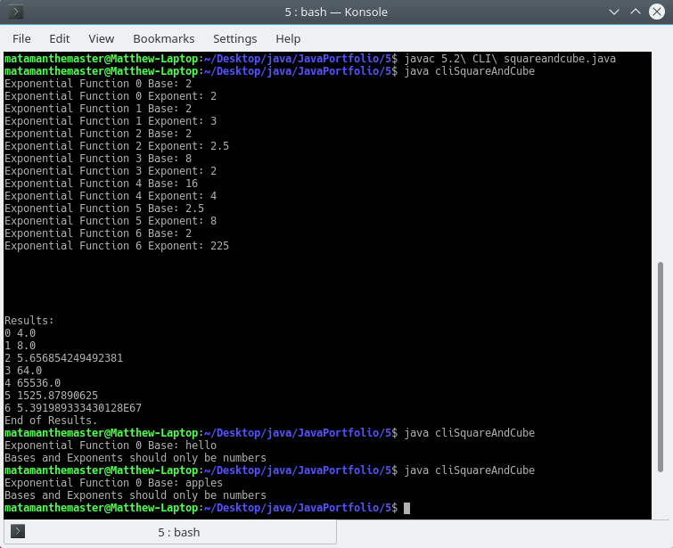

**GUI**

Design

GUI Design

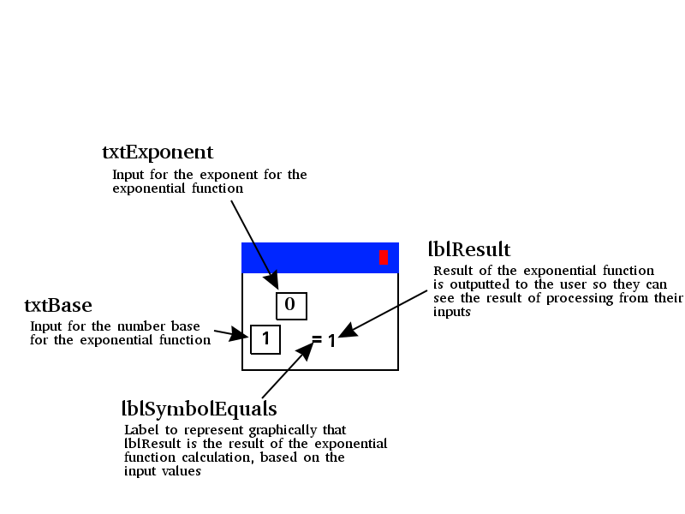

Pseudocode

On event txtBase’s text being changed

Set base to txtBase converted to type intager

Set exponent to txtExponent converted to type intager

Set txtResult to base to the power of exp

End

On event txtExponent’s text being changed

Set base to txtBase converted to type intager

Set exponent to txtExponent converted to type intager

Set txtResult to base to the power of exp

End

Code

Main Class

package squareAndCube;  
  
import javafx.application.Application;  
import javafx.fxml.FXMLLoader;  
import javafx.scene.Parent;  
import javafx.scene.Scene;  
import javafx.stage.Stage;  
  
public class Main extends Application {  
  
 @Override  
 public void start(Stage stageMain) throws Exception  
 {  
  
 //get the contents of Main.fxml to append to the scene  
 Parent root = FXMLLoader.*load*(getClass().getResource("Main.fxml"));  
  
 //set the scene with the contents of Main.fxml and default size.  
 Scene sceneMain = new Scene(root, 250, 100);  
  
  
 //get the css file and add it to the scene's stylesheets.  
 sceneMain.getStylesheets().add(getClass().getResource("css/style.css").toExternalForm());  
  
 //set title, scene and show the stage.  
 stageMain.setTitle("5.2 Square and Cube");  
 stageMain.setScene(sceneMain);  
 stageMain.show();  
  
  
 /*IF to check OS names, as setResizable does not work with some operating systems, such as linux.  
 By default we want to do it the longer method with more set actions, and looks worse on windows. If we can just use set  
 resizable then we can do that. Linux based OS' do not work with setResizable, which is an issue because  
 that is the kernel I am using to program javafx*/  
 String osName = System.*getProperty*("os.name");  
  
 if (osName.indexOf("Windows") != -1)  
 {  
 //any os that contains "Windows" within its name (e.g. "Windows 10"  
 stageMain.setResizable(false);  
 }  
 else  
 {  
 /*sets resize properties. Sets current height and width at the top, then sets the max and mins  
 dependent on their current value (what was set at the top)*/  
 stageMain.setHeight(100);  
 stageMain.setWidth(250);  
 stageMain.setMaxWidth(stageMain.getWidth());  
 stageMain.setMaxHeight(stageMain.getHeight());  
 stageMain.setMinWidth(stageMain.getWidth());  
 stageMain.setMinHeight(stageMain.getHeight());  
 }  
  
 }  
  
  
 public static void main(String[] args) {  
 *launch*(args);  
 }  
}

Some code here was generated by the IDE, mainly the package and class (which I modified the package name of) and the two methods. I wrote the code inside the start method.

Controller Class

package squareAndCube;  
  
import javafx.fxml.FXML;  
import javafx.scene.control.Label;  
import javafx.scene.control.TextField;  
  
  
public class Controller {  
  
 @FXML private TextField txtExponent;  
 @FXML private TextField txtBase;  
 @FXML private Label lblResult;  
  
 public void changeText()  
 {  
 /*default values for base and exponent. If a NumberFormatException is thrown (which it is whenever  
 Double.parseDouble() is ran on not a number) then these default values will be used, as this method  
 is ran on any text change, and resets base and exponent any time it is invoked.*/  
 Double base = 1.0;  
 Double exponent = 0.0;  
  
 try  
 {  
 /*get the values of the text inputs and set them to their respective variable, converting them to  
 a double*/  
 base = Double.*parseDouble*(txtBase.getText());  
 exponent = Double.*parseDouble*(txtExponent.getText());  
 }  
 catch (NumberFormatException e) {  
 /*On NumberFormatException, do nothing. Suppresses errors in the console which we do not need to  
 know about, this is an expected and solved issue.*/  
 }  
  
 //calculate the new result, based on the current values of exponent and base, then set it to the output.  
 Double result = Math.*pow*(base, exponent);  
 lblResult.setText(result.toString());  
 }  
}

The package and the class were auto-generated by the IDE, everything else I wrote.

Scene Builder generated FXML:

<?xml version="1.0" encoding="UTF-8"?>  
  
<?import javafx.scene.control.Label?>  
<?import javafx.scene.control.TextField?>  
<?import javafx.scene.layout.ColumnConstraints?>  
<?import javafx.scene.layout.GridPane?>  
<?import javafx.scene.layout.RowConstraints?>  
<?import javafx.scene.text.Font?>  
  
<GridPane maxHeight="-Infinity" maxWidth="-Infinity" minHeight="-Infinity" minWidth="-Infinity" prefHeight="100.0" prefWidth="255.0" xmlns="http://javafx.com/javafx/9" xmlns:fx="http://javafx.com/fxml/1" fx:controller="squareAndCube.Controller">  
 <columnConstraints>  
 <ColumnConstraints hgrow="SOMETIMES" maxWidth="87.0" minWidth="10.0" prefWidth="40.0" />  
 <ColumnConstraints hgrow="SOMETIMES" maxWidth="111.0" minWidth="0.0" prefWidth="41.0" />  
 <ColumnConstraints hgrow="SOMETIMES" maxWidth="159.0" minWidth="10.0" prefWidth="23.0" />  
 <ColumnConstraints hgrow="SOMETIMES" maxWidth="210.0" minWidth="10.0" prefWidth="112.0" />  
 </columnConstraints>  
 <rowConstraints>  
 <RowConstraints minHeight="10.0" prefHeight="30.0" vgrow="SOMETIMES" />  
 <RowConstraints minHeight="10.0" prefHeight="30.0" vgrow="SOMETIMES" />  
 </rowConstraints>  
 <children>  
 <Label id="lblResult" fx:id="lblResult" text="1.0" GridPane.columnIndex="3" GridPane.rowIndex="1" />  
 <Label id="lblSymbolEquals" fx:id="lblSymbolEquals" text="=" GridPane.columnIndex="2" GridPane.rowIndex="1">  
 <font>  
 <Font size="29.0" />  
 </font>  
 </Label>  
 <TextField id="txtBase" fx:id="txtBase" alignment="CENTER" onKeyReleased="#changeText" prefHeight="30.0" prefWidth="0.0" promptText="Base" styleClass="txt" text="1" GridPane.rowIndex="1" />  
 <TextField id="txtExponent" fx:id="txtExponent" alignment="CENTER" onKeyReleased="#changeText" prefHeight="28.0" prefWidth="42.0" promptText="Exp." styleClass="txt" text="0" GridPane.columnIndex="1" />  
 </children>  
</GridPane>

All was generated using Gluon Scene Builder, which I designed in its GUI.

JavaFX CSS

GridPane {  
 -fx-background-color: #444444;  
}  
  
.txt {  
 -fx-text-fill: #bbbbbb;  
 -fx-background-color: #676767;  
}  
  
#lblSymbolEquals {  
 -fx-text-fill: #bbbbbb;  
}  
  
#lblResult {  
 -fx-text-fill: #ff0000;  
 -fx-font-size: 14px;  
}

All was written by me.

Output

(Windows 10)

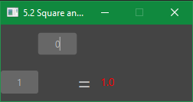

(Kbuntu)

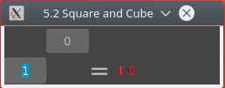

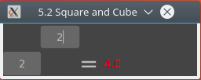

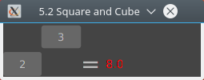

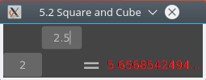

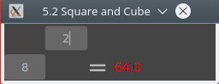

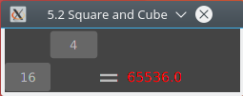

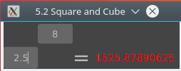

### Exercise 5.3. Payslips

* Design, write, and test a program to input 5 pairs of numbers, the first number representing hours worked and the second number representing rate of pay per hour for each of 5 workers. For each worker, calculate and output the gross pay earned.

**CLI**

Design

Pseudocode

Define a custom datatype “CalcWork” that has inHoursWorked, inRatePay and outGrossPay.

Define array “work” as type CalcWork, with a size of 5 elements.

Set i to 0;

For i to 4

Set work[i].inHoursWorked to value set by the client

Set work[i].inRatePay to value set by the user

Set work[i] outGrossPay = inHours*inRatePay

End

For i to 4

Output work[i].outGrossPay

End

Code

import java.util.Scanner;

import java.util.InputMismatchException;

//Class defines a custom data structure for an array.

class payCalcWork

{

//define variables for the object.

public double inHoursWorked;

public double inRatePay;

public double outGrossPay;

//method for calculating the gross pay.

public void calcGrossPay()

{

//hours worked * hourly rate, then assign it to the gross pay of the current object.

this.outGrossPay = inHoursWorked * inRatePay;

}

}

//main class

class payslips

{

public static void main(String[] args)

{

//create an array for my class, that has 5 elements.

CalcWork[] work = new CalcWork[5];

//create a variable to input data from a terminal.

Scanner input = new Scanner(System.in);

for (int i = 0; i < 5; i++)

{

//initiate the current array position as my class.

work[i] = new CalcWork();

try

{

//Input the next hours worked and store it in the current array row, in the hours worked variable.

System.out.print("[" + i + "] Input Hours Worked: ");

work[i].inHoursWorked = input.nextDouble();

//Input next hourly rate, store in same row, in the hourly rate variable.

System.out.print("[" + i + "] Input Hourly Rate: ");

work[i].inRatePay = input.nextDouble();

}

catch (InputMismatchException e)

{

//catch InputMismatchExceptions, generated when inputted value is not the correct datatype (double)

//inform the user what went wrong and exit.

System.out.println("Inputted values must be numbers.");

System.exit(0);

}

//invoke the method calcGrossPay for the current array row.

work[i].calcGrossPay();

}

//labels following output.

System.out.println();

System.out.println("Gross Pays:");

//print each gross pay.

for (int i = 0; i < 5; i++)

{

System.out.println("[" + i + "] " + work[i].outGrossPay);

}

}

}

Output

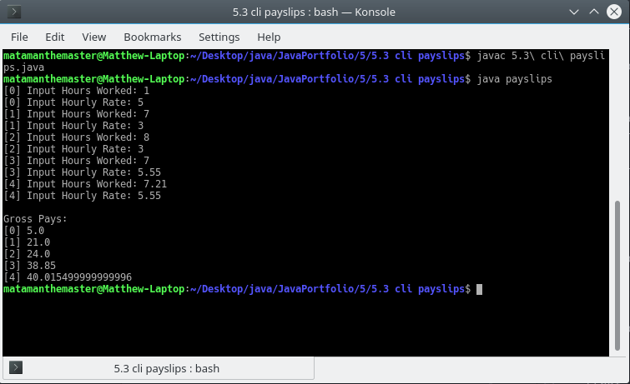

**GUI**

Design

GUI Design

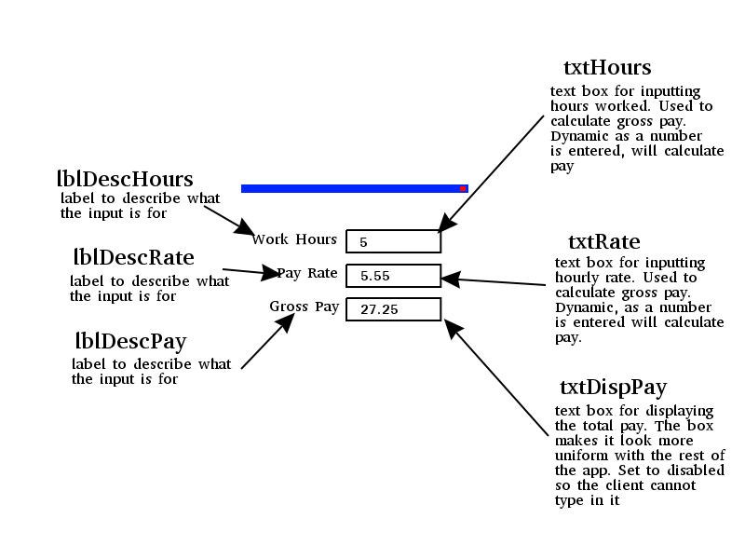

Pseudocode

On event txtHours’ text being changed

Set inHoursWorked to the text value of txtHours converted to double

Set inRatePay to the text value of txtRate converted to double

Set txtDispPay’s text to inHoursWorked * inRatePay

End

On event txtRate’s text being changed

Set inHoursWorked to the text value of txtHours converted to double

Set inRatePay to the text value of txtRate converted to double

Set txtDispPay’s text to inHoursWorked * inRatePay

End

Code

Main Class

package payslips;  
  
import javafx.application.Application;  
import javafx.fxml.FXMLLoader;  
import javafx.scene.Parent;  
import javafx.scene.Scene;  
import javafx.stage.Stage;  
  
public class Main extends Application {  
  
 @Override  
 public void start(Stage stageMain) throws Exception  
 {  
 //get the contents of Main.fxml to append to the scene  
 Parent root = FXMLLoader.*load*(getClass().getResource("payslips.fxml"));  
  
 //set the scene with the contents of Main.fxml and default size.  
 Scene sceneMain = new Scene(root, 500, 250);  
  
  
 //get the css files and add it to the scene's stylesheets.  
 sceneMain.getStylesheets().add(getClass().getResource("css/style.css").toExternalForm());  
 sceneMain.getStylesheets().add(getClass().getResource("css/colour.css").toExternalForm());  
  
 //set stage minimum sizes  
 stageMain.setMinWidth(300);  
 stageMain.setMinHeight(150);  
  
 //set title, scene and show the stage.  
 stageMain.setTitle("5.3 Payslips");  
 stageMain.setScene(sceneMain);  
 stageMain.show();  
 }  
  
  
 public static void main(String[] args) {  
 *launch*(args);  
 }  
}

Part of this class were auto-generated by my IDE. Everything written within the method start was written by me.

Controller Class

package payslips;  
  
import javafx.fxml.FXML;  
import javafx.scene.control.TextField;  
  
public class Controller {  
  
 @FXML private TextField txtHours;  
 @FXML private TextField txtRate;  
 @FXML private TextField txtDispPay;  
  
 public void textChanged()  
 {  
 /* define variables to assign the values in the text boxes, which are strings. Default to 0.0 in case  
 of NumberFormatException*/  
 Double inHoursWorked = 0.0;  
 Double inRatePay = 0.0;  
  
 try  
 {  
 /*get the values of the text inputs and set them to their respective variable, converting them to  
 a double*/  
 inHoursWorked = Double.*parseDouble*(txtHours.getText());  
 inRatePay = Double.*parseDouble*(txtRate.getText());  
 }  
 catch (NumberFormatException e){  
 /*On NumberFormatException, do nothing. Suppresses errors in the console which we do not need to  
 know about, this is an expected and solved issue.*/  
 }  
  
 //calculate the gross pay as double, then set it to the text of the display text box.  
 Double outGrossPay = inHoursWorked * inRatePay;  
  
 txtDispPay.setText(outGrossPay.toString());  
 }  
}

Only the class definition and package definition were auto-generated. The rest was written by me.

Payslips FXML

<?xml version="1.0" encoding="UTF-8"?>  
  
<?import java.lang.String?>  
<?import javafx.geometry.Insets?>  
<?import javafx.scene.control.Label?>  
<?import javafx.scene.control.TextField?>  
<?import javafx.scene.layout.ColumnConstraints?>  
<?import javafx.scene.layout.GridPane?>  
<?import javafx.scene.layout.RowConstraints?>  
<?import javafx.scene.text.Font?>  
  
<GridPane xmlns="http://javafx.com/javafx/9.0.1" xmlns:fx="http://javafx.com/fxml/1" fx:controller="payslips.Controller">  
 <columnConstraints>  
 <ColumnConstraints />  
 <ColumnConstraints hgrow="SOMETIMES" maxWidth="100.0" minWidth="100.0" prefWidth="100.0" />  
 <ColumnConstraints hgrow="SOMETIMES" maxWidth="1.7976931348623157E308" minWidth="100.0" />  
 </columnConstraints>  
 <rowConstraints>  
 <RowConstraints />  
 <RowConstraints minHeight="10.0" prefHeight="30.0" vgrow="SOMETIMES" />  
 <RowConstraints minHeight="10.0" prefHeight="30.0" vgrow="SOMETIMES" />  
 <RowConstraints minHeight="10.0" prefHeight="30.0" vgrow="SOMETIMES" />  
 </rowConstraints>  
 <children>  
 <Label id="lblDescHours" fx:id="lblDescHours" prefHeight="16.0" prefWidth="81.0" styleClass="lblDesc" text="Work Hours" GridPane.columnIndex="1" GridPane.rowIndex="1">  
 <font>  
 <Font size="15.0" />  
 </font></Label>  
 <Label id="lblDescRate" fx:id="lblDescRate" prefHeight="16.0" prefWidth="63.0" styleClass="lblDesc" text="Pay Rate" GridPane.columnIndex="1" GridPane.rowIndex="2">  
 <font>  
 <Font size="15.0" />  
 </font></Label>  
 <Label id="lblDescPay" fx:id="lblDescPay" prefHeight="16.0" prefWidth="69.0" styleClass="lblDesc" text="Gross Pay" GridPane.columnIndex="1" GridPane.rowIndex="3">  
 <font>  
 <Font size="15.0" />  
 </font></Label>  
 <TextField id="txtHours" fx:id="txtHours" onKeyReleased="#textChanged" styleClass="txt" GridPane.columnIndex="2" GridPane.rowIndex="1">  
 <GridPane.margin>  
 <Insets right="20.0" />  
 </GridPane.margin>  
 <font>  
 <Font size="15.0" />  
 </font></TextField>  
 <TextField id="txtRate" fx:id="txtRate" onKeyReleased="#textChanged" styleClass="txt" GridPane.columnIndex="2" GridPane.rowIndex="2">  
 <GridPane.margin>  
 <Insets right="20.0" />  
 </GridPane.margin>  
 <font>  
 <Font size="15.0" />  
 </font></TextField>  
 <TextField id="txtDispPay" fx:id="txtDispPay" editable="false" text="0.0" GridPane.columnIndex="2" GridPane.rowIndex="3">  
 <styleClass>  
 <String fx:value="txt" />  
 <String fx:value="txtDisp" />  
 </styleClass>  
 <GridPane.margin>  
 <Insets right="20.0" />  
 </GridPane.margin>  
 <font>  
 <Font size="15.0" />  
 </font>  
 </TextField>  
 </children>  
</GridPane>

The interface was designed by me in Gluon Scene Builder, which generated the FXML file above.

Style.css

#txtDispPay {  
 -fx-font-weight: bold;  
}

This was all written by me.

Colour.css

GridPane {  
 -fx-background-color: #ededed;  
}  
  
.lblDesc {  
 -fx-text-fill: #000000;  
}  
  
.txt {  
 -fx-text-fill: #000000;  
 -fx-background-color: #ffffff;  
}  
  
#txtDispPay {  
 -fx-text-fill: #35c5ff;  
 -fx-background-color: #e0e0e0;  
}

This was all written by me

Output

(Windows)

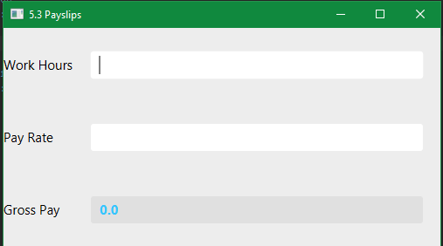

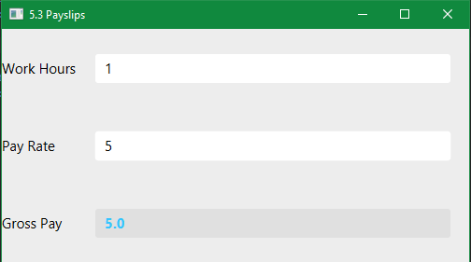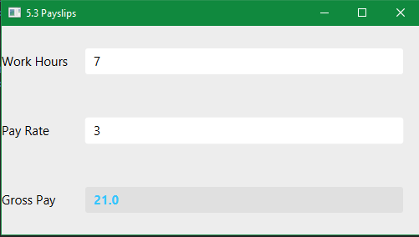

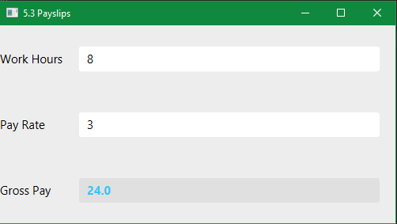

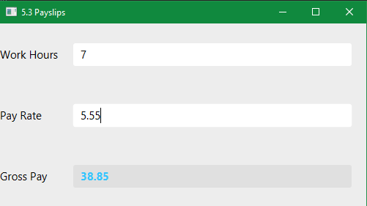

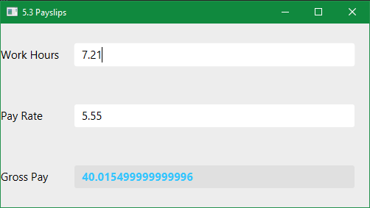

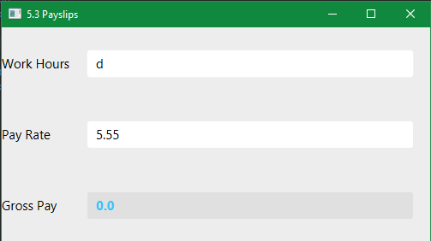

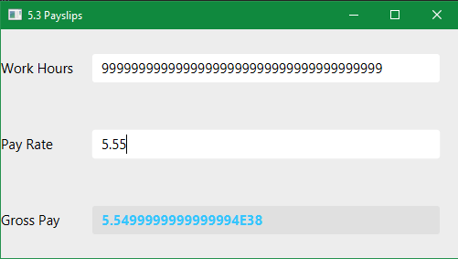

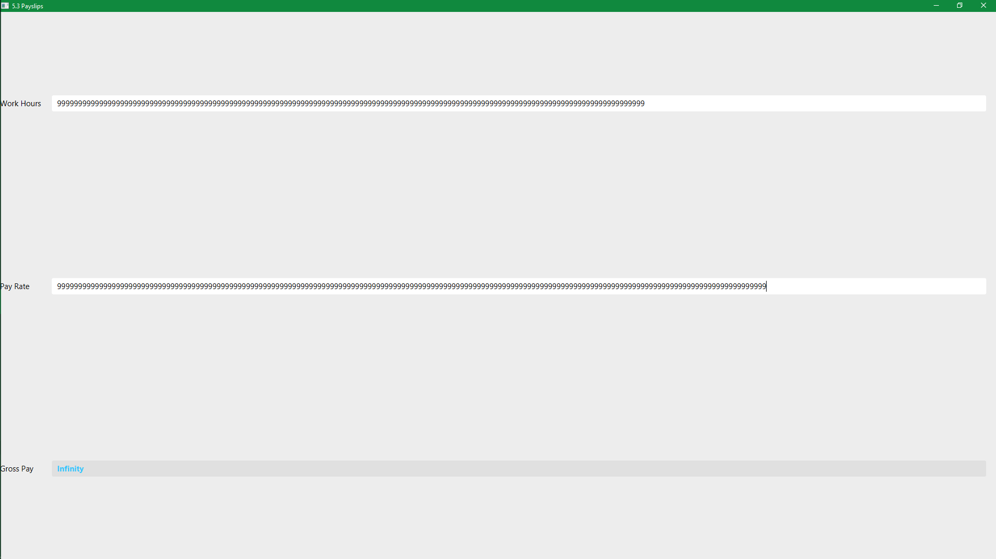

### **Exercise 5.4. Commission**

* Design, write, and test a program to input the commission figures for 10 sales staff; calculate and output the total commission overall and the average commission.

I am no longer producing CLI applications as they are not necessary alongside a GUI application and make the process take much longer than it needs to be. For this exercise I plan on inputting as many values as the user wishes to input, and work out the total sales and average sale. This solution would be better suited to an event driven package such as JavaFX. I will use tabs to separate user input and system output because it is a simple and good looking solution to having multiple windows that need to store different groups of controls. Instead of writing logic for managing scenes or stages and passing variables between them, everything is stored on the same stage in the same scene.

Design

GUI Design

New Tab:

This tab, when selected (by default or by the user) separates controls for inputting new commissions into the system.

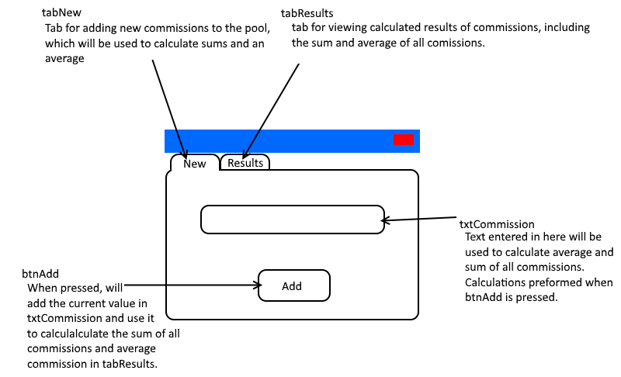

Results Tab:

This tab, when selected by the user, separates outputs for displaying the results of inputs.

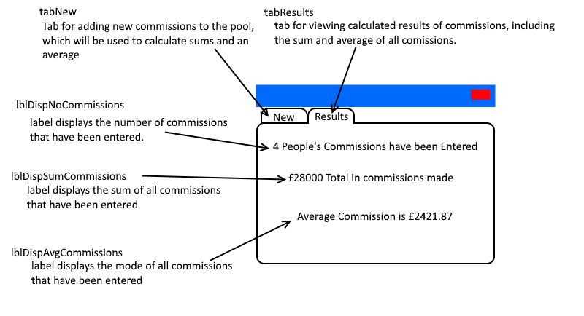

Pseudocode:

Define noCommissions as 0

Define sumCommissions as 0

On event btnAdd is pressed

Increment noCommissions by 1

Add the numeric value of txtCommission to sumCommission

End

On event tabResults is changed to

if noCommissions == 0

Set lblDispNoCommissions' text to "No commissions have been made."

else if noCommissions == 1

Set lblDispNoCommissions' text to "1 person has made commissions."

else

Set lblDispNoCommissions' text to noCommissions + " people have made commissions."

End

Set lblDispSumCommissions' text to "£" + sumCommissions + " total in commissions have been made."

Set lbbDispAvgCommissions' text to "The average commission is £" + sumCommissions / noCommissions

End

Code

Main Class:

package commissions;  
  
import javafx.application.Application;  
import javafx.fxml.FXMLLoader;  
import javafx.scene.Parent;  
import javafx.scene.Scene;  
import javafx.stage.Stage;  
  
public class Main extends Application {  
  
 @Override  
 public void start(Stage stageMain) throws Exception  
 {  
  
 //get the contents of Main.fxml to append to the scene  
 Parent root = FXMLLoader.*load*(getClass().getResource("Main.fxml"));  
  
 //set the scene with the contents of Main.fxml and default size.  
 Scene sceneMain = new Scene(root, 600, 400);  
  
  
  
 //get the css files and add them to the scene's stylesheets.  
 sceneMain.getStylesheets().add(getClass().getResource("css/colour.css").toExternalForm());  
  
 //set title, scene, min height and widths, and show the stage.  
 stageMain.setTitle("5.4 Commissions");  
 stageMain.setScene(sceneMain);  
 stageMain.setMinHeight(200);  
 stageMain.setMinWidth(500);  
 stageMain.show();  
  
 }  
  
  
 public static void main(String[] args) {  
 *launch*(args);  
 }  
}

Class stores method for bootstrapping GUI application by loading libraries and setting variables for instances of classes. Everything in the start method was written by me, the rest was an auto-generated snippet from my IDE intelij idea.

Controller Class:

package commissions;  
  
import javafx.fxml.FXML;  
import javafx.scene.control.Button;  
import javafx.scene.control.Tab;  
import javafx.scene.control.TextField;  
import javafx.scene.text.Text;  
  
public class Controller {  
  
 //Controls in FXML, so we can manipulate them in the controller file.  
 @FXML Button btnAdd;  
 @FXML TextField txtCommission;  
 @FXML Tab tabResults;  
 @FXML Text lblDispNoCommissions;  
 @FXML Text lblDispSumCommissions;  
 @FXML Text lblDispAvgCommissions;  
  
 //variables used for commission calculations and displays.  
 int noCommissions = 0;  
 double sumCommissions = 0;  
  
 public void btnAddPressed()  
 {  
 //increment number of commissions and convert txtCommission's text to a double, add that to the sum on event btnAdd is pressed.  
 noCommissions++;  
  
 try  
 {  
 sumCommissions += Double.*parseDouble*(txtCommission.getText());

txtCommission.setText("");

}  
 catch (java.lang.NumberFormatException e)  
 {  
 /*if setting a commission does cause an error, decrement the number of commissions, and pretend they didn't add anything. No value will be added to sumCommissions because that line generated the exception.*/  
 noCommissions--;  
 }  
 }  
  
 public void tabChanged()  
 {  
 //if makes sure we only run on switching to tabResults. Saves wasted instruction processing.  
 if (tabResults.isSelected())  
 {  
 if (noCommissions == 0)  
 {  
 //if no commissions have been entered, set text to display results grammatically correctly.  
 lblDispNoCommissions.setText("No commissions have been entered.");  
  
 //sets visibility for fields to invisible, cleaner UI, if no commissions have been added then nothing to display that isn't already displayed by lblDispNoCommissions.  
 lblDispSumCommissions.setVisible(false);  
 lblDispAvgCommissions.setVisible(false);  
 }  
 else  
 {  
 //if 1 or more commission has been made (inclusive as some text fields do not care about 1 or more than 1).  
  
 //set text and visibility of sum and average text. In that order just in case the program hangs in between steps. Average commissions is calculated inline setting text.  
 lblDispSumCommissions.setText("£" + sumCommissions + " total in commissions has been entered.");  
 lblDispAvgCommissions.setText("The average (mean) commission is £" + (sumCommissions/noCommissions));  
 lblDispSumCommissions.setVisible(true);  
 lblDispAvgCommissions.setVisible(true);  
  
 if (noCommissions == 1)  
 {  
 //if 1 commission has been entered, set text to display results grammatically correctly.  
 lblDispNoCommissions.setText("1 commission has been entered.");  
 }  
 else  
 {  
 //if >1 commissions have been entered, grammatically format text for more than 1 commission.  
 lblDispNoCommissions.setText(noCommissions + " commissions have been entered.");  
 }  
 }  
 }  
 }  
}

This was mostly written by me. Package and class definition was auto-generated as a snippet from the IDE intelij idea.

FXML File:

<?xml version="1.0" encoding="UTF-8"?>  
  
<?import javafx.geometry.Insets?>  
<?import javafx.scene.control.Button?>  
<?import javafx.scene.control.Tab?>  
<?import javafx.scene.control.TabPane?>  
<?import javafx.scene.control.TextField?>  
<?import javafx.scene.layout.HBox?>  
<?import javafx.scene.layout.VBox?>  
<?import javafx.scene.text.Font?>  
<?import javafx.scene.text.Text?>  
  
<TabPane tabClosingPolicy="UNAVAILABLE" xmlns="http://javafx.com/javafx/9.0.1" xmlns:fx="http://javafx.com/fxml/1" fx:controller="commissions.Controller">  
 <tabs>  
 <Tab fx:id="tabAdd" closable="false" text="New">  
 <content>  
 <VBox alignment="CENTER">  
 <children>  
 <HBox alignment="CENTER">  
 <children>  
 <TextField id="txtCommission" fx:id="txtCommission" prefHeight="25.0" prefWidth="274.0" styleClass="txt" />  
 </children>  
 </HBox>  
 <HBox alignment="CENTER">  
 <children>  
 <Button id="btnAdd" fx:id="btnAdd" mnemonicParsing="false" onMousePressed="#btnAddPressed" styleClass="btn" text="Add Commission">  
 <HBox.margin>  
 <Insets top="20.0" />  
 </HBox.margin></Button>  
 </children>  
 </HBox>  
 </children>  
 </VBox>  
 </content></Tab>  
 <Tab fx:id="tabResults" closable="false" onSelectionChanged="#tabChanged" text="Results">  
 <content>  
 <VBox alignment="CENTER" fillWidth="false">  
 <children>  
 <HBox alignment="CENTER" VBox.vgrow="ALWAYS">  
 <children>  
 <Text id="lblDispNoCommissions" fx:id="lblDispNoCommissions" strokeType="OUTSIDE" strokeWidth="0.0" styleClass="lbl" text="Text">  
 <font>  
 <Font size="24.0" />  
 </font></Text>  
 </children>  
 </HBox>  
 <HBox alignment="CENTER" layoutX="10.0" layoutY="61.0" VBox.vgrow="ALWAYS">  
 <children>  
 <Text id="lblDispSumCommissions" fx:id="lblDispSumCommissions" strokeType="OUTSIDE" strokeWidth="0.0" styleClass="lbl" text="Text">  
 <font>  
 <Font size="24.0" />  
 </font></Text>  
 </children>  
 </HBox>  
 <HBox alignment="CENTER" layoutX="10.0" layoutY="136.0" VBox.vgrow="ALWAYS">  
 <children>  
 <Text id="lblDispAvgCommissions" fx:id="lblDispAvgCommissions" strokeType="OUTSIDE" strokeWidth="0.0" styleClass="lbl" text="Text">  
 <font>  
 <Font size="24.0" />  
 </font></Text>  
 </children>  
 </HBox>  
 </children>  
 </VBox>  
 </content></Tab>  
 </tabs>  
</TabPane>

This was all designed by me in Gluon Scene Builder, which from the GUI design I made in its interfaces, generated FXML.

Colour CSS:

#txtCommission {  
 -fx-text-fill: #35c5ff;  
 -fx-font-weight: bold;  
}

This was all written by me.

Output

(windows)

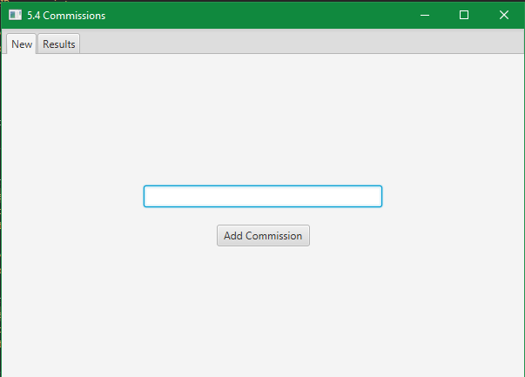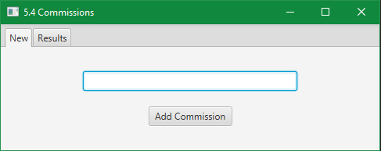

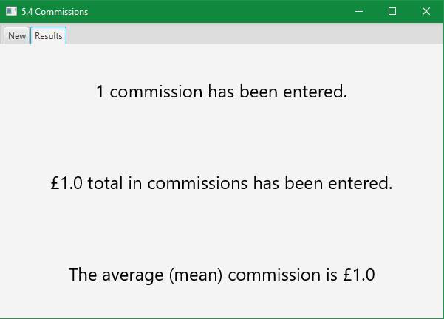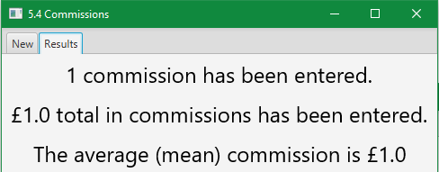

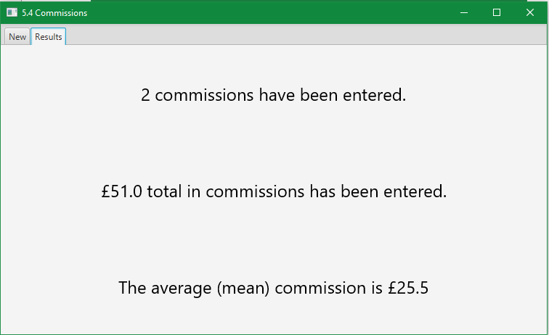

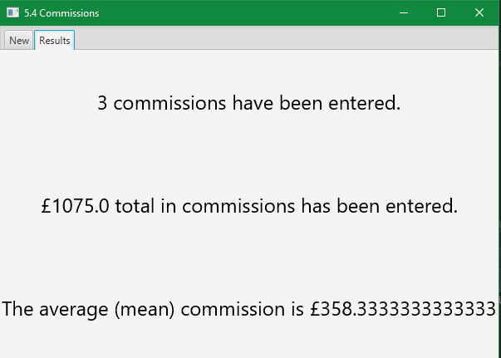

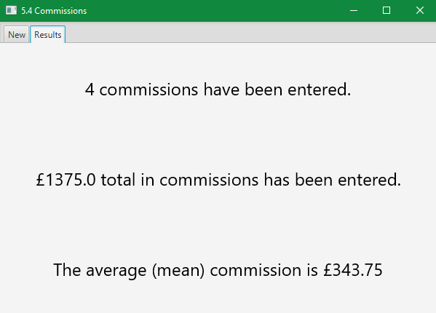

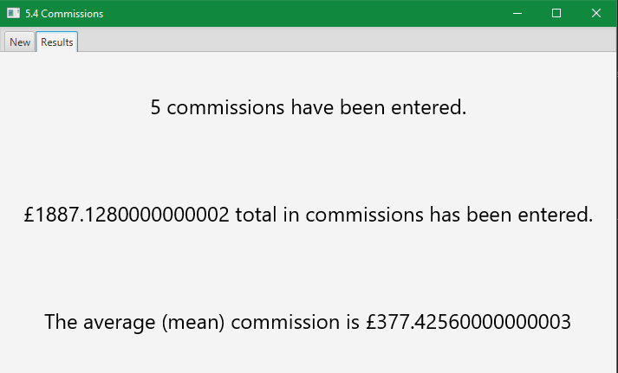

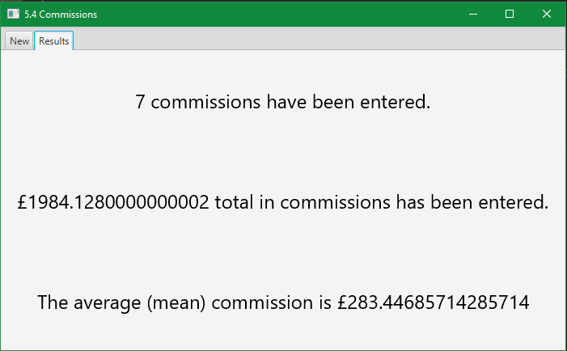

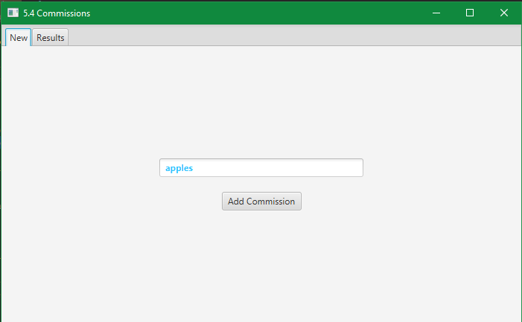

Results Table:

|  |  |  |  |  |  |
| --- | --- | --- | --- | --- | --- |
| Sequence  Number | Initial Sum | Input | New No. of Commissions | New Sum | New Average |
| 0 | 0 | 1 | 1 | 1 | 1 |
| 1 | 1 | 50 | 2 | 51 | 25.5 |
| 2 | 51 | 1024 | 3 | 1075 | 358.333* |
| 3 | 1075 | 300 | 4 | 1375 | 343.75 |
| 4 | 1375 | 512.128 | 5 | 1887.128 | 377.4256 |
| 5 | 1887.128 | 1.7E2 | 6 | 2057.128 | 342.854666* |
| 6 | 2057.128 | -73 | 7 | 1984.128 | 283.446857142… |
| 7 | 1984.128 | apples | 7 | 1984.128 | 283.446857142… |

(* suffix for a recurring decimal).

### Exercise 5.5. Student marks

* Design, write, and test a program to input the number of students sitting an examination, followed by an exam mark for each of the students. For each student, display the mark and a message 'Pass' or 'Fail', depending on whether the mark is at least 40 (for a Pass) or less than 40 (for a Fail).

Inputting the number of students is a requirement that better suits CLI applications using for loops. While I am making GUI applications that are event driven rather than loop driven, I will be able to implement a certain number of students. My idea is to use tabs to store individual students, and have dynamic generation of tabs based on the user clicking a button to add more users. All data can be stored in memory and belonging to specific tabs. I plan on having delete buttons on the tabs so you can select what student to remove the details from.

From now on, I have also decided to not design any CSS. JavaFX CSS uses different styles to traditional CSS 3 (of which I am used to). The process of looking up the equivalent of what I want to do and debugging CSS issues where styles are not applying, in addition to

Design

GUI Design

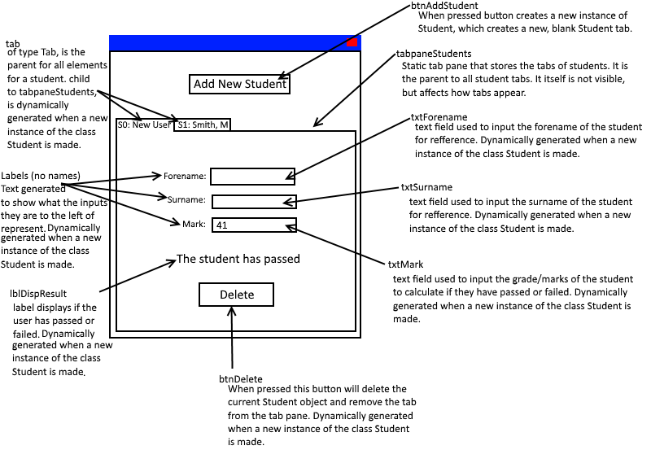

Class Diagram:

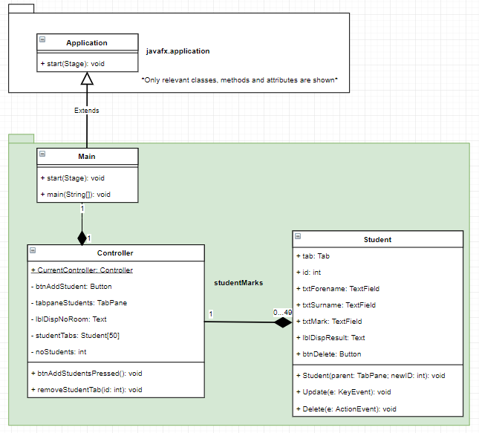

Pseudocode:

* Class Student:
  + Method Student (initialisation):

Input parent and newID from method call.

Set this.tab as a new Tab

Add this.tab to parent

Set this.id to newID

Set the text of this.tab to “S” + newID + “: New Student”

Set tabRoot as a new HBox

Add tabRoot to this.tab

Set tabRootsChild as a new VBox

Add tabRootsChild to tabRoot

Set this.txtForename as a new TextField

Set this.txtSurname as a new TextField

Set this.txtMark as a new TextField

Set this.lblDispResults as a new Text

Set this.lblDispResult to be invisible.

Set this.btnDelete to be a Button with the text “Delete”

Set on event OnKeyReleased for txtForename to run the method this.Update

Set on event OnKeyReleased for txtSurname to run the method this.Update

Set on event OnKeyReleased for txtMark to run the method this.Update

Set on event ButtonPressed for btnDelete to run the method this.Delete

Set hboxForname as a new HBox

Add the Text “Forename: ” to hboxForename

Add this.txtForename to hboxForename

Add hboxForename to tabRootsChild

Set hboxSurname as a new HBox

Add the text “Surname: “ to hboxSurname

Add this.txtSurname to hboxSurname

Add hboxSurname to tabRootsChild

Set hboxMark as a new HBox

Add the Text “Marks: “ to hboxMark

Add this.txtMark to hboxMark

Add hboxMark to tabRootsChild

Add this.lblDispResult to tabRootsChild

Add this.btnDelete to tabRootsChild

* + Method Update:

If the text of txtForename is “” (blank)

Set the text of this.tab to “S” + this.id + “: New Student”

Else

Set the text of this.tab to “S” + this.id + txtSurname’s text + “, “ + the first character of txtForename

End If

* + Method Delete:

Remove this.tab from this.tab’s parent (the tab pane)

Call method Controller.removeStudentTab(this.id)

* Class Controller:
  + Method btnAddStudentPressed:

Set the element of studentTabs at position noStudents to a new instance of the Student class.

Increment noStudents by 1

If noStudents == the array size of studentTabs

Disable btnAddStudent

End

* + Method removeStudentTab:

Input id from method call

If studentTabs at element position of id is not null

If id is 0 and noStudents is 1

Set studentTabs at element position 0 to null

Set noStudents to 0

End Method

Else If id is between and including 0 and the array size of studentTabs -1 (49 if array size is 50)

Set studentTabs at element position of id to null

For i is the value of (id+1), while less than the array size of studentTabs

If studentTabs at the current element position of I is not null

Set studentTabs at element position i-1 to studentTabs at element position i

Decrement studentTabs.id at element position i-1

Call method studentTabs.Update(null) at element position i-1

Set studentTabs at element position i to null

Else

End Method

End If

End For

Else

Throw error, End Method

End

Else

Throw error, End Method

End

Code

Main Class

package studentMarks;  
  
import javafx.application.Application;  
import javafx.fxml.FXMLLoader;  
import javafx.scene.Parent;  
import javafx.scene.Scene;  
import javafx.stage.Stage;  
  
public class Main extends Application {  
  
 @Override  
 public void start(Stage primaryStage) throws Exception  
 {  
 //Create an FXMLLoader to load Main.fxml, and load it.  
 FXMLLoader loader = new FXMLLoader(getClass().getResource("Main.fxml"));  
 Parent root = loader.load();  
 primaryStage.setTitle("5.5 Student Marks");  
 Scene sceneMain = new Scene(root, 300, 300);  
  
 /*While I am not adding my own CSS, the option to modify the CSS exists for the end user, though is going to  
 require a knowledge of javafx CSS.*/  
 sceneMain.getStylesheets().add(getClass().getResource("css/Main.css").toExternalForm());  
  
 //Add the scene to the stage, and show it.  
 primaryStage.setScene(sceneMain);  
 primaryStage.show();  
  
 /*Store the reference of the FXMLLoader's controller (the controller which the FXMLLoader is using defined by  
 the FXML) statically in the Controller. Only exists so Student class instances can call an instance of Controller  
 to call the method removeStudentTab*/  
 Controller.*CurrentController* = loader.getController();  
  
 }  
  
  
 public static void main(String[] args)  
 {  
 *launch*(args);  
 }  
}

I wrote the code **inside** the start method (not the method definition). The rest was auto-generated by the IDE.

Student Class

package studentMarks;  
  
import javafx.event.ActionEvent;  
import javafx.scene.control.*;  
import javafx.scene.input.KeyEvent;  
import javafx.scene.layout.HBox;  
import javafx.scene.layout.VBox;  
import javafx.scene.text.Text;  
import static javafx.geometry.Pos.*CENTER*;  
import static javafx.geometry.Pos.*CENTER_RIGHT*;  
  
public class Student  
{  
 //Student's tab attributes  
 public Tab tab;  
 public int id;  
 public TextField txtForename;  
 public TextField txtSurname;  
 public TextField txtMark;  
 public Text lblDispResult;  
 public Button btnDelete;  
  
 //method invoked on creating new instance of Student. Generates a tab with controls and event handling.  
 public Student(TabPane parent, int newID)  
 {  
 /*create a tab, store it as the student's tab attribute, set the ID from the ID provided in the creation and set  
 a title for new students.*/  
 this.tab = new Tab();  
 this.id = newID;  
 this.tab.setText("S" + newID + ": New Student");  
  
 /*create elements that will become nested in the tab, and nested in this nested element. Second and Third are  
 arbitrary names as their only point is to structure the scene objects. We need to reference them to append  
 children. Center objects to everything appears in the middle of the tab.*/  
 HBox hbSecond = new HBox();  
 VBox vbThird = new VBox();  
 hbSecond.setAlignment(*CENTER*);  
 vbThird.setAlignment(*CENTER*);  
  
 //create javafx scene objects and assign them to this classes attributes. Set up attributes for the scene objects.  
 this.txtForename = new TextField();  
 this.txtSurname = new TextField();  
 this.txtMark = new TextField();  
 this.lblDispResult = new Text();  
 this.lblDispResult.setVisible(false);  
 this.btnDelete = new Button("Delete Current Student");  
  
 /*Events handled by existing method. Compiler deals with how we get to the method. Method must implement the event  
 type.*/  
 this.txtForename.setOnKeyReleased(this::Update);  
 this.txtSurname.setOnKeyReleased(this::Update);  
 this.txtMark.setOnKeyReleased(this::Update);  
 this.btnDelete.setOnAction(this::Delete);  
  
 /*encapsulate the text entries within a hbox, and have a text label before them. alignment so text fields match  
 in alignment.*/  
 HBox hbForename = new HBox();  
 hbForename.getChildren().add(new Text("Forename: "));  
 hbForename.getChildren().add(this.txtForename);  
 hbForename.setAlignment(*CENTER_RIGHT*);  
  
 HBox hbSurname = new HBox();  
 hbSurname.getChildren().add(new Text("Surname: "));  
 hbSurname.getChildren().add(this.txtSurname);  
 hbSurname.setAlignment(*CENTER_RIGHT*);  
  
 HBox hbMark = new HBox();  
 hbMark.getChildren().add(new Text("Marks: "));  
 hbMark.getChildren().add(this.txtMark);  
 hbMark.setAlignment(*CENTER_RIGHT*);  
  
  
 /*add the scene objects (and scene objects through their encapsulating hboxes) to their root. Create and add  
 spacing so there is space between scene objects.*/  
 vbThird.setSpacing(5);  
 vbThird.getChildren().add(hbForename);  
 vbThird.getChildren().add(hbSurname);  
 vbThird.getChildren().add(hbMark);  
 vbThird.getChildren().add(this.lblDispResult);  
 vbThird.getChildren().add(this.btnDelete);  
  
 //Add the child to tabRoot (that contains all control objects) to tabRoot  
 hbSecond.getChildren().add(vbThird);  
  
 //add the tab root to the current tab. Add the current tab to the parent, the tabpane.  
 this.tab.setContent(hbSecond);  
 parent.getTabs().add(this.tab);  
 }  
  
 public void Update(KeyEvent e)  
 {  
 if (this.txtForename.getText().equals(""))  
 {  
 //set the text of the tab (what is displayed) to show the student id and "New Student" if no forename exists.  
 this.tab.setText("S" + this.id + ": New Student");  
 }  
 else  
 {  
 //set the text of the tab (what is displayed) to show the student id and name. if a forename exists.  
 //e.g. S0: Smith, M  
 this.tab.setText("S" + id + ": " + this.txtSurname.getText() + ", " + this.txtForename.getText().charAt(0));  
 }  
  
  
 //catch exceptions thrown  
 try  
 {  
 //convert the text of the TextField to an int, throws NumberFormatException if not a valid int.  
 int mark = Integer.*parseInt*(this.txtMark.getText());  
  
 //check if the student is above or below grade threshold. pass if above, fail if below.  
 if (mark < 40)  
 {  
 this.lblDispResult.setText("This student has failed.");  
 }  
 else if (mark >= 40)  
 {  
 this.lblDispResult.setText("This student has passed.");  
 }  
  
 //make sure that the result is always visible if no NumberFormatException was thrown.  
 this.lblDispResult.setVisible(true);  
 this.lblDispResult.setVisible(true);  
 }  
 catch (NumberFormatException x)  
 {  
 //exception thrown when trying to parse a number data type and the input string is NaN (Not a Number).  
 //Hide lblDispResult on NumberFormatException thrown.  
 this.lblDispResult.setVisible(false);  
 }  
 }  
  
  
 public void Delete(ActionEvent e)  
 {  
 //Remove the tab from the tabpane  
 this.tab.getTabPane().getTabs().remove(this.tab);  
  
 /*Call Controller.removeStudentTab to remove the current student from the array studentTabs (and kill this  
 instance). Have to get a statically defined variable from Controller that stores the instance of Controller used  
 by the FXMLLoader, as that is the instance of the class that stores the studentTabs array and instance of this  
 class*/  
 Controller.*CurrentController*.removeStudentTab(this.id);  
 }  
}

This class was all my work, and only imports and package definition were auto-generated

Controller Class

package studentMarks;  
  
import javafx.fxml.FXML;  
import javafx.scene.control.Button;  
import javafx.scene.control.TabPane;  
import javafx.scene.text.Text;  
  
public class Controller  
{  
 /* static variable stores the instance of this class that is being used by FXML. Set when loading the FXML in Main  
 class, used by Student class to invoke the method removeStudentTab*/  
 public static Controller *CurrentController* = null;  
  
 //Instances of FXML elements, that we are going to manipulate in some way.  
 @FXML private Button btnAddStudent;  
 @FXML private TabPane tabpaneStudents; //Tabs stored in here, we can add new students which generates a tab added into the pane.  
 @FXML private Text lblDispNoRoom; //Only shown when noStudents == studentTabs.length  
  
 //Array stores instances of class Student. Array size can be changed and all code will work normally.  
 private Student[] studentTabs = new Student[50];  
  
 //Stores number of students. If adding, the value is used as next student id. e.g. 0 students, the next id is 0.  
 private int noStudents = 0;  
  
 //Method called when btnAddStudent is pressed, event managed by class FXMLLoader  
 public void btnAddStudentPressed()  
 {  
 //Add a new instance of the Student class to the next free array position. Requires the tabpane and new ID.  
 studentTabs[noStudents] = new Student(tabpaneStudents, noStudents);  
  
 //increment number of students as new student has been added.  
 noStudents++;  
  
 //if we have hit the tab limit, disable input button so can't create more students, show message why.  
 if (noStudents == studentTabs.length)  
 {  
 lblDispNoRoom.setVisible(true);  
 btnAddStudent.setDisable(true);  
 }  
 }  
  
 //method invoked when the delete button for a student has been pressed. Called from the student  
 public void removeStudentTab(int id)  
 {  
 //check the student we are trying to remove exists.  
 if (studentTabs[id] != null)  
 {  
 /*if id is 0 and is the only element, we can't shift the next element down, so manually delete the student  
 and set noStudents to 0 (no students exist). id 0 should be the only one that exists at 1 student according  
 to this method*/  
 if (id == 0 && noStudents == 1)  
 {  
 studentTabs[0] = null;  
 noStudents = 0;  
 return;  
 }  
 else if (id > -1 && id < studentTabs.length) //if we are between the valid ranges (and noStudents is > 1)  
 {  
 //delete the current student.  
 studentTabs[id] = null;  
  
 //start at the next ID, work down.  
 for (int i = id+1; i < studentTabs.length; i++)  
 {  
 //if we have not hit the end of array  
 if (studentTabs[i] != null)  
 {  
 /*shift the current element down by 1, decrease its id to the new id based on array position,  
 call update method to fix the name.*/  
 studentTabs[i-1] = studentTabs[i];  
 studentTabs[i-1].id--;  
 studentTabs[i-1].Update(null);//null provided as we are not updating from an ActionEvent.  
  
 /*set the current element to null as we have finished with it. If the end of elements in array  
 it allows for detecting end on other deletions.*/  
 studentTabs[i] = null;  
 }  
 else  
 {  
 /*if the next element is null then assume we have hit the current end of array, decrement number  
 of students and return as we have removed specific ID from array. Ends loop early. Enable button  
 and remove end of array text as array is not full*/  
  
 lblDispNoRoom.setVisible(false);  
 btnAddStudent.setDisable(false);  
  
 noStudents--;  
 return;  
 }  
 }  
 /*once we have gone through every element decrement number of students as we have been able to remove  
 the element at specific ID. enable button and hide text as array is not full.*/  
  
 lblDispNoRoom.setVisible(false);  
 btnAddStudent.setDisable(false);  
  
 noStudents--;  
 }  
 else  
 {  
 //id is not in valid range. Throw an exception.  
 throw new IllegalArgumentException("Value of 'ID' was invalid. Value was " + id + ", it should have been between 0 and " + (studentTabs.length-1) + ".");  
 }  
 }  
 else  
 {  
 //Could not remove id because it did not exist, throw an exception.  
 throw new IllegalArgumentException("Value of 'ID' was invalid. Element at position " + id + " did not exist (was null), so cannot be deleted.");  
 }  
 }  
}

Only the class definition, imports and package definition were auto-generated. The rest is my own work.

Scene Builder Generated FXML

<?xml version="1.0" encoding="UTF-8"?>  
  
<?import javafx.scene.control.Button?>  
<?import javafx.scene.control.TabPane?>  
<?import javafx.scene.layout.HBox?>  
<?import javafx.scene.layout.VBox?>  
<?import javafx.scene.text.Text?>  
  
<VBox maxHeight="-Infinity" maxWidth="-Infinity" minHeight="-Infinity" minWidth="-Infinity" prefHeight="400.0" prefWidth="600.0" xmlns="http://javafx.com/javafx/9.0.1" xmlns:fx="http://javafx.com/fxml/1" fx:controller="studentMarks.Controller">  
 <children>  
 <HBox alignment="CENTER" prefHeight="119.0" prefWidth="600.0">  
 <children>  
 <VBox alignment="CENTER" prefHeight="47.0" prefWidth="100.0">  
 <children>  
 <Button id="btnAddStudent" fx:id="btnAddStudent" alignment="CENTER" mnemonicParsing="false" onAction="#btnAddStudentPressed" prefHeight="25.0" prefWidth="140.0" text="Add New Student" />  
 <Text fx:id="lblDispNoRoom" strokeType="OUTSIDE" strokeWidth="0.0" text="Maximum Number of students reached,." visible="false" />  
 </children>  
 </VBox>  
 </children>  
 </HBox>  
 <TabPane id="tabpaneStudents" fx:id="tabpaneStudents" prefHeight="200.0" prefWidth="200.0" tabClosingPolicy="UNAVAILABLE" />  
 </children>  
</VBox>

This was all designed by me in Gluon Scene Builder, which from the GUI design I made in its interfaces, generated FXML.

Main.css is blank for a user to apply a custom style. It would take too long to colour and structure every application.

Output

(windows)

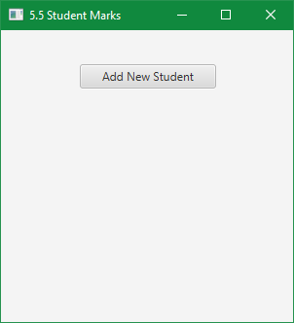

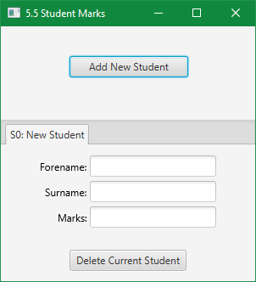

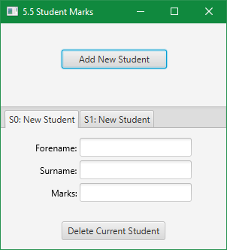

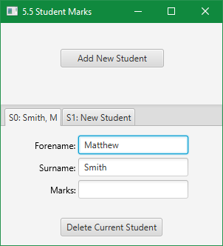

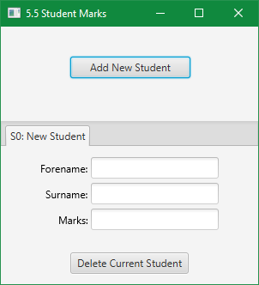

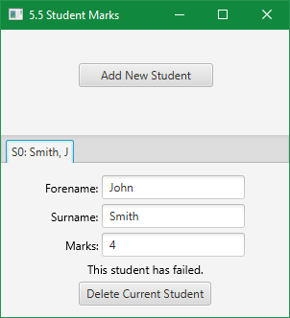

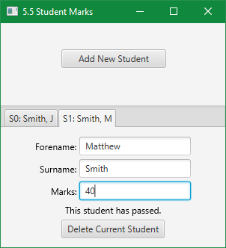

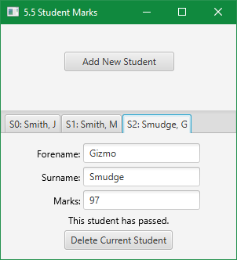

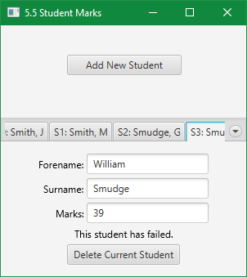

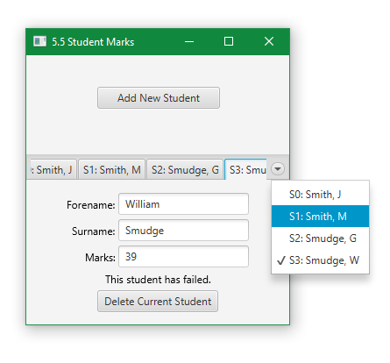

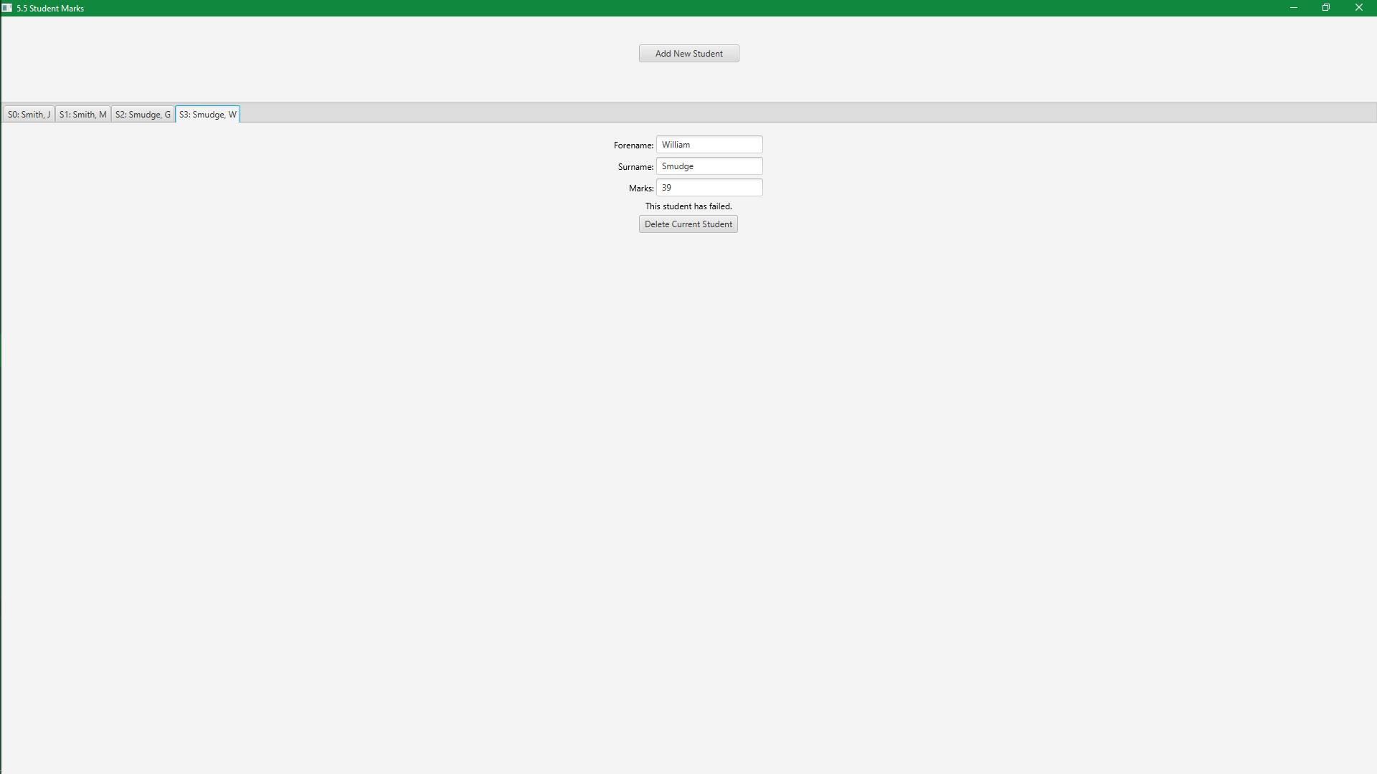

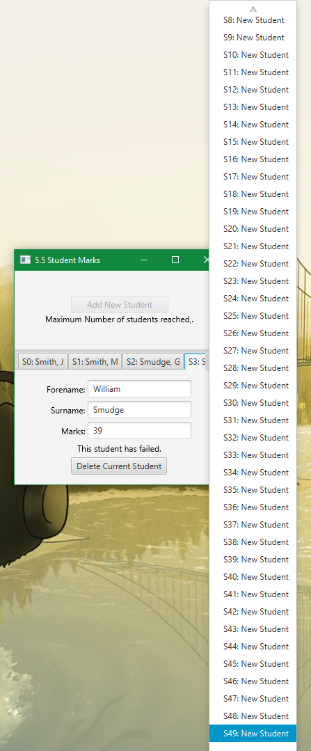

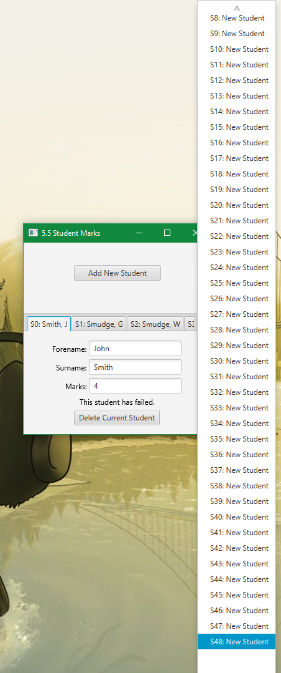

### Exercise 5.6. Multiplication table

* Input an integer between 1 and 100 and output the multiplication table for that integer

(i.e. 1  X integer = ?   
       2  X integer = ?

....

12 X integer = ?).

This exercise seems quite simple, and the complexity is just in how to display 12 different values. Rather than placing 12 text elements, I will dynamically generate the text elements and pass an instance of them to the controller class, to manipulate when text is entered.

Design

GUI Design

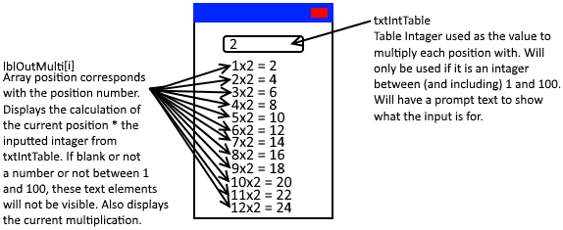

Pseudocode

on event txtIntTable’s Text Changed

Set intTable to the integer value of txtIntTable’s text

If intTable is an integer

If intTable > 0 or intTable < 101

Set i to 1

For i to lblOutMulti.length

Set the text of lblOutMulti[i] to (i + “x“ + intTable + “ = “ + (intTable * i))

Set lblOutMulti[i] to be visible

End For

Else

Set i to 1

For i to lblOutMulti.length

Set lblOutMulti[i] to be invisible

End For

End If

Else

Set i to 1

For i to lblOutMulti.length

Set lblOutMulti[i] to be invisible

End For

End If

End

Code

Main Class

package multiplicationTable;  
  
import javafx.application.Application;  
import javafx.fxml.FXMLLoader;  
import javafx.scene.Parent;  
import javafx.scene.Scene;  
import javafx.stage.Stage;  
  
public class Main extends Application {  
  
 @Override  
 public void start(Stage primaryStage) throws Exception{  
  
 //ints store height and widths of application stage and scene, so they are all changed by changing 1 variable.  
 int width = 215;  
 int height = 300;  
  
 //creates a new FXMLLoader, loads it in, stores the computed node as root.  
 Parent root = FXMLLoader.*load*(getClass().getResource("Main.fxml"));  
  
 //sets the stage title, creates a new scene with the root node of root, with specified widths and heights, show.  
 primaryStage.setTitle("5.6 Multiplication Tables");  
 primaryStage.setScene(new Scene(root, width, height));  
 primaryStage.show();  
  
  
  
  
   
 //Same code as in 5.2, but simplified. Should cover all bases in event both are needed by a specific OS.  
 //Sets resizable to false, which works in specific OS' like windows.  
 primaryStage.setResizable(false);  
  
 //Sets widths and heignts, and max/min widths and heights. For operating systems that do not support setResizable property.  
 primaryStage.setWidth(width);  
 primaryStage.setHeight(height);  
 primaryStage.setMaxWidth(width);  
 primaryStage.setMaxHeight(height);  
 primaryStage.setMinWidth(width);  
 primaryStage.setMinHeight(height);  
 }  
  
  
 public static void main(String[] args) {  
 *launch*(args);  
 }  
}

I wrote the code **inside** the start method (not the method definition). The rest was auto-generated by the IDE.

Controller Class

package multiplicationTable;  
  
import javafx.application.Application;  
import javafx.fxml.FXMLLoader;  
import javafx.scene.Parent;  
import javafx.scene.Scene;  
import javafx.stage.Stage;  
  
public class Main extends Application {  
  
 @Override  
 public void start(Stage primaryStage) throws Exception{  
  
 //ints store height and widths of application stage and scene, so they are all changed by changing 1 variable.  
 int width = 200;  
 int height = 300;  
  
 //creates a new FXMLLoader, loads it in, stores the computed node as root.  
 Parent root = FXMLLoader.*load*(getClass().getResource("Main.fxml"));  
  
 //Create a new scene with the root element gotten from the FXML loader, at specified dimensions.  
 Scene sceneMain = new Scene(root, width, height);  
  
 /*Get the Main.css file and add it to the list of stylesheets for this scene. I do not plan on writing any but  
 the option is there for an advanced used to add their own styles.*/  
 sceneMain.getStylesheets().add(getClass().getResource("css/Main.css").toExternalForm());  
  
 //sets the stage title, adds the main scene to stage, show the stage.  
 primaryStage.setTitle("5.6 Multiplication Tables");  
 primaryStage.setScene(sceneMain);  
 primaryStage.show();  
  
  
  
  
  
 //Same code as in 5.2, but simplified. Should cover all bases in event both are needed by a specific OS.  
 //Sets resizable to false, which works in specific OS' like windows.  
 primaryStage.setResizable(false);  
  
 //Sets widths and heignts, and max/min widths and heights. For operating systems that do not support setResizable property.  
 primaryStage.setWidth(width);  
 primaryStage.setHeight(height);  
 primaryStage.setMaxWidth(width);  
 primaryStage.setMaxHeight(height);  
 primaryStage.setMinWidth(width);  
 primaryStage.setMinHeight(height);  
 }  
  
  
 public static void main(String[] args) {  
 *launch*(args);  
 }  
}

This whole class was written by me. The IDE generated the class and package definition.

Main.FXML

<?xml version="1.0" encoding="UTF-8"?>  
  
<?import javafx.geometry.Insets?>  
<?import javafx.scene.control.TextField?>  
<?import javafx.scene.layout.Pane?>  
<?import javafx.scene.layout.VBox?>  
  
<Pane maxHeight="300.0" maxWidth="200.0" minHeight="300.0" minWidth="200.0" prefHeight="300.0" prefWidth="200.0" xmlns="http://javafx.com/javafx/9.0.1" xmlns:fx="http://javafx.com/fxml/1" fx:controller="multiplicationTable.Controller">  
 <children>  
 <VBox fx:id="vbRoot" alignment="TOP_CENTER" maxHeight="300.0" maxWidth="200.0" minWidth="200.0" prefHeight="300.0" prefWidth="200.0">  
 <children>  
 <TextField id="txtIntTable" fx:id="txtIntTable" alignment="CENTER" maxWidth="100.0" minWidth="100.0" onKeyReleased="#txtIntTableTextChanged" prefWidth="100.0" promptText="Multiply Value" styleClass="txt" VBox.vgrow="NEVER">  
 <VBox.margin>  
 <Insets bottom="10.0" top="10.0" />  
 </VBox.margin>  
 </TextField>  
 </children>  
 </VBox>  
 </children>  
</Pane>

I designed the whole FXML in Scene Builder, which generated the code for Main.FXML

While I have loaded and made a CSS file, I left them blank. See reason from last Exercise.

Output

(windows)

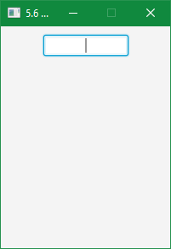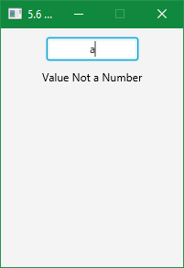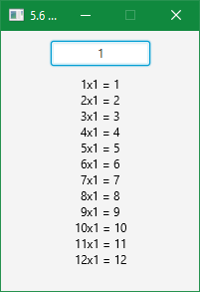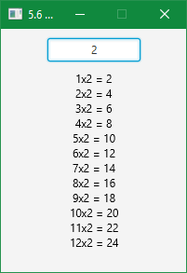

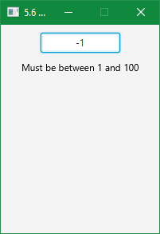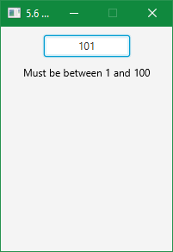

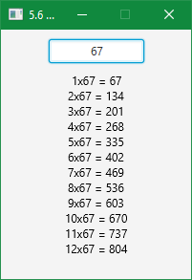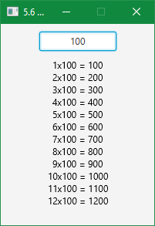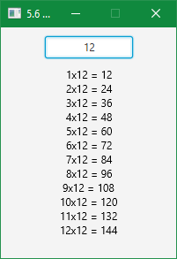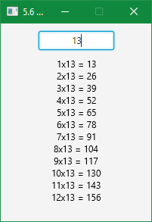

### Exercise 5.7. Even more coffee

* Modify your coffee survey program (which used a for loop) to use a while loop instead, as in the example. You may choose to open your original program and save it with a new name. Remember to modify the class name too though!
* A new requirement for the program is to output the number of people surveyed in the report. Use a new variable called personCount to do this, which you should update every time you run through the loop.

This exercise has already been completed in my version of 5.1 More coffee, as I implemented a person counter. Rather than using a loop, we use methods that are called by event handlers in external libraries. For my answer to this exercise, see 5.1.

### Exercise 5.8. Does not exist!

### Exercise 5.9. More student marks

* Design, write and test a program to input student marks in a test. Output 'Pass' if the mark is 40 or above, otherwise output 'Fail'. Input a mark of -1 to finish the program.
* Modify the design and the code of the above program to output the number of students who took the test, the number of passes, the number of fails, and the overall average mark.
* What happens in the above program if there are no students? Make sure your program can cope with zero or more students.

Design

All design will be copied from 5.5, as that is the basis of this exercise (as we are extending it). Anything that was modified after the designs in 5.5 will not be represented on these designs.

GUI Design

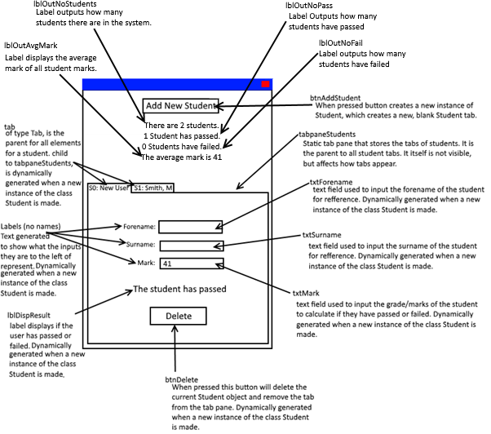

Class Diagram:

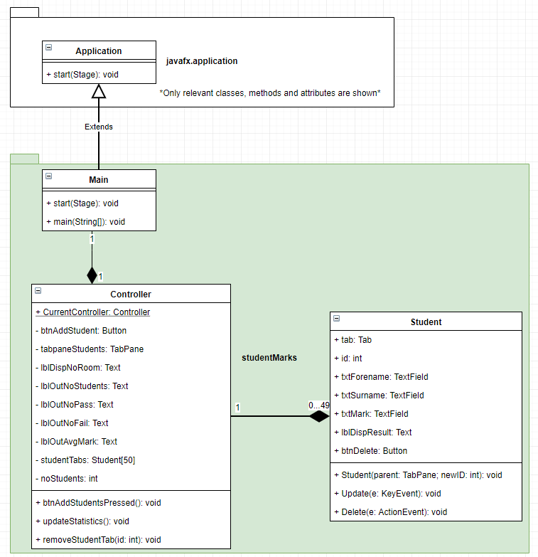

Pseudocode

* Class Student:
  + Method Student (initialisation):

Input parent and newID from method call.

Set this.tab as a new Tab

Add this.tab to parent

Set this.id to newID

Set the text of this.tab to “S” + newID + “: New Student”

Set tabRoot as a new HBox

Add tabRoot to this.tab

Set tabRootsChild as a new VBox

Add tabRootsChild to tabRoot

Set this.txtForename as a new TextField

Set this.txtSurname as a new TextField

Set this.txtMark as a new TextField

Set this.lblDispResults as a new Text

Set this.lblDispResult to be invisible.

Set this.btnDelete to be a Button with the text “Delete”

Set on event OnKeyReleased for txtForename to run the method this.Update

Set on event OnKeyReleased for txtSurname to run the method this.Update

Set on event OnKeyReleased for txtMark to run the method this.Update

Set on event ButtonPressed for btnDelete to run the method this.Delete

Set hboxForname as a new HBox

Add the Text “Forename: ” to hboxForename

Add this.txtForename to hboxForename

Add hboxForename to tabRootsChild

Set hboxSurname as a new HBox

Add the text “Surname: “ to hboxSurname

Add this.txtSurname to hboxSurname

Add hboxSurname to tabRootsChild

Set hboxMark as a new HBox

Add the Text “Marks: “ to hboxMark

Add this.txtMark to hboxMark

Add hboxMark to tabRootsChild

Add this.lblDispResult to tabRootsChild

Add this.btnDelete to tabRootsChild

* + Method Update:

If the text of txtForename is “” (blank)

Set the text of this.tab to “S” + this.id + “: New Student”

Else

Set the text of this.tab to “S” + this.id + txtSurname’s text + “, “ + the first character of txtForename

End If

Call Method Controller.updateStatistics()

* + Method Delete:

Remove this.tab from this.tab’s parent (the tab pane)

Call method Controller.removeStudentTab(this.id)

* Class Controller:
  + Method btnAddStudentPressed:

Set the element of studentTabs at position noStudents to a new instance of the Student class.

Increment noStudents by 1

Call method updateStatistics()

If noStudents == the array size of studentTabs

Disable btnAddStudent

End

* + Method removeStudentTab:

Input id from method call

If studentTabs at element position of id is not null

If id is 0 and noStudents is 1

Set studentTabs at element position 0 to null

Set noStudents to 0

Call method updateStatistics()

End Method

Else If id is between and including 0 and the array size of studentTabs -1 (49 if array size is 50)

Set studentTabs at element position of id to null

For i is the value of (id+1), while less than the array size of studentTabs

If studentTabs at the current element position of I is not null

Set studentTabs at element position i-1 to studentTabs at element position i

Decrement studentTabs.id at element position i-1

Call method studentTabs.Update(null) at element position i-1

Set studentTabs at element position i to null

Else

Decrement noStudents by 1

Call method updateStatistics()

End Method

End If

End For

Decrement noStudents by 1

Call method updateStatistics()

Else

Throw error, End Method

End

Else

Throw error, End Method

End

* + Method updateStatistics:

If noStudents == 0

Set the text of lblOutNoStudents to “There are no students.”

Make lblOutNoPass, lblOutNoFail and lblOutAvgMark invisible

Else

If noStudents == 1

Set the text of lblOutNoStudents to “There is 1 student.”

Else

Set the text of lblOutNoStudents to “There are “ + noStudents + “ students.”

End If

Define noPass, noFail and avgMark and set them as 0

For each student in the students array

Define curMarkText and set it to the value of the current student’s txtMark

Define curMark and set it to 0

Set curMark to the value of curMarkText converted to an integer

Increment avgMark by curMark

If curMark >= 40

Increment noPass by 1

Else

Increment noFail by 1

End If

If noPass == 0

Set the text of lblOutNoPass to “No students have passed.”

If noPass == 1

Set the text of lblOutNoPass to “1 student has passed.”

Else

Set the text of lblOutNoPass to noPass + “ students have passed.”

End If

If noFail == 0

Set the text of lblOutNoFail to “No students have failed.”

Else If noFail == 1

Set the text of lblOutNoFail to “1 student has failed.”

Else

Set the text of lblOutNoFail to noFail + “ students have passed.”

End If

Set avgMark to avgMark / noStudents

Set the text of lblOutAvgMark to “The average grade is “ + avgMark

If lblOutNoPass, lblOutNoFail and lblOutNoStudents are invisible

Make lblOutNoPass, lblOutNoFail and lblOutNoStudents visible

End If

End For

End If

Code

All base code was duplicated from 5.5. Modifications were made from the design of 5.5, and also from the design of this exercise.

Main Class

package moreStudentMarks;  
  
import javafx.application.Application;  
import javafx.fxml.FXMLLoader;  
import javafx.scene.Parent;  
import javafx.scene.Scene;  
import javafx.stage.Stage;  
  
public class Main extends Application {  
  
 @Override  
 public void start(Stage primaryStage) throws Exception  
 {  
 //Create an FXMLLoader to load Main.fxml, and load it.  
 FXMLLoader loader = new FXMLLoader(getClass().getResource("Main.fxml"));  
 Parent root = loader.load();  
 primaryStage.setTitle("5.5 Student Marks");  
 Scene sceneMain = new Scene(root, 300, 350);  
  
 /*While I am not adding my own CSS, the option to modify the CSS exists for the end user, though is going to  
 require a knowledge of javafx CSS.*/  
 sceneMain.getStylesheets().add(getClass().getResource("css/Main.css").toExternalForm());  
  
 //Add the scene to the stage, and show it.  
 primaryStage.setScene(sceneMain);  
 primaryStage.show();  
  
 /*Store the reference of the FXMLLoader's controller (the controller which the FXMLLoader is using defined by  
 the FXML) statically in the Controller. Only exists so Student class instances can call an instance of Controller  
 to call the method removeStudentTab*/  
 Controller.*CurrentController* = loader.getController();  
  
 }  
  
  
 public static void main(String[] args)  
 {  
 *launch*(args);  
 }  
}

I wrote the code **inside** the start method (not the method definition). The rest was auto-generated by the IDE.

Student Class

package moreStudentMarks;  
  
import javafx.event.ActionEvent;  
import javafx.scene.control.*;  
import javafx.scene.input.KeyEvent;  
import javafx.scene.layout.HBox;  
import javafx.scene.layout.VBox;  
import javafx.scene.text.Text;  
import static javafx.geometry.Pos.*CENTER*;  
import static javafx.geometry.Pos.*CENTER_RIGHT*;  
  
public class Student  
{  
 //Student's tab attributes  
 public Tab tab;  
 public int id;  
 public TextField txtForename;  
 public TextField txtSurname;  
 public TextField txtMark;  
 public Text lblDispResult;  
 public Button btnDelete;  
  
 //method invoked on creating new instance of Student. Generates a tab with controls and event handling.  
 public Student(TabPane parent, int newID)  
 {  
 /*create a tab, store it as the student's tab attribute, set the ID from the ID provided in the creation and set  
 a title for new students.*/  
 this.tab = new Tab();  
 this.id = newID;  
 this.tab.setText("S" + newID + ": New Student");  
  
 /*create elements that will become nested in the tab, and nested in this nested element. Second and Third are  
 arbitrary names as their only point is to structure the scene objects. We need to reference them to append  
 children. Center objects to everything appears in the middle of the tab.*/  
 HBox hbSecond = new HBox();  
 VBox vbThird = new VBox();  
 hbSecond.setAlignment(*CENTER*);  
 vbThird.setAlignment(*CENTER*);  
  
 //create javafx scene objects and assign them to this classes attributes. Set up attributes for the scene objects.  
 this.txtForename = new TextField();  
 this.txtSurname = new TextField();  
 this.txtMark = new TextField();  
 this.lblDispResult = new Text();  
 this.lblDispResult.setVisible(false);  
 this.btnDelete = new Button("Delete Current Student");  
  
 /*Events handled by existing method. Compiler deals with how we get to the method. Method must implement the event  
 type.*/  
 this.txtForename.setOnKeyReleased(this::Update);  
 this.txtSurname.setOnKeyReleased(this::Update);  
 this.txtMark.setOnKeyReleased(this::Update);  
 this.btnDelete.setOnAction(this::Delete);  
  
 /*encapsulate the text entries within a hbox, and have a text label before them. alignment so text fields match  
 in alignment.*/  
 HBox hbForename = new HBox();  
 hbForename.getChildren().add(new Text("Forename: "));  
 hbForename.getChildren().add(this.txtForename);  
 hbForename.setAlignment(*CENTER_RIGHT*);  
  
 HBox hbSurname = new HBox();  
 hbSurname.getChildren().add(new Text("Surname: "));  
 hbSurname.getChildren().add(this.txtSurname);  
 hbSurname.setAlignment(*CENTER_RIGHT*);  
  
 HBox hbMark = new HBox();  
 hbMark.getChildren().add(new Text("Marks: "));  
 hbMark.getChildren().add(this.txtMark);  
 hbMark.setAlignment(*CENTER_RIGHT*);  
  
  
 /*add the scene objects (and scene objects through their encapsulating hboxes) to their root. Create and add  
 spacing so there is space between scene objects.*/  
 vbThird.setSpacing(5);  
 vbThird.getChildren().add(hbForename);  
 vbThird.getChildren().add(hbSurname);  
 vbThird.getChildren().add(hbMark);  
 vbThird.getChildren().add(this.lblDispResult);  
 vbThird.getChildren().add(this.btnDelete);  
  
 //Add the child to tabRoot (that contains all control objects) to tabRoot  
 hbSecond.getChildren().add(vbThird);  
  
 //add the tab root to the current tab. Add the current tab to the parent, the tabpane.  
 this.tab.setContent(hbSecond);  
 parent.getTabs().add(this.tab);  
 }  
  
 public void Update(KeyEvent e)  
 {  
 if (this.txtForename.getText().equals(""))  
 {  
 //set the text of the tab (what is displayed) to show the student id and "New Student" if no forename exists.  
 this.tab.setText("S" + this.id + ": New Student");  
 }  
 else  
 {  
 //set the text of the tab (what is displayed) to show the student id and name. if a forename exists.  
 //e.g. S0: Smith, M  
 this.tab.setText("S" + id + ": " + this.txtSurname.getText() + ", " + this.txtForename.getText().charAt(0));  
 }  
  
  
 //catch exceptions thrown  
 try  
 {  
 //convert the text of the TextField to an int, throws NumberFormatException if not a valid int.  
 int mark = Integer.*parseInt*(this.txtMark.getText());  
  
 //basic validation for marks.  
 if (mark > -1 && mark < 101)  
 {  
 //check if the student is above or below grade threshold. pass if above, fail if below.  
 if (mark < 40)  
 {  
 this.lblDispResult.setText("This student has failed.");  
 }  
 else if (mark >= 40)  
 {  
 this.lblDispResult.setText("This student has passed.");  
 }  
  
 //make sure that the result is always visible if no NumberFormatException was thrown.  
 this.lblDispResult.setVisible(true);  
 }  
 else  
 {  
 this.lblDispResult.setText("Mark must be between 0 and 100");  
 this.lblDispResult.setVisible(true);  
 }  
 }  
 catch (NumberFormatException x)  
 {  
 /*exception thrown when trying to parse a number data type and the input string is NaN (Not a Number).  
 Hide lblDispResult on NumberFormatException thrown. They have still technically failed but is not shown  
 on the student information.*/  
 this.lblDispResult.setVisible(false);  
 }  
  
 //Update student statistics.  
 Controller.*CurrentController*.updateStatistics();  
 }  
  
  
 public void Delete(ActionEvent e)  
 {  
 //Remove the tab from the tabpane  
 this.tab.getTabPane().getTabs().remove(this.tab);  
  
 /*Call Controller.removeStudentTab to remove the current student from the array studentTabs (and kill this  
 instance). Have to get a statically defined variable from Controller that stores the instance of Controller used  
 by the FXMLLoader, as that is the instance of the class that stores the studentTabs array and instance of this  
 class*/  
 Controller.*CurrentController*.removeStudentTab(this.id);  
 }  
}

This class was all my work, and only imports and package definition were auto-generated. This file was modified to add basic validation for mark (which should have been in the original) and to call the method to update the new statistics.

Controller Class

package moreStudentMarks;  
  
import javafx.fxml.FXML;  
import javafx.scene.control.Button;  
import javafx.scene.control.TabPane;  
import javafx.scene.text.Text;  
  
public class Controller  
{  
 /* static variable stores the instance of this class that is being used by FXML. Set when loading the FXML in Main  
 class, used by Student class to invoke the method removeStudentTab*/  
 public static Controller *CurrentController* = null;  
  
 //Instances of FXML elements, that we are going to manipulate in some way.  
 @FXML private Button btnAddStudent;  
 @FXML private TabPane tabpaneStudents; //Tabs stored in here, we can add new students which generates a tab added into the pane.  
 @FXML private Text lblDispNoRoom; //Only shown when noStudents == studentTabs.length  
 @FXML private Text lblOutNoStudents;  
 @FXML private Text lblOutNoPass;  
 @FXML private Text lblOutNoFail;  
 @FXML private Text lblOutAvgMark;  
  
 //Array stores instances of class Student. Array size can be changed and all code will work normally.  
 private Student[] studentTabs = new Student[50];  
  
 //Stores number of students. If adding, the value is used as next student id. e.g. 0 students, the next id is 0.  
 private int noStudents = 0;  
  
 //Method called when btnAddStudent is pressed, event managed by class FXMLLoader  
 public void btnAddStudentPressed()  
 {  
 //Add a new instance of the Student class to the next free array position. Requires the tabpane and new ID.  
 studentTabs[noStudents] = new Student(tabpaneStudents, noStudents);  
  
 //increment number of students as new student has been added.  
 noStudents++;  
  
 //update user statistics. Pushes average down, increases noFails.  
 updateStatistics();  
  
 //if we have hit the tab limit, disable input button so can't create more students, show message why.  
 if (noStudents == studentTabs.length)  
 {  
 lblDispNoRoom.setVisible(true);  
 btnAddStudent.setDisable(true);  
 }  
 }  
  
 //Method called to update the application statistics and counts displayed to the user.  
 public void updateStatistics()  
 {  
 if (noStudents < 1)  
 {  
 //if no students state that there are none, hide the statistics labels as they can't show anything.  
 lblOutNoStudents.setText("There are no students.");  
  
 lblOutNoPass.setVisible(false);  
 lblOutNoFail.setVisible(false);  
 lblOutAvgMark.setVisible(false);  
 }  
 else  
 {  
 //Format the text of lblOutNoStudents for the context of singular or multiple.  
 if (noStudents == 1)  
 {  
 lblOutNoStudents.setText("There is 1 student.");  
 }  
 else  
 {  
 lblOutNoStudents.setText("There are " + noStudents + " students.");  
 }  
  
 //set temporary variables for storing the statistics per Student element.  
 int noPass = 0;  
 int noFail = 0;  
 int avgMark = 0;  
 int noValidMarks = 0;//Used to calculate average based only on valid marks. (not on NumberFormatException)  
  
 //for each student element  
 for (int i = 0; i < noStudents; i++)  
 {  
 //Get the string value of txtMark to evaluate. Set a variable to store the int version.  
 String curMarkText = studentTabs[i].txtMark.getText();  
 int curMark;  
  
 try  
 {  
 //convert the text to an intager.  
 curMark = Integer.*parseInt*(curMarkText);  
 }  
 catch (NumberFormatException e)  
 {  
 //if the text could not be converted default to -1 (invalid).  
 curMark = -1;  
 }  
  
 //if valid  
 if (curMark > -1 && curMark < 101 )  
 {  
 //increment the average by the current mark, increment number of valid marks.  
 avgMark += curMark;  
 noValidMarks++;  
  
 //determine if they passed or fail to display.  
 if (curMark >= 40)  
 {  
 noPass++;  
 }  
 else if (curMark < 40 && curMark != -1)  
 {  
 noFail++;  
 }  
 }  
 }  
  
 //Display how many passed, formatting it grammatically.  
 if (noPass == 0)  
 {  
 lblOutNoPass.setText("No students have passed.");  
 }  
 else if (noPass == 1)  
 {  
 lblOutNoPass.setText("1 student has passed.");  
 }  
 else  
 {  
 lblOutNoPass.setText(noPass + " students have passed.");  
 }  
  
 //Display how many failed, formatting it grammatically.  
 if (noFail == 0)  
 {  
 lblOutNoFail.setText("No students have failed.");  
 }  
 else if (noFail == 1)  
 {  
 lblOutNoFail.setText("1 student has failed.");  
 }  
 else  
 {  
 lblOutNoFail.setText(noFail + " students have failed.");  
 }  
  
 /*calculate the average from the total and number of students that had valid marks if there are valid marks.  
 Otherwise there are no valid marks, avgMark will not have been incremented so should be 0, do not divide  
 (otherwise you would divide 0 by 0).*/  
 if (noValidMarks > 0)  
 {  
 avgMark = avgMark/noValidMarks;  
 }  
  
 //Display the average  
 lblOutAvgMark.setText("The average mark is " + avgMark + ".");  
  
 //if the statistics out labels were not visible before, make them visible (basing off of a single label).  
 if (!lblOutAvgMark.isVisible())  
 {  
 lblOutNoPass.setVisible(true);  
 lblOutNoFail.setVisible(true);  
 lblOutAvgMark.setVisible(true);  
 }  
 }  
 }  
  
 //method invoked when the delete button for a student has been pressed. Called from the student  
 public void removeStudentTab(int id)  
 {  
 //check the student we are trying to remove exists.  
 if (studentTabs[id] != null)  
 {  
 /*if id is 0 and is the only element, we can't shift the next element down, so manually delete the student  
 and set noStudents to 0 (no students exist). id 0 should be the only one that exists at 1 student according  
 to this method*/  
 if (id == 0 && noStudents == 1)  
 {  
 studentTabs[0] = null;  
 noStudents = 0;  
 updateStatistics();  
 return;  
 }  
 else if (id > -1 && id < studentTabs.length) //if we are between the valid ranges (and noStudents is > 1)  
 {  
 //delete the current student.  
 studentTabs[id] = null;  
  
 //start at the next ID, work down.  
 for (int i = id+1; i < studentTabs.length; i++)  
 {  
 //if we have not hit the end of array  
 if (studentTabs[i] != null)  
 {  
 /*shift the current element down by 1, decrease its id to the new id based on array position,  
 call update method to fix the name.*/  
 studentTabs[i-1] = studentTabs[i];  
 studentTabs[i-1].id--;  
 studentTabs[i-1].Update(null);//null provided as we are not updating from an ActionEvent.  
  
 /*set the current element to null as we have finished with it. If the end of elements in array  
 it allows for detecting end on other deletions.*/  
 studentTabs[i] = null;  
 }  
 else  
 {  
 //if the next element is null then assume we have hit the current end of array, break the loop.  
 break;  
 }  
 }  
 /*once we have gone through every element decrement number of students as we have been able to remove  
 the element at specific ID. enable button and hide text as array is not full. Updates statistics to  
 show less students and might lower the average.*/  
  
 lblDispNoRoom.setVisible(false);  
 btnAddStudent.setDisable(false);  
  
 noStudents--;  
  
 updateStatistics();  
 }  
 else  
 {  
 //id is not in valid range. Throw an exception.  
 throw new IllegalArgumentException("Value of 'ID' was invalid. Value was " + id + ", it should have been between 0 and " + (studentTabs.length-1) + ".");  
 }  
 }  
 else  
 {  
 //Could not remove id because it did not exist, throw an exception.  
 throw new IllegalArgumentException("Value of 'ID' was invalid. Element at position " + id + " did not exist (was null), so cannot be deleted.");  
 }  
 }  
}

Only the class definition, imports and package definition were auto-generated. The rest is my own work. This class was modified to add the statistics text nodes, the method to update the statistics on particular events, the updateStatistics method call in key places, and I simplified part of the deletion code where I could have broken the main loop and I was returning instead needlessly.

Scene Builder Generated FXML

<?xml version="1.0" encoding="UTF-8"?>  
  
<?import javafx.geometry.Insets?>  
<?import javafx.scene.control.Button?>  
<?import javafx.scene.control.TabPane?>  
<?import javafx.scene.layout.HBox?>  
<?import javafx.scene.layout.VBox?>  
<?import javafx.scene.text.Text?>  
  
<VBox maxHeight="-Infinity" maxWidth="-Infinity" minHeight="-Infinity" minWidth="-Infinity" prefHeight="400.0" prefWidth="600.0" xmlns="http://javafx.com/javafx/8.0.121" xmlns:fx="http://javafx.com/fxml/1" fx:controller="moreStudentMarks.Controller">  
 <children>  
 <HBox alignment="CENTER" prefHeight="119.0" prefWidth="600.0">  
 <children>  
 <VBox alignment="CENTER" prefHeight="47.0" prefWidth="100.0">  
 <children>  
 <Button id="btnAddStudent" fx:id="btnAddStudent" alignment="CENTER" mnemonicParsing="false" onAction="#btnAddStudentPressed" prefHeight="25.0" prefWidth="140.0" text="Add New Student">  
 <VBox.margin>  
 <Insets top="10.0" />  
 </VBox.margin></Button>  
 <Text fx:id="lblDispNoRoom" strokeType="OUTSIDE" strokeWidth="0.0" text="Maximum Number of students reached,." visible="false">  
 <VBox.margin>  
 <Insets bottom="10.0" />  
 </VBox.margin></Text>  
 <Text fx:id="lblOutNoStudents" strokeType="OUTSIDE" strokeWidth="0.0" text="There are no students." visible="true" />  
 <Text fx:id="lblOutNoPass" strokeType="OUTSIDE" strokeWidth="0.0" text="Text" visible="false" />  
 <Text fx:id="lblOutNoFail" strokeType="OUTSIDE" strokeWidth="0.0" text="Text" visible="false" />  
 <Text fx:id="lblOutAvgMark" strokeType="OUTSIDE" strokeWidth="0.0" text="Text" visible="false">  
 <VBox.margin>  
 <Insets bottom="20.0" />  
 </VBox.margin>  
 </Text>  
 </children>  
 </VBox>  
 </children>  
 </HBox>  
 <TabPane id="tabpaneStudents" fx:id="tabpaneStudents" prefHeight="200.0" prefWidth="200.0" tabClosingPolicy="UNAVAILABLE" />  
 </children>  
</VBox>

This was all designed by me in Gluon Scene Builder, which from the GUI design I made in its interfaces, generated FXML. It was modified to add the text nodes, and add some margins to prettify slightly.

Main.css is blank for a user to apply a custom style. It would take too long to colour and structure every application.

Output

(windows)

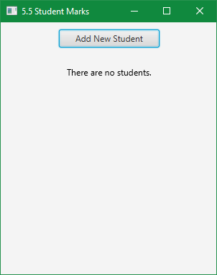

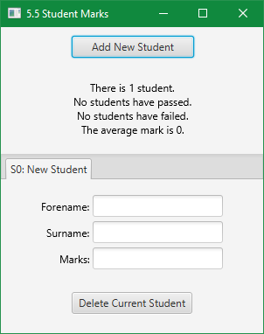

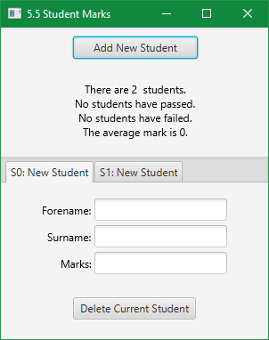

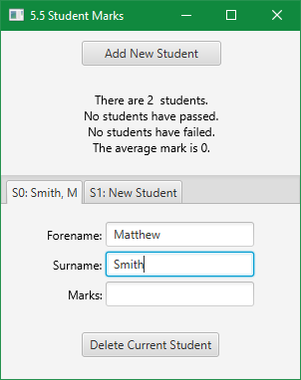

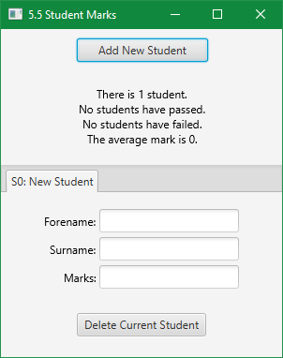

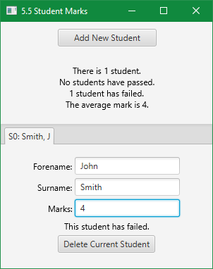

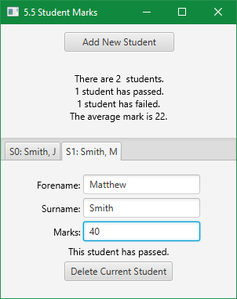



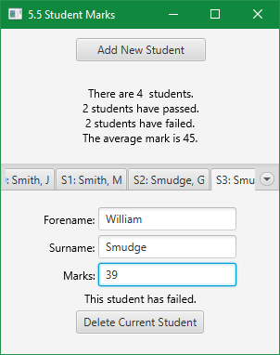

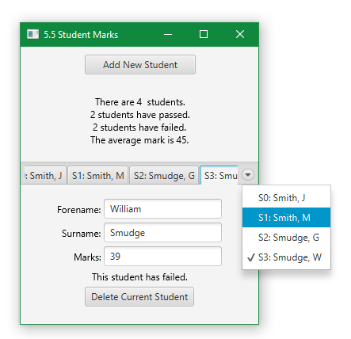

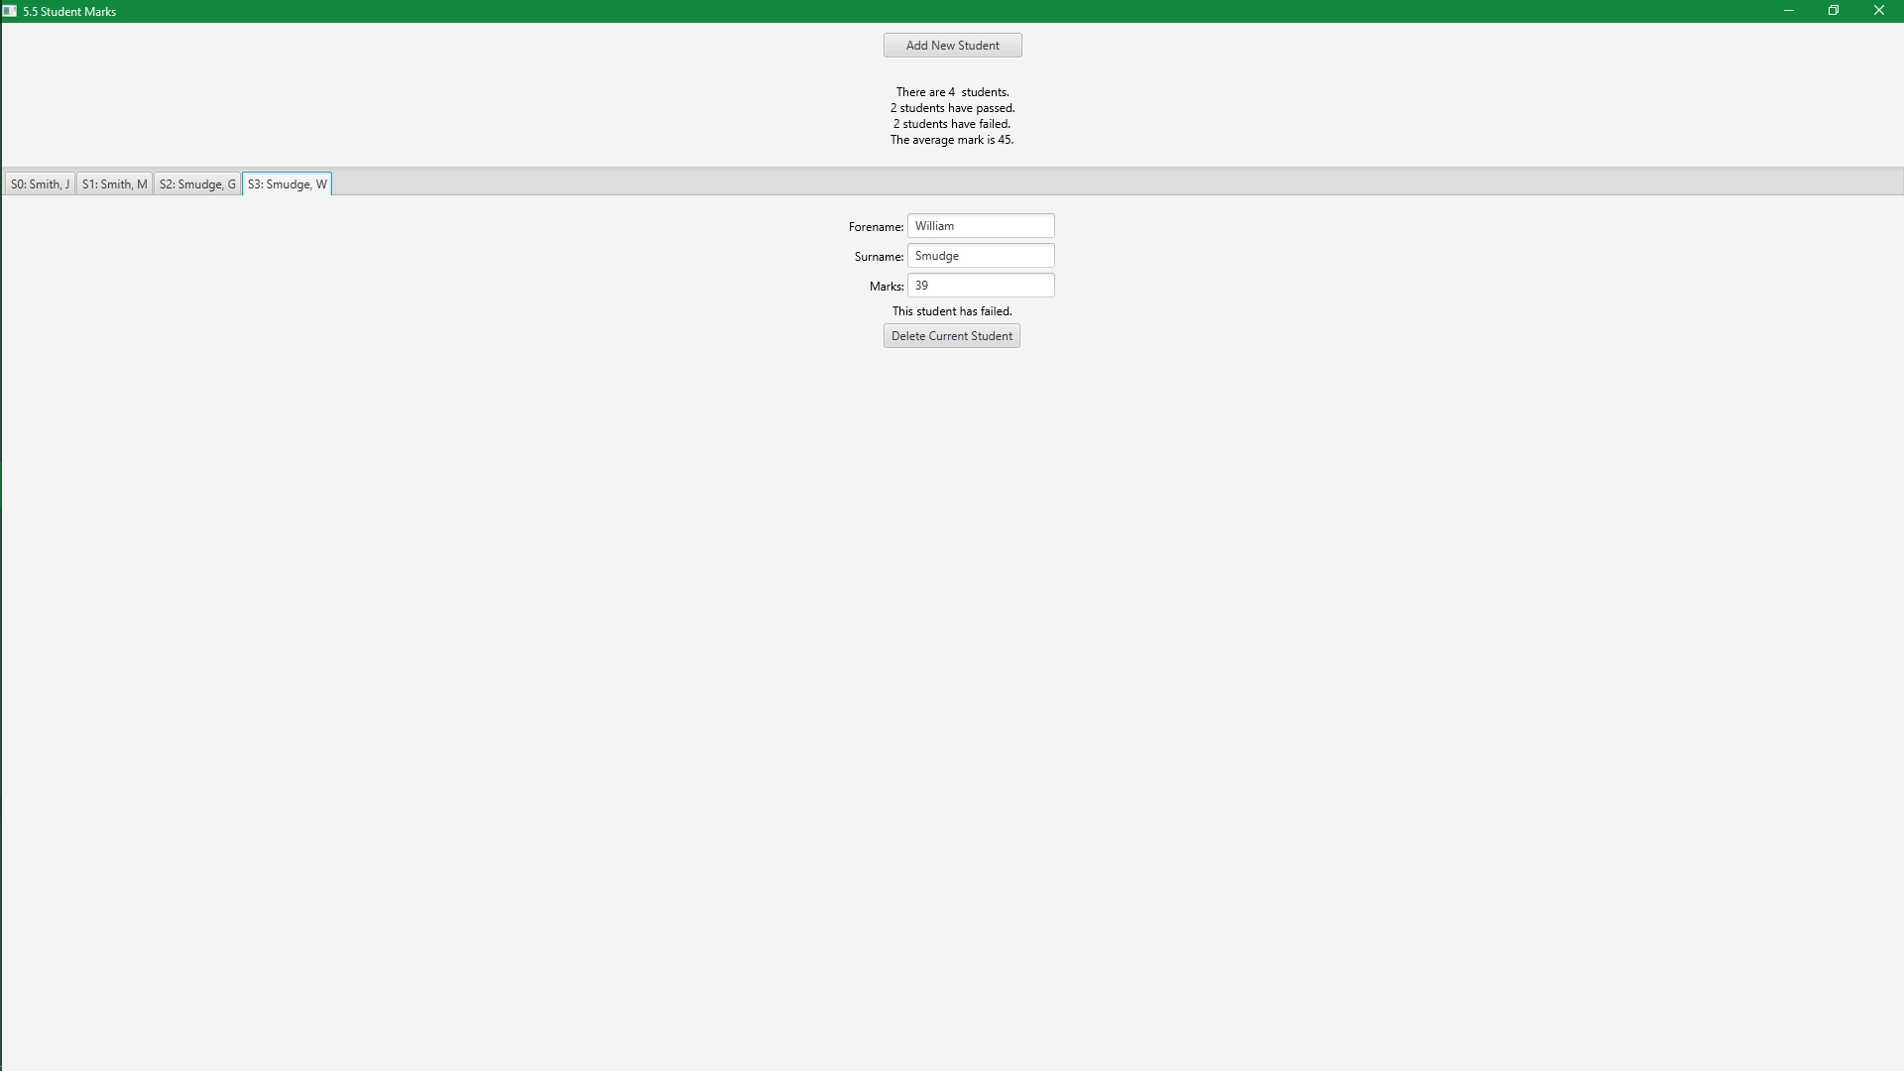

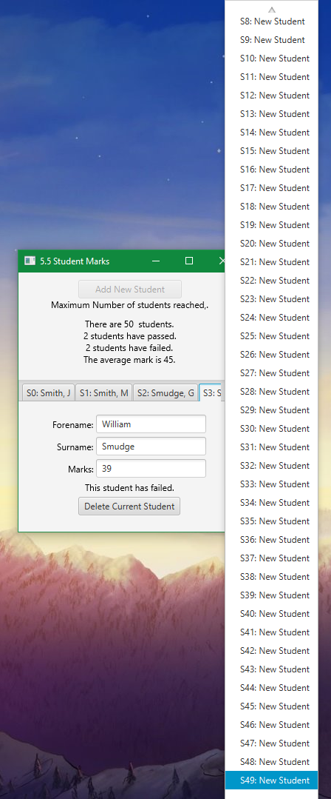

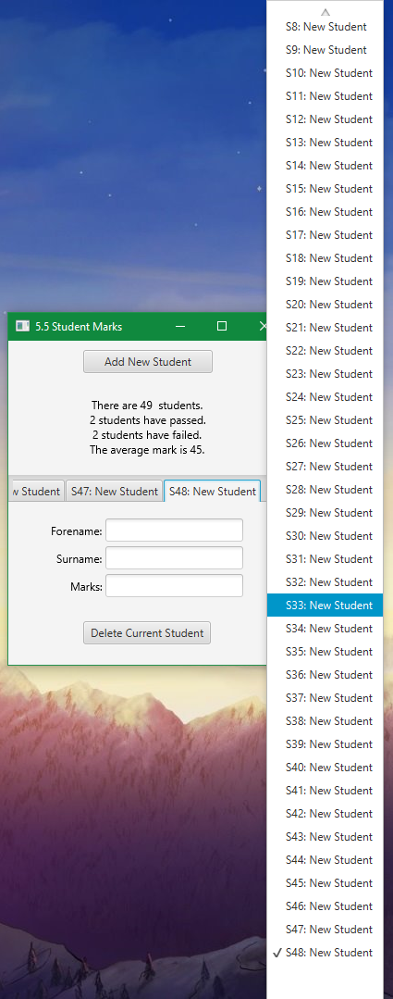

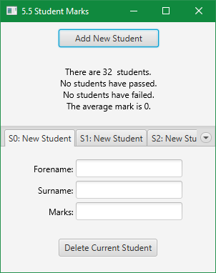

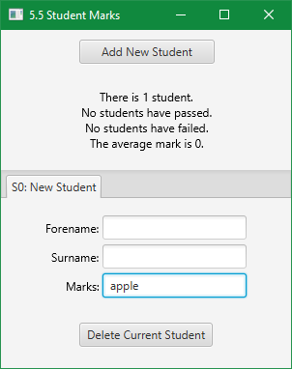

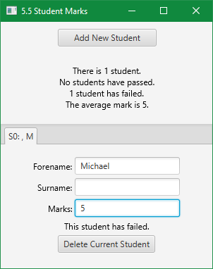

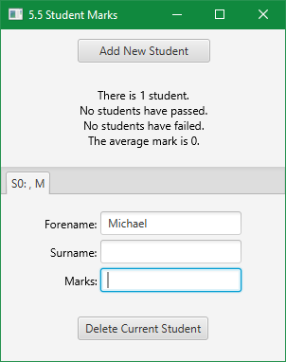

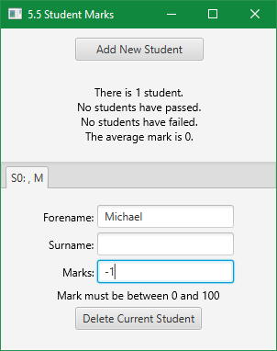

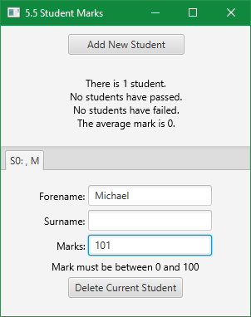

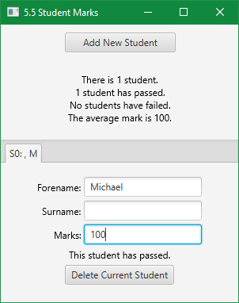

### Exercise 5.10. Payroll

* Design, write and test a program to process a payroll. You should input the employee name, their hourly rate, and the number of hours each employee has worked. Output the gross pay and the net pay (with a tax rate of 30%). When there are no more employees, input the word "End", instead of the employee name.

I am going to design a similar application to that in 5.5 where I used tabs to store each student, and a class to store the student data (including the tab). I will start with a copy of that application as a basis, and modify the student class to an employee class, and change up the nodes and processes. Most of the controller class should stay roughly the same.

Design

GUI Design

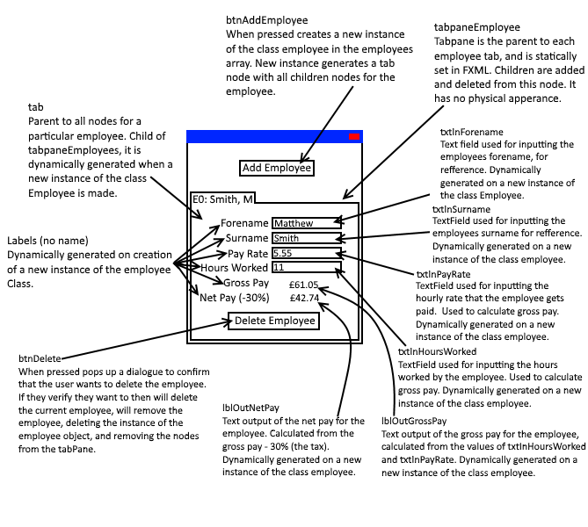

Class Diagram

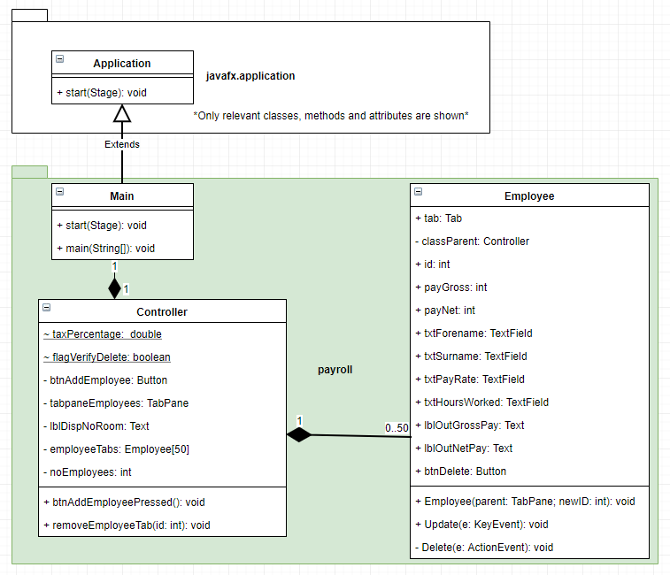

Code

Main Class

package payroll;  
  
import javafx.application.Application;  
import javafx.fxml.FXMLLoader;  
import javafx.scene.Parent;  
import javafx.scene.Scene;  
import javafx.scene.image.Image;  
import javafx.stage.Stage;  
  
public class Main extends Application {  
  
 @Override  
 public void start(Stage primaryStage) throws Exception  
 {  
 //Create an FXMLLoader to load Main.fxml, and load it.  
 FXMLLoader loader = new FXMLLoader(getClass().getResource("Main.fxml"));  
 Parent root = loader.load();  
 primaryStage.setTitle("5.10 Payroll");  
 Scene sceneMain = new Scene(root, 300, 350);  
  
 //Add the scene to the stage, and show it.  
 primaryStage.setScene(sceneMain);  
  
 /*Set the stage logo. Icon from silk icons, http://www.famfamfam.com/lab/icons/silk/. Uses a Creative Commons  
 Attribution 2.5 License.*/  
 primaryStage.getIcons().add(new Image(getClass().getResourceAsStream("img/icon.png")));  
  
 //min height essential for making sure the user can't hide the delete button at lower window sizes.  
 primaryStage.setMinHeight(340);  
 primaryStage.setMinWidth(300);  
  
 primaryStage.show();  
  
  
  
  
 }  
  
  
 public static void main(String[] args)  
 {  
 *launch*(args);  
 }  
}

Controller Class

package payroll;  
  
import javafx.fxml.FXML;  
import javafx.scene.control.Button;  
import javafx.scene.control.TabPane;  
import javafx.scene.text.Text;  
  
public class Controller  
{  
 //static variables store important application variables.  
 static int *taxPercentage* = 30; //percentage of tax for calculation of net pay.  
 static boolean *flagVerifyDelete* = true; //flag for enabling and disabling the deletion verification dialogue.  
  
 //Instances of FXML elements, that we are going to manipulate in some way.  
 @FXML private Button btnAddEmployee;  
 @FXML private TabPane tabpaneEmployees; //Tabs stored in here, we can add new employees which generates a tab added into the pane.  
 @FXML private Text lblDispNoRoom; //Only shown when noEmployees == employeeTabs.length  
  
 //Array stores instances of class Employee. Array size can be changed and all code will work normally.  
 private Employee[] employeeTabs = new Employee[50];  
  
 //Stores number of employees. If adding, the value is used as next employee id. e.g. 0 employees, the next id is 0.  
 private int noEmployees = 0;  
  
 //Method called when btnAddEmployee is pressed, event managed by class FXMLLoader  
 public void btnAddEmployeePressed()  
 {  
 /*Add a new instance of the Employee class to the next free array position. Requires the current instance of this  
 class (the parent to the class instance we are making), tabpane and new ID.*/  
 employeeTabs[noEmployees] = new Employee(this, tabpaneEmployees, noEmployees);  
  
 //increment number of employees as new employee has been added.  
 noEmployees++;  
  
 //if we have hit the tab limit, disable input button so can't create more employees, show message why.  
 if (noEmployees == employeeTabs.length)  
 {  
 lblDispNoRoom.setVisible(true);  
 btnAddEmployee.setDisable(true);  
 }  
 }  
  
 //method invoked when the delete button for a employee has been pressed. Called from the employee  
 public void removeEmployeeTab(int id)  
 {  
 //check the employee we are trying to remove exists.  
 if (employeeTabs[id] != null)  
 {  
 /*if id is 0 and is the only element, we can't shift the next element down, so manually delete the employee  
 and set noEmployees to 0 (no employees exist). id 0 should be the only one that exists at 1 employee according  
 to this method*/  
 if (id == 0 && noEmployees == 1)  
 {  
 employeeTabs[0] = null;  
 noEmployees = 0;  
 return;  
 }  
 else if (id > -1 && id < employeeTabs.length) //if we are between the valid ranges (and noEmployees is > 1)  
 {  
 //delete the current employee.  
 employeeTabs[id] = null;  
  
 //start at the next ID, work down.  
 for (int i = id+1; i < employeeTabs.length; i++)  
 {  
 //if we have not hit the end of array  
 if (employeeTabs[i] != null)  
 {  
 /*shift the current element down by 1, decrease its id to the new id based on array position,  
 call update method to fix the name.*/  
 employeeTabs[i-1] = employeeTabs[i];  
 employeeTabs[i-1].id--;  
 employeeTabs[i-1].Update(null);//null provided as we are not updating from an ActionEvent.  
  
 /*set the current element to null as we have finished with it. If the end of elements in array  
 it allows for detecting end on other deletions.*/  
 employeeTabs[i] = null;  
 }  
 else  
 {  
 /*if the next element is null then assume we have hit the current end of array, decrement number  
 of employees and return as we have removed specific ID from array. Ends loop early. Enable button  
 and remove end of array text as array is not full*/  
  
 lblDispNoRoom.setVisible(false);  
 btnAddEmployee.setDisable(false);  
  
 noEmployees--;  
 return;  
 }  
 }  
 /*once we have gone through every element decrement number of employees as we have been able to remove  
 the element at specific ID. enable button and hide text as array is not full.*/  
  
 lblDispNoRoom.setVisible(false);  
 btnAddEmployee.setDisable(false);  
  
 noEmployees--;  
 }  
 else  
 {  
 //id is not in valid range. Throw an exception.  
 throw new IllegalArgumentException("Value of 'ID' was invalid. Value was " + id + ", it should have been between 0 and " + (employeeTabs.length-1) + ".");  
 }  
 }  
 else  
 {  
 //Could not remove id because it did not exist, throw an exception.  
 throw new IllegalArgumentException("Value of 'ID' was invalid. Element at position " + id + " did not exist (was null), so cannot be deleted.");  
 }  
 }  
}

Employee Class

package payroll;  
  
import javafx.event.ActionEvent;  
import javafx.scene.control.*;  
import javafx.scene.input.KeyEvent;  
import javafx.scene.layout.HBox;  
import javafx.scene.layout.VBox;  
import javafx.scene.text.Text;  
import javafx.scene.text.TextAlignment;  
import javafx.stage.StageStyle;  
  
import java.math.RoundingMode;  
import java.text.DecimalFormat;  
import java.util.Optional;  
  
import static javafx.geometry.Pos.*CENTER*;  
import static javafx.geometry.Pos.*CENTER_RIGHT*;  
  
public class Employee  
{  
 //Employee's tab attributes  
 public Tab tab;  
 private Controller classParent;  
 public int id;  
 public double payGross;  
 public double payNet;  
 public TextField txtForename;  
 public TextField txtSurname;  
 public TextField txtPayRate;  
 public TextField txtHoursWorked;  
 public Text lblOutGrossPay;  
 public Text lblOutNetPay;  
 public Button btnDelete;  
  
 //method invoked on creating new instance of Employee. Generates a tab with controls and event handling.  
 public Employee(Controller classParent, TabPane tabParent, int newID)  
 {  
 this.classParent = classParent;  
  
 /*create a tab, store it as the employee's tab attribute, set the ID from the ID provided in the creation and set  
 a title for new employees.*/  
 this.tab = new Tab();  
 this.id = newID;  
 this.tab.setText("E" + newID + ": New Employee");  
  
 /*create elements that will become nested in the tab, and nested in this nested element. Second and Third are  
 arbitrary names as their only point is to structure the scene objects. We need to reference them to append  
 children. Center objects to everything appears in the middle of the tab.*/  
 HBox hbSecond = new HBox();  
 VBox vbThird = new VBox();  
 hbSecond.setAlignment(*CENTER*);  
 vbThird.setAlignment(*CENTER*);  
  
 //create javafx scene objects and assign them to this classes attributes. Set up attributes for the scene objects.  
 this.txtForename = new TextField();  
 this.txtSurname = new TextField();  
 this.txtPayRate = new TextField();  
 this.txtHoursWorked = new TextField();  
 this.lblOutGrossPay = new Text();  
 this.lblOutGrossPay.setVisible(false);  
 this.lblOutNetPay = new Text();  
 this.lblOutNetPay.setVisible(false);  
 this.btnDelete = new Button("Delete Current Employee");  
  
 /*Events handled by existing method. Compiler deals with how we get to the method. Method must implement the event  
 type.*/  
 this.txtForename.setOnKeyReleased(this::Update);  
 this.txtSurname.setOnKeyReleased(this::Update);  
 this.txtPayRate.setOnKeyReleased(this::Update);  
 this.txtHoursWorked.setOnKeyReleased(this::Update);  
 this.btnDelete.setOnAction(this::Delete);  
  
 /*encapsulate the text entries within a hbox, and have a text label before them. alignment so text fields match  
 in alignment.*/  
 HBox hbForename = new HBox();  
 hbForename.getChildren().add(new Text("Forename: "));  
 hbForename.getChildren().add(this.txtForename);  
 hbForename.setAlignment(*CENTER_RIGHT*);  
  
 HBox hbSurname = new HBox();  
 hbSurname.getChildren().add(new Text("Surname: "));  
 hbSurname.getChildren().add(this.txtSurname);  
 hbSurname.setAlignment(*CENTER_RIGHT*);  
  
 HBox hbRate = new HBox();  
 hbRate.getChildren().add(new Text("Hourly Rate: £"));  
 hbRate.getChildren().add(this.txtPayRate);  
 hbRate.setAlignment(*CENTER_RIGHT*);  
  
 HBox hbHours = new HBox();  
 hbHours.getChildren().add(new Text("Hours Worked: "));  
 hbHours.getChildren().add(this.txtHoursWorked);  
 hbHours.setAlignment(*CENTER_RIGHT*);  
  
 VBox vbLblOut = new VBox();  
 vbLblOut.getChildren().add(this.lblOutGrossPay);  
 vbLblOut.getChildren().add(this.lblOutNetPay);  
 vbLblOut.setAlignment(*CENTER*);  
 this.lblOutGrossPay.setTextAlignment(TextAlignment.*CENTER*);  
  
  
 /*add the scene objects (and scene objects through their encapsulating hboxes) to their root. Create and add  
 spacing so there is space between scene objects.*/  
 vbThird.setSpacing(5);  
 vbThird.getChildren().add(hbForename);  
 vbThird.getChildren().add(hbSurname);  
 vbThird.getChildren().add(hbRate);  
 vbThird.getChildren().add(hbHours);  
 vbThird.getChildren().add(vbLblOut);  
 vbThird.getChildren().add(this.btnDelete);  
  
 //Add the child to tabRoot (that contains all control objects) to tabRoot  
 hbSecond.getChildren().add(vbThird);  
  
 //add the tab root to the current tab. Add the current tab to the parent, the tabpane.  
 this.tab.setContent(hbSecond);  
 tabParent.getTabs().add(this.tab);  
 }  
  
 public void Update(KeyEvent e)  
 {  
 if (this.txtForename.getText().equals(""))  
 {  
 //set the text of the tab (what is displayed) to show the employee id and "New Employee" if no forename exists.  
 this.tab.setText("E" + this.id + ": New Employee");  
 }  
 else  
 {  
 //set the text of the tab (what is displayed) to show the employee id and name. if a forename exists.  
 //e.g. E0: Smith, M  
 this.tab.setText("E" + id + ": " + this.txtSurname.getText() + ", " + this.txtForename.getText().charAt(0));  
 }  
  
 //if either txtPayRate or txtHoursWorked have no value.  
 if (txtPayRate.getText().equals("") || txtHoursWorked.getText().equals(""))  
 {  
 //hide the output  
 lblOutGrossPay.setVisible(false);  
 this.lblOutNetPay.setVisible(false);  
 }  
 else  
 {  
 //if both txtPayRate and txtHoursWorked have a value, show the output. Try and calculate gross and net pay.  
 lblOutGrossPay.setVisible(true);  
  
  
 //set temporary working variables to track double values and flags for varied output messages.  
 double payRate = 0;  
 double hoursWorked = 0;  
  
 //flags determine if a value is invalid, used to display specific outputs. in relation to what the current issue is.  
 boolean flagPayInvalid = false;  
 boolean flagHoursInvalid = false;  
  
  
  
 //Input txtPayRate  
  
 //catch exceptions thrown  
 try  
 {  
 //convert the text of the TextField to an int, throws NumberFormatException if not a valid int.  
 payRate = Double.*parseDouble*(this.txtPayRate.getText());  
  
 } catch (NumberFormatException x)  
 {  
  
 //exception thrown when trying to parse a number data type and the input string is NaN (Not a Number).  
 flagPayInvalid = true;  
  
 }  
  
  
  
 //Input txtHoursWorked  
  
 //catch exceptions thrown.  
 try  
 {  
 hoursWorked = Double.*parseDouble*(this.txtHoursWorked.getText());  
 } catch (NumberFormatException x)  
 {  
 //exception thrown when trying to parse a number data type and the input string is NaN (Not a Number).  
 flagHoursInvalid = true;  
 }  
  
  
  
 //Test to format a reason for a failed calculation.  
 if (flagHoursInvalid && flagPayInvalid) //Both hours and pay invalid  
 {  
 this.lblOutGrossPay.setText("The pay rate and hours worked must be\npositive decimal numbers.");  
 this.lblOutNetPay.setVisible(false);  
 }  
 else if (flagPayInvalid) //Pay invalid  
 {  
 this.lblOutGrossPay.setText("The pay rate must be a positive decimal\nnumber.");  
 this.lblOutNetPay.setVisible(false);  
 }  
 else if (flagHoursInvalid) //Hours invalid  
 {  
 this.lblOutGrossPay.setText("The hours worked must be a positive decimal\nnumber.");  
 this.lblOutNetPay.setVisible(false);  
 }  
 else //Both valid  
 {  
 /*re-uses temporary flags, assigns them to the result of expressions that determine if they are valid  
 (within ranges). E.g. if payRate > 0 and < 5001, then the flag will be false. Only if both flags were  
 false before (valid) will we hit the else, so will both start out as false.*/  
 flagPayInvalid = !(payRate > 0 && payRate < 5001);  
 flagHoursInvalid = !(hoursWorked > 0 && hoursWorked <= 168);  
  
 //check validity flag  
 if (!flagPayInvalid && !flagHoursInvalid) //Both valid.  
 {  
 //both values are v alid so we can use them to calculate gross and net pay.  
  
 //Calculate gross pay from valid pay rate and hours.  
 this.payGross = payRate * hoursWorked;  
  
 //Set the net pay to gross pay minus the tax rate percentage (30% in the question).  
 this.payNet = this.payGross - ((this.payGross / 100) * Controller.*taxPercentage*);  
  
 //set the display outputs  
 this.lblOutNetPay.setVisible(true);  
  
 //Creates a DecimalFormat to format the decimals when outputted.  
 DecimalFormat df = new DecimalFormat("#####0.00");  
  
 /*Rounding Mode manipulates how DecimalFormat rounds. I noticed that this did not work but according  
 to the documentation for the library it should, so I have left it in.*/  
 df.setRoundingMode(RoundingMode.*HALF_UP*);  
  
 this.lblOutGrossPay.setText("Gross Pay: £" + df.format(this.payGross));  
 this.lblOutNetPay.setText("Net Pay: £" + df.format(this.payNet));  
 }  
 else if (flagPayInvalid && flagHoursInvalid)//if both were invalid.  
 {  
 this.lblOutGrossPay.setText("The pay rate must be between 1 and 5000,\n and hours worked between 1 and 168.");  
 this.lblOutNetPay.setVisible(false);  
 }  
 else if (flagPayInvalid) //if pay was invalid.  
 {  
 this.lblOutGrossPay.setText("The pay rate must be between 1 and 5000.");  
 this.lblOutNetPay.setVisible(false);  
 }  
 else if (flagHoursInvalid) //if hours was invalid.  
 {  
 this.lblOutGrossPay.setText("The hours worked must be between 1 and 168.");  
 this.lblOutNetPay.setVisible(false);  
 }  
 }  
 }  
 }  
  
 private void Delete(ActionEvent e)  
 {  
 //if we want to verify that the user wants to delete the current employee  
 if (Controller.*flagVerifyDelete*)  
 {  
 /*crate a new alert of type warning, with a title and content text, which informs the user the implications  
 of clicking yes. StageStyle.utility means it has no icon.*/  
 Alert verifyDeletion = new Alert(Alert.AlertType.*WARNING*);  
 verifyDeletion.setTitle("Verify Action");  
 verifyDeletion.setHeaderText(null);  
 verifyDeletion.setContentText("Are you sure you want to delete the current user? This action cannot be undone.");  
 verifyDeletion.initStyle(StageStyle.*UTILITY*);  
  
 //button for yes, allows us to detect if the user clicks yes.  
 ButtonType verifyDeletionBtnYes = new ButtonType("Yes");  
  
 /*adds button types to the dialogue. Adds the yes button, and creates a no and cancel button (which we don't  
 need to store in memory because they will not be used for testing what was pressed).*/  
 verifyDeletion.getButtonTypes().setAll(verifyDeletionBtnYes, new ButtonType("No"), new ButtonType("Cancel", ButtonBar.ButtonData.*CANCEL_CLOSE*));  
  
 /*Create an object called result of type optional, meaning that it can have no value. show and wait for a  
 result of the dialogue. The result is used to determine what the user clicked on the dialogue.*/  
 Optional<ButtonType> result = verifyDeletion.showAndWait();  
  
 /*If the user clicked anything other than yes, return, skipping the deletion part in this method. If the user  
 did click yes then it will skip the return, completing the scope of the current if, and then completing the  
 deletion portion of this method.*/  
 if (result.get() != verifyDeletionBtnYes)  
 {  
 return;  
 }  
 }  
  
 //Remove the tab from the tabpane  
 this.tab.getTabPane().getTabs().remove(this.tab);  
  
 //call the method to remove the reference to the instance of this class from the parent class (controller).  
 this.classParent.removeEmployeeTab(this.id);  
 }  
}

Main FXML

<?xml version="1.0" encoding="UTF-8"?>  
  
<?import javafx.scene.control.Button?>  
<?import javafx.scene.control.TabPane?>  
<?import javafx.scene.layout.HBox?>  
<?import javafx.scene.layout.VBox?>  
<?import javafx.scene.text.Text?>  
  
<VBox maxHeight="-Infinity" maxWidth="-Infinity" minHeight="-Infinity" minWidth="-Infinity" prefHeight="400.0" prefWidth="600.0" xmlns="http://javafx.com/javafx/8.0.121" xmlns:fx="http://javafx.com/fxml/1" fx:controller="payroll.Controller">  
 <children>  
 <HBox alignment="CENTER" prefHeight="119.0" prefWidth="600.0">  
 <children>  
 <VBox alignment="CENTER" prefHeight="47.0" prefWidth="100.0">  
 <children>  
 <Button id="btnAddEmployee" fx:id="btnAddEmployee" alignment="CENTER" mnemonicParsing="false" onAction="#btnAddEmployeePressed" prefHeight="25.0" prefWidth="140.0" text="Add New Employee" />  
 <Text fx:id="lblDispNoRoom" strokeType="OUTSIDE" strokeWidth="0.0" text="Maximum Number of students reached,." visible="false" />  
 </children>  
 </VBox>  
 </children>  
 </HBox>  
 <TabPane id="tabpaneEmployees" fx:id="tabpaneEmployees" prefHeight="250.0" prefWidth="200.0" tabClosingPolicy="UNAVAILABLE" />  
 </children>  
</VBox>

Output

(windows)

Employee Management:

Adding

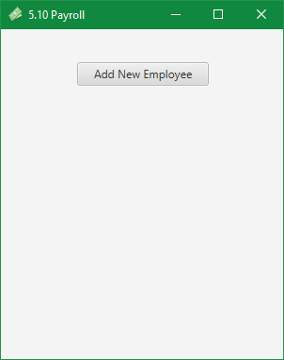

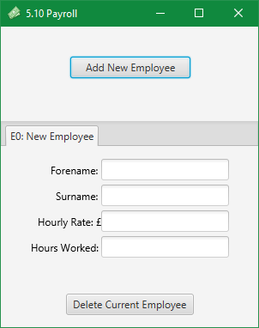

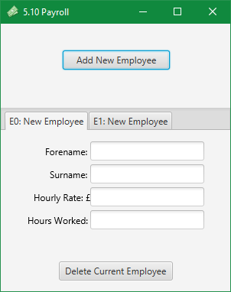

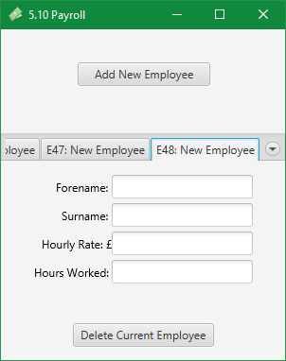

Editing

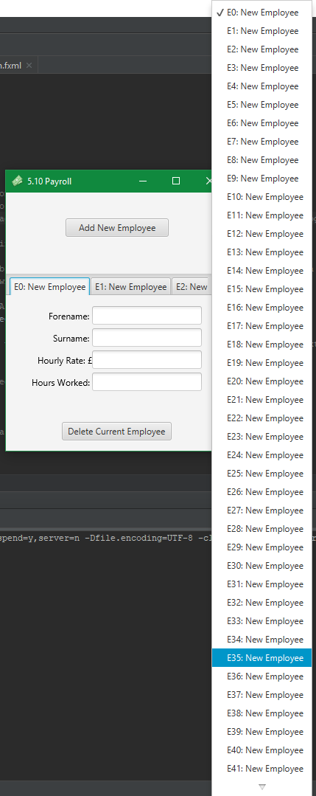

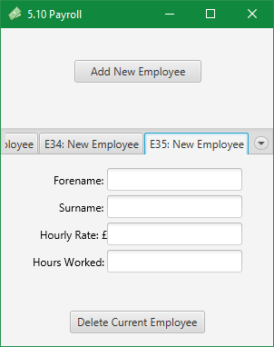

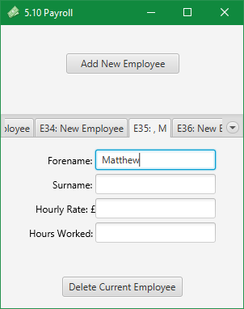

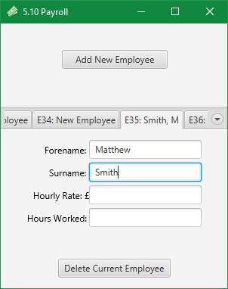

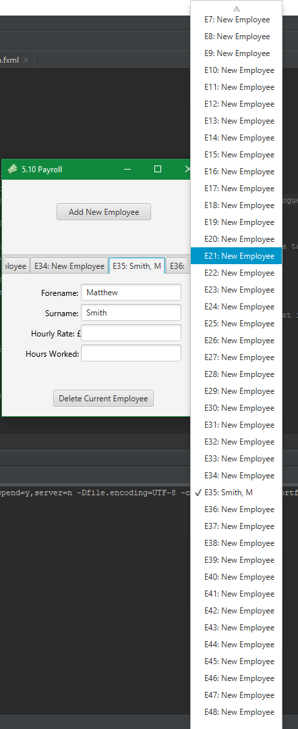

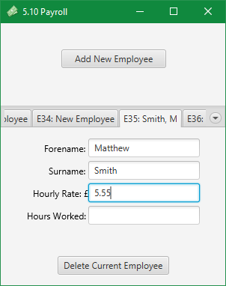

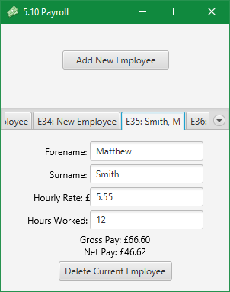

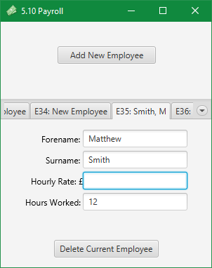

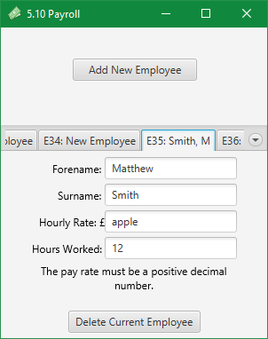

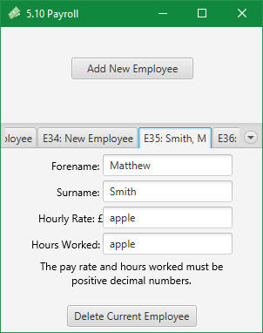

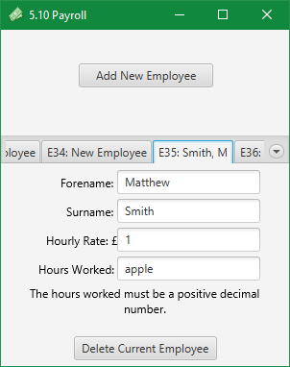

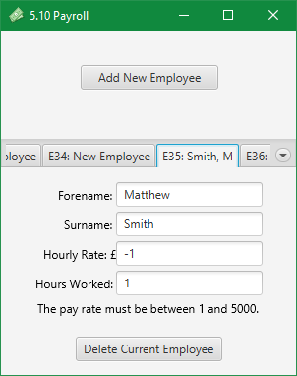

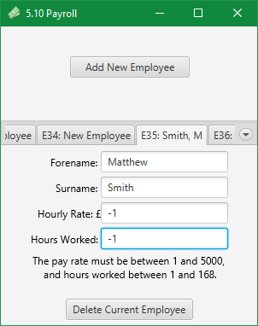

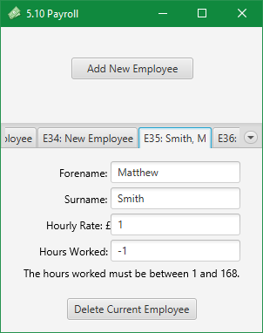

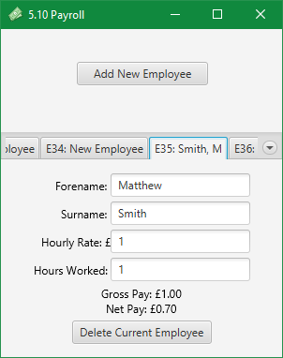

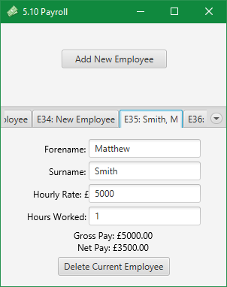

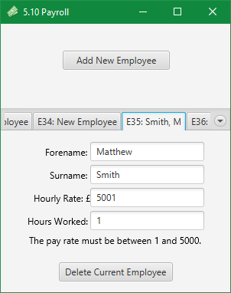

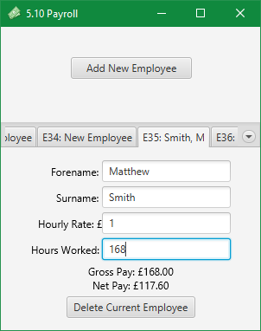

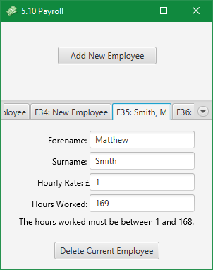

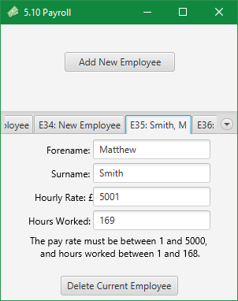

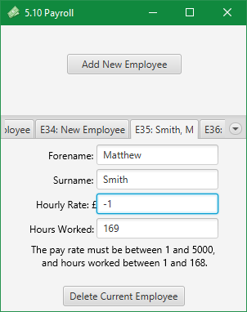

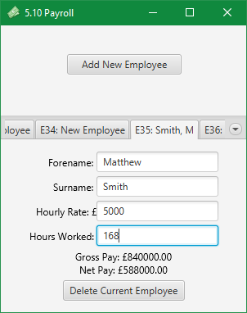

Removing

With flagVerifyDelete set to true:



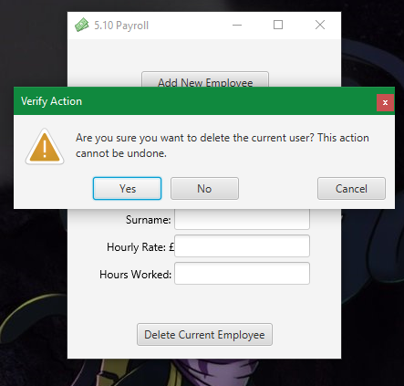

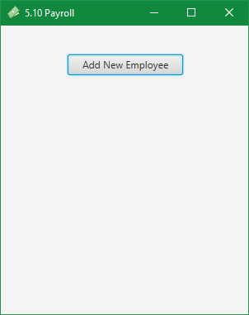

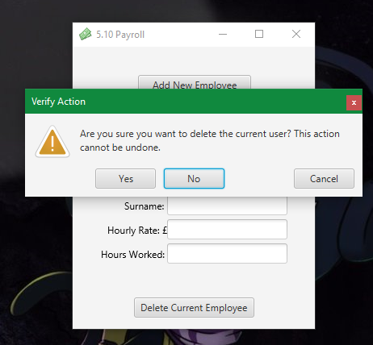

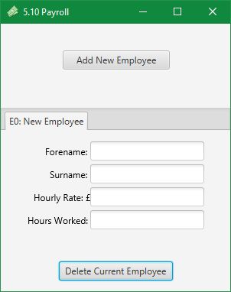

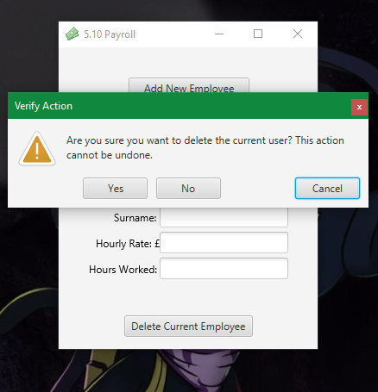



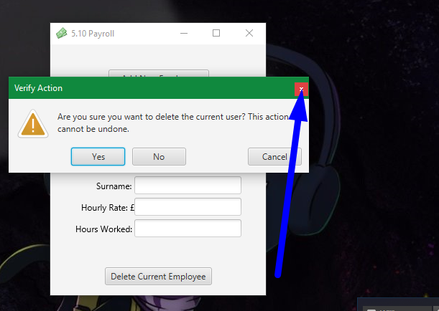



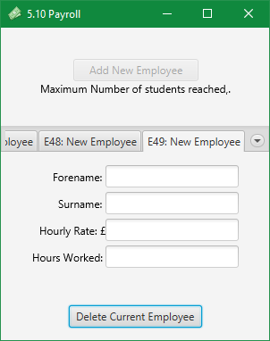

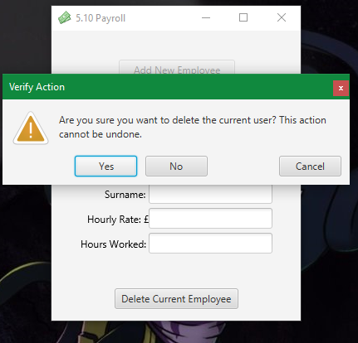

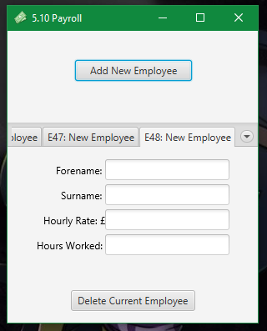

With flagVerifyDelete set to false:





Calculations

|  |  |  |  |  |  |  |  |
| --- | --- | --- | --- | --- | --- | --- | --- |
| **Test No,** | **txtPayRate** | **txtHoursWorked** | **Predicted Gross Pay** | **Predicted Net Pay** | **lblOutGrossPay** | **lblOutNetPay** | **As Predicted?** |
| 0 |  |  |  |  |  |  | Yes |
| 1 | 1 |  |  |  |  |  | Yes |
| 2 |  | 1 |  |  |  |  | Yes |
| 3 | 1 | 1 | 1 | 0.7 | 1 | 0.70 | Yes |
| 4 | 5 | 1 | 5 | 3.5 | 5 | 3.50 | Yes |
| 5 | 5.5 | 1 | 5.5 | 3.85 | 5.50 | 3.85 | Yes |
| 6 | 5.55 | 1 | 5.55 | 3.885 (3.89) | 5.55 | 3.88 | No |
| 7 | 5.55 | 10 | 55.5 | 38.85 | 55.50 | 38.85 | Yes |
| 8 | 5.55 | 12 | 66.6 | 46.62 | 66.60 | 46.62 | Yes |
| 9 | 11 | 12 | 132 | 92.4 | 132.00 | 92.40 | Yes |
| 10 | 11.83 | 12 | 141.96 | 99.372  (99.37) | 141.96 | 99.37 | Yes |
| 11 | 11.83 | 12.77 | 151.0691  (151.07) | 105.74837  (105.75) | 151.07 | 105.75 | Yes |
| 12 | 5.55 | 168 | 932.4 | 652.68 | 932.40 | 652.68 | Yes |
| 13 | 5000 | 168 | 840,000 | 588,999 | 840000.00 | 588000.00 | Yes |

Test No. 6 failed, which I did predict while programming. I wanted to program the output to be formatted as a currency, so I used a [DecimalFormat](https://docs.oracle.com/javase/7/docs/api/java/text/DecimalFormat.html). While reading the [documentation for DecimalFormat](https://docs.oracle.com/javase/7/docs/api/java/text/DecimalFormat.html), I learned that it supported rounding, and could round using the [RoundingMode](https://docs.oracle.com/javase/7/docs/api/java/math/RoundingMode.html) class. [RoundingMode.HALF_UP](https://docs.oracle.com/javase/7/docs/api/java/math/RoundingMode.html#HALF_UP)is the rounding mode we are taught in school and we tend to use, so I used RoundingMode.HALF_UP for the rounding mode. This has not worked as described in the [RoundingMode documentation](https://docs.oracle.com/javase/7/docs/api/java/math/RoundingMode.html). I tested to see if the [RoundingMode.UP](https://docs.oracle.com/javase/7/docs/api/java/math/RoundingMode.html#UP) rounding mode worked and it did round up. Therefore, this seems to be a bug in a JRE library, and out of my control.



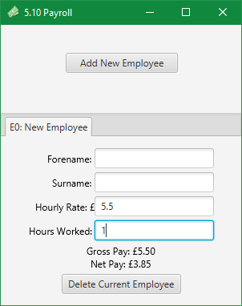

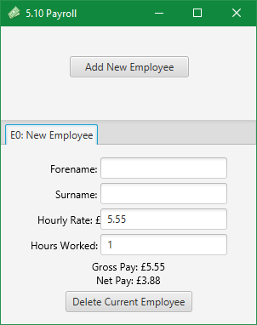

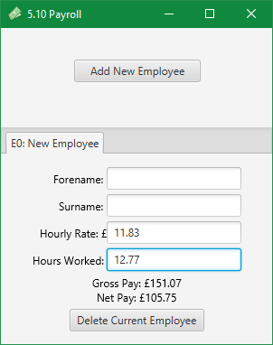

### Exercise 5.11. Higher or lower?

* A simple two player game involves player 1 typing in a number, and player 2 guessing the number. Each time player 2 guesses the wrong answer, the computer must reply "Try higher" or "Try lower", to give the player a clue for the next try. When the correct number is guessed, the number of guesses taken will be output, and the program will end. Design and write a program to play the guessing game.

This game has two potential ways of working. One could be using two separate windows or player switching on a single window to separate the clients. Another alternative could be to code a socket client which joins players into a game and handles the guesses between the clients using a node.js socket server online (written in javascript). I like the second idea a lot but as it is not important to the application I will keep the idea stored away, and later on if I feel like it I could program this solution.

For this exercise I am going to go the first route and program an application with two windows that interact. The will be using separate FXML files and separate controllers to manage their separate roles in the game. They will be able to interact with each other.

Design

GUI Design

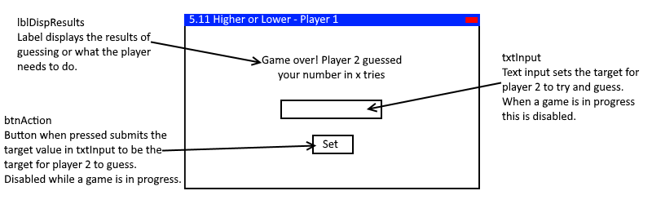

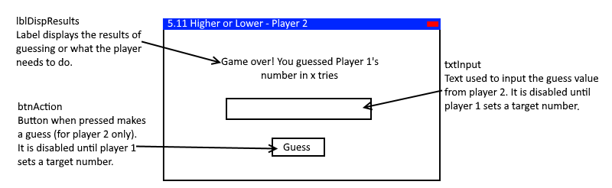

Class Diagram

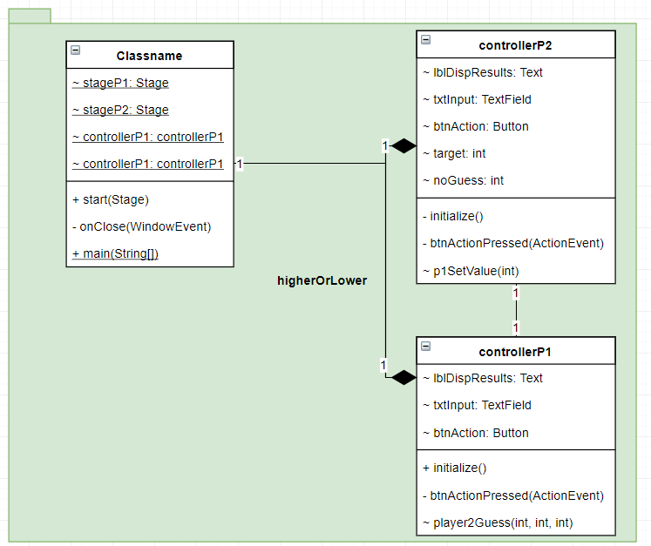

Code

Main class

package higherOrLower;  
  
import javafx.application.Application;  
import javafx.application.Platform;  
import javafx.fxml.FXMLLoader;  
import javafx.scene.Parent;  
import javafx.scene.Scene;  
import javafx.stage.Stage;  
import javafx.stage.WindowEvent;  
  
public class Main extends Application {  
  
 static Stage *stageP1*;  
 static Stage *stageP2*;  
 static controllerP1 *controllerP1*;  
 static controllerP2 *controllerP2*;  
  
 @Override  
 public void start(Stage primaryStage) throws Exception{  
  
 //store instances of stages within the class, including a new stage.  
 this.*stageP1* = primaryStage;  
 this.*stageP2* = new Stage();  
  
 //create an FXMLLoader to load the FXML files  
 FXMLLoader fxmlLoaderP1 = new FXMLLoader(getClass().getResource("player.fxml"));  
 FXMLLoader fxmlLoaderP2 = new FXMLLoader(getClass().getResource("player.fxml"));  
  
 //create a new instance of the controllers  
 this.*controllerP1* = new higherOrLower.controllerP1();  
 this.*controllerP2* = new higherOrLower.controllerP2();  
  
 //assign the instance of the controllers to the fxmlLoaders loading the FXML.  
 fxmlLoaderP1.setController(this.*controllerP1*);  
 fxmlLoaderP2.setController(this.*controllerP2*);  
  
 //load the fxml scenes from the loader and store them in a temporary variable.  
 Parent rootNodeP1 = fxmlLoaderP1.load();  
 Parent rootNodeP2 = fxmlLoaderP2.load();  
  
 //set the titles of the scenes  
 this.*stageP1*.setTitle("5.11 Higher or Lower - Player 1");  
 this.*stageP2*.setTitle("5.11 Higher or Lower - Player 2");  
  
 //set the root nodes to be the scenes for the stages.  
 this.*stageP1*.setScene(new Scene(rootNodeP1, 400, 275));  
 this.*stageP2*.setScene(new Scene(rootNodeP2, 400, 275));  
  
 //show the stages  
 this.*stageP1*.show();  
 this.*stageP2*.show();  
  
 //set onclose event handlers to exit the application when either windows is closed  
 *stageP1*.setOnCloseRequest(this::onClose);  
 *stageP2*.setOnCloseRequest(this::onClose);  
 }  
  
 private void onClose(WindowEvent ev)  
 {  
 //close the application, if one window is closed then assume the clients want to close both.  
 Platform.*exit*();  
 }  
  
  
 public static void main(String[] args) {  
 *launch*(args);  
 }  
}

controllerP1 Class

package higherOrLower;  
  
import javafx.event.ActionEvent;  
import javafx.fxml.FXML;  
import javafx.scene.control.Button;  
import javafx.scene.control.TextField;  
import javafx.scene.text.Text;  
  
public class controllerP1  
{  
 //nodes injected by FXMLLoader  
 @FXML Text lblDispResults;  
 @FXML TextField txtInput;  
 @FXML Button btnAction;  
  
 //initialise method injected by FXMLLoader, called after node injection  
 @FXML  
 private void initialize()  
 {  
 //sets default results text, sets the specific action for clicking btnAction, sets btnAction's text.  
 lblDispResults.setText("Set a number for player 2 to guess.");  
 btnAction.setOnAction(this::btnActionPressed);  
 btnAction.setText("Set");  
 }  
  
 //On setting a target  
 private void btnActionPressed(ActionEvent ev)  
 {  
 //define a target and a flag to determine if the target input was a valid int  
 int target = 0;  
 boolean flagTargetValid = true;  
  
 try  
 {  
 //convert string to integer  
 target = Integer.*parseInt*(txtInput.getText());  
 }  
 catch (NumberFormatException ex)  
 {  
 //if NumberFormatException thrown text was not a valid int. Set flag to false  
 flagTargetValid = false;  
 }  
  
 //if the flag was valid  
 if (flagTargetValid)  
 {  
 //disable player 1 inputs to prevent starting multiple games, locks in so they know the number they set.  
 btnAction.setDisable(true);  
 txtInput.setDisable(true);  
  
 //Tells player 1 that they don't need to do anything any more.  
 lblDispResults.setText("Wait for player 2 to make a vote.");  
  
 //calls the player 2 method to start the game for player 2. Passes the target int that is valid to test against.  
 Main.*controllerP2*.p1SetValue(target);  
 }  
 else  
 {  
 //else if flag was false, number was invalid, tell player 1 setting a target failed because it was invalid.  
 lblDispResults.setText("Target value must be a number.");  
 }  
 }  
  
 //on a guess by player 2  
 void player2Guess(int type, int noGuess, int guess)  
 {  
 /*  
 type = an arbitrary value passed from one class to another. It represents where in relation player 2 guessed.  
 0 = it matched / they are the same  
 1 = it was higher  
 2 = it was lower  
 noGuess = number of the guess sent for display and results.  
 guess = number player 2 guessed, for informing player 1 how close player 2 was.  
 */  
  
 //if guess == target  
 if (type == 0)  
 {  
 //tell player 1 that player 2 won.  
 lblDispResults.setText("Player 2 guessed correctly on guess #" + noGuess + ".\nEnter a new number to play again.");  
  
 //allow player 1 to set a new target.  
 txtInput.setDisable(false);  
 btnAction.setDisable(false);  
  
 //clear last target.  
 txtInput.setText("");  
 }  
 else if (type == 1)//if guess > target  
 {  
 //tell player 1 player 2 was too high, the guess number and the guess value.  
 lblDispResults.setText("Player 2 guessed incorrectly on guess #" + noGuess + ".\nThey guessed too high with " + guess + ".");  
 }  
 else if (type == 2)//if guess < target  
 {  
 //tell player 1 player 2 was too low, the guess number and the guess value.  
 lblDispResults.setText("Player 2 guessed incorrectly on guess #" + noGuess + ".\nThey guessed too low with " + guess + ".");  
 }  
 }  
}

controllerP2 Class

package higherOrLower;  
  
import javafx.event.ActionEvent;  
import javafx.fxml.FXML;  
import javafx.scene.control.Button;  
import javafx.scene.control.TextField;  
import javafx.scene.text.Text;  
  
public class controllerP2  
{  
 //FXML injected nodes  
 @FXML Text lblDispResults;  
 @FXML TextField txtInput;  
 @FXML Button btnAction;  
  
 //game variables to store current guess number and the target to try and guess.  
 int target;  
 int noGuess;  
  
 //initialisation method that sets up player 2 after loading and injecting the FXML (and nodes)  
 @FXML  
 private void initialize()  
 {  
 //tells player 2 to wait  
 lblDispResults.setText("Wait for player 1 to set a number.");  
  
 //set up btnAction to invoke a method on being clicked, sets its text.  
 btnAction.setOnAction(this::btnActionPressed);  
 btnAction.setText("Guess");  
  
 //disables button and input to prevent player 2 from submitting a guess before a target is set.  
 btnAction.setDisable(true);  
 txtInput.setDisable(true);  
 }  
  
 //on btnAction being pressed  
 public void btnActionPressed(ActionEvent ev)  
 {  
 //define a guess and valid flag to convert a string to an int.  
 int guess = 0;  
 boolean flagGuessValid = true;  
  
 try  
 {  
 //try to convert the text of txtInput to an int.  
 guess = Integer.*parseInt*(txtInput.getText());  
 }  
 catch (NumberFormatException ex)  
 {  
 //if NumberFormatException is thrown, txtInput could not be converted to an int, guess was invalid, change flag.  
 flagGuessValid = false;  
 }  
  
 //if the guess was valid  
 if (flagGuessValid)  
 {  
 //increment guess number by 1. This is the new guess number for this guess.  
 noGuess++;  
  
 //if player 2 guessed too high.  
 if (guess > target)  
 {  
 //tell player 2 what they need to do next, tell player 1 what player 2 guessed.  
 lblDispResults.setText("Your guess is too high.");  
 Main.*controllerP1*.player2Guess(1, noGuess, guess);  
 }  
 else if (guess < target)//if player 2 guessed too low.  
 {  
 //tell player 2 what they need to do next, tell player 1 what player 2 guessed.  
 lblDispResults.setText("Your guess is too low.");  
 Main.*controllerP1*.player2Guess(2, noGuess, guess);  
 }  
 else//if player 2 guessed correctly (only other condition).  
 {  
 //tell player 1 player 2 guessed correct, tell player 2 they guessed correct.  
 Main.*controllerP1*.player2Guess(0, noGuess, 0);  
 lblDispResults.setText("You guessed correctly in " + noGuess + " guesses.");  
  
 //disable input and button to prevent player 2 from sending new guesses.  
 btnAction.setDisable(true);  
 txtInput.setDisable(true);  
  
 //clear the input and unset the guess number  
 txtInput.setText("");  
 noGuess = 0;  
  
 }  
 }  
 else  
 {  
 //else if guess was invalid tell player 2 what they did wrong.  
 lblDispResults.setText("Your guess must be a number.");  
 }  
 }  
  
 //on player 1 deciding a target value.  
 void p1SetValue(int target)  
 {  
 //set the class instance variable for target to the target from player 1.  
 this.target = target;  
   
 //enable txtInput and btnAction to allow player 2 to guess.  
 txtInput.setDisable(false);  
 btnAction.setDisable(false);  
   
 //tell player 2 what they need to do.  
 lblDispResults.setText("Try and guess the target number player 1 has set.");  
   
 //reset guess number to show player 1 and 2 how many guesses it took to guess correctly.  
 noGuess = 0;  
 }  
}

player FXML

<?xml version="1.0" encoding="UTF-8"?>  
  
<?import javafx.geometry.Insets?>  
<?import javafx.scene.control.Button?>  
<?import javafx.scene.control.TextField?>  
<?import javafx.scene.layout.HBox?>  
<?import javafx.scene.layout.VBox?>  
<?import javafx.scene.text.Text?>  
  
<HBox alignment="CENTER" xmlns="http://javafx.com/javafx/8.0.121" xmlns:fx="http://javafx.com/fxml/1">  
 <children>  
 <VBox alignment="CENTER" HBox.hgrow="ALWAYS">  
 <children>  
 <Text fx:id="lblDispResults" strokeType="OUTSIDE" strokeWidth="0.0" text="lblDispResults" textAlignment="CENTER" textOrigin="CENTER" />  
 <TextField fx:id="txtInput" maxHeight="25.0" maxWidth="100.0" minHeight="25.0" minWidth="100.0" prefHeight="25.0" prefWidth="100.0">  
 <opaqueInsets>  
 <Insets />  
 </opaqueInsets>  
 <VBox.margin>  
 <Insets bottom="20.0" top="20.0" />  
 </VBox.margin>  
 </TextField>  
 <Button fx:id="btnAction" maxHeight="25.0" maxWidth="70.0" minHeight="25.0" minWidth="70.0" mnemonicParsing="false" prefHeight="25.0" prefWidth="70.0" text="btnAction" VBox.vgrow="NEVER" />  
 </children>  
 </VBox>  
 </children>  
</HBox>

Output

(windows)

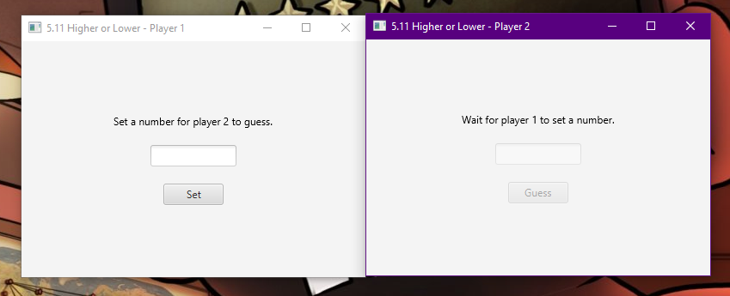

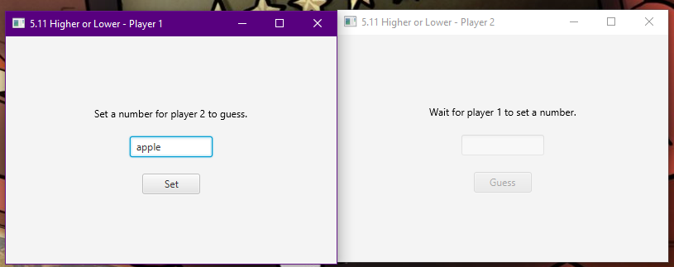

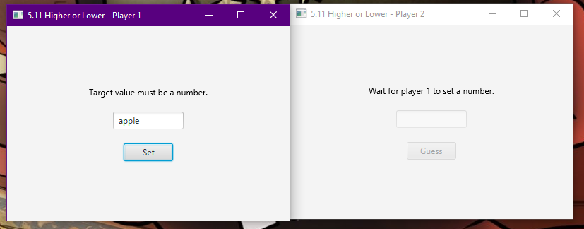

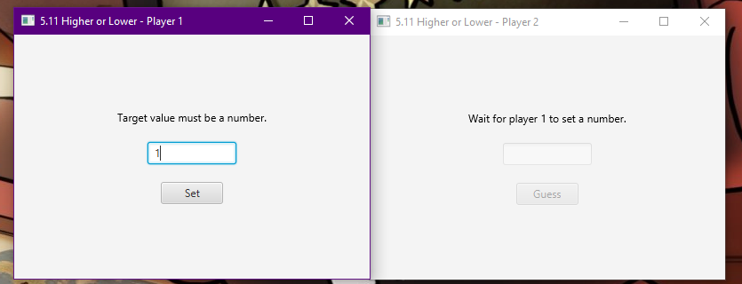

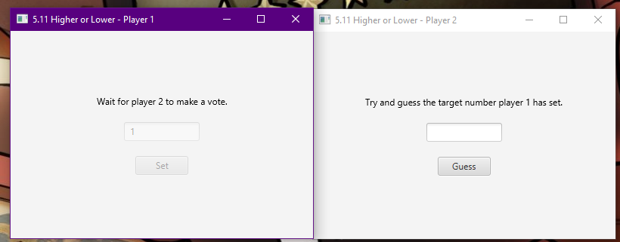

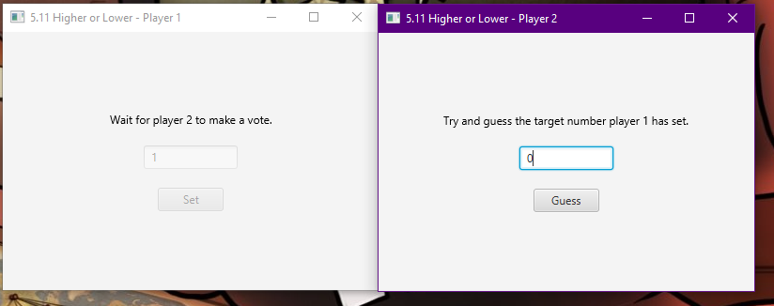

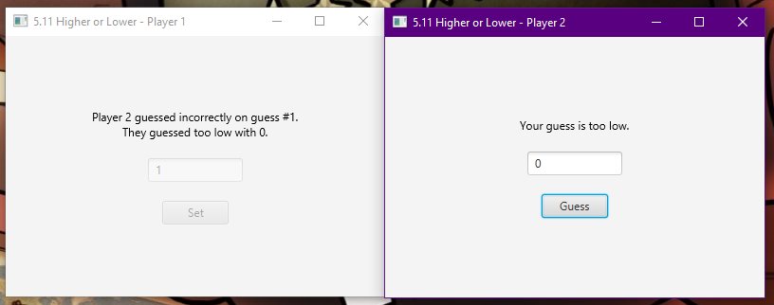 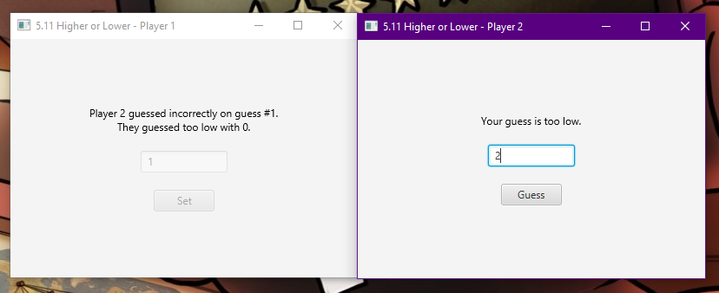

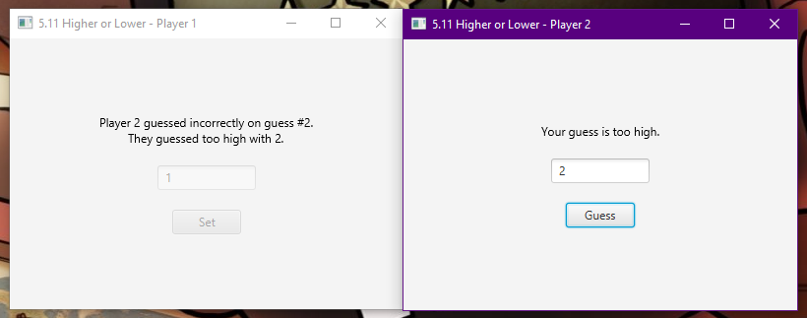 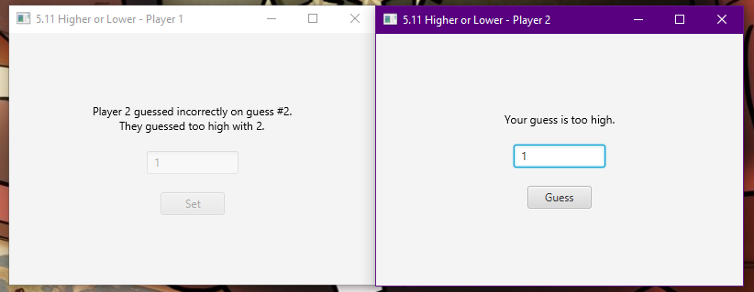 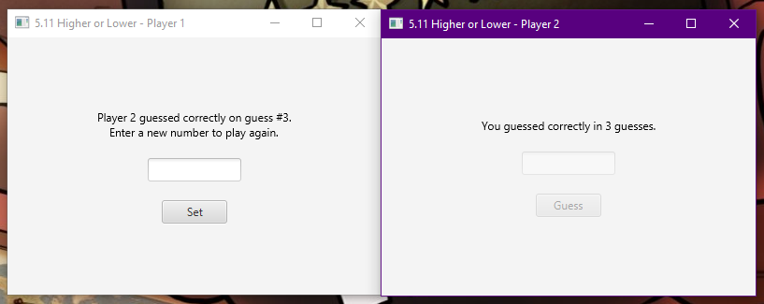

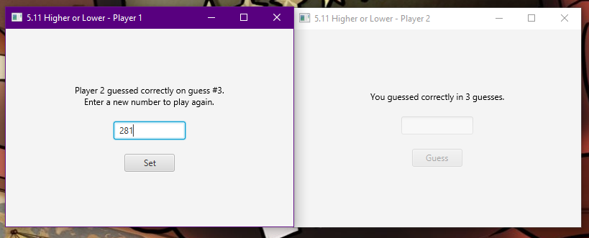

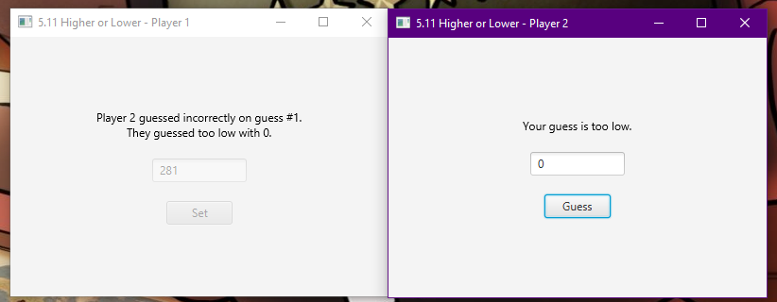

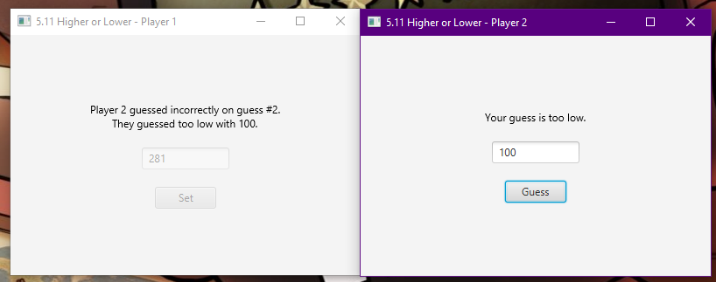 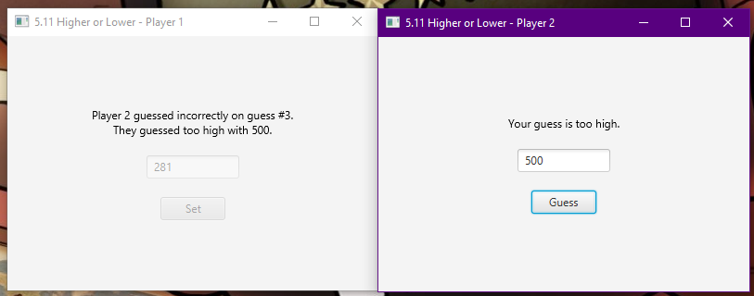 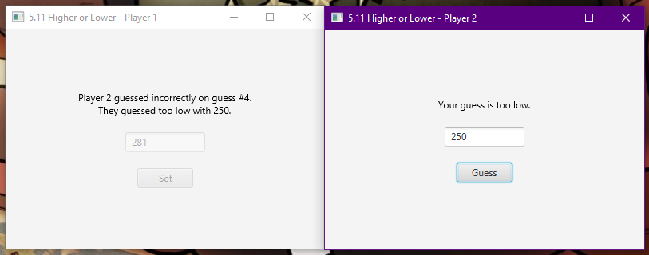

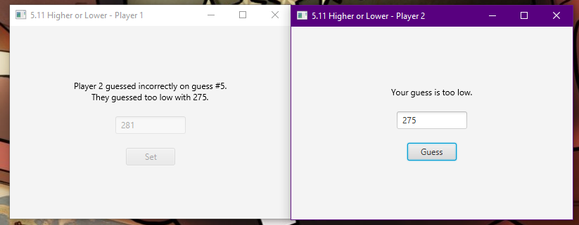 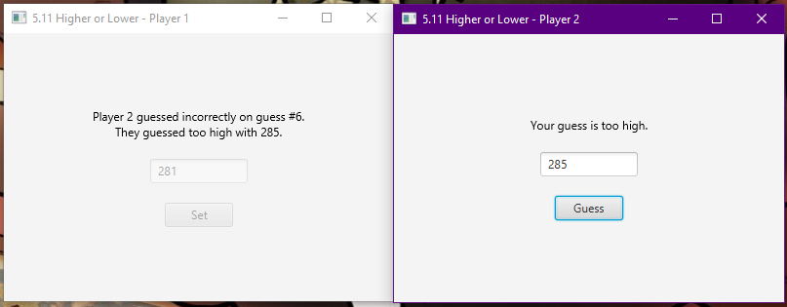

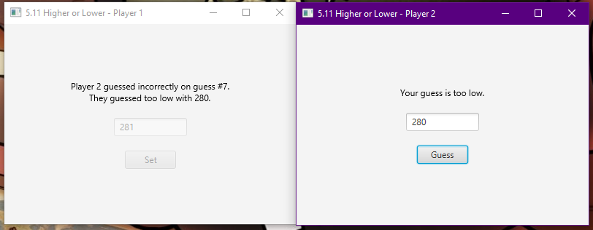

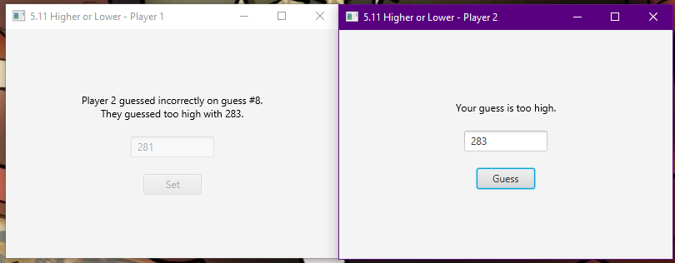

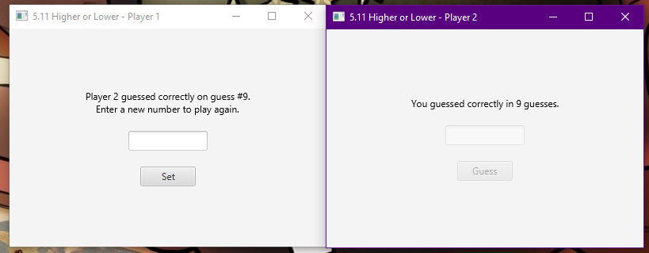

### Exercise 5.12. Module marks

* Design, write and test a program to process student module marks. The input data for each student consists of their name, followed by a group of 6 marks for each student (e.g. 56, 45, 75, 32, 68, 39). For each student, calculate the average mark and print a result depending on this average - 'Pass' if at least 40, otherwise 'Fail'. The program finishes when the user types “End” when prompted for the student’s name. Your program should process any number of students.

I am going to recycle my code from 5.5 to make an application that instead of inputting 1 grade will input 5 grades. Unlike 5.9 where I had statistics of all students, it is nicer to remove the excess clutter that it brought. However I will be implementing the deletion dialogue used in 5.10. Like 5.5, I will not pass an instance of the controller to every instance of employee to save on wasteful repetition potentially wasting memory. Instead I will use the single reference to the object statically defined in the controller class.

Design

GUI Design

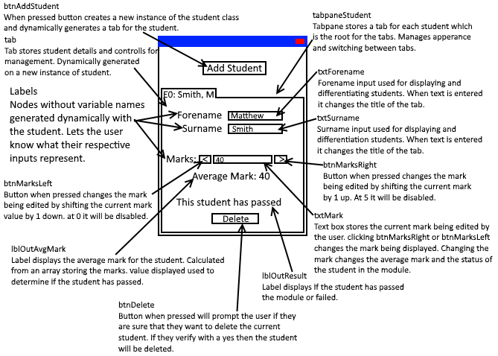

Class Diagram

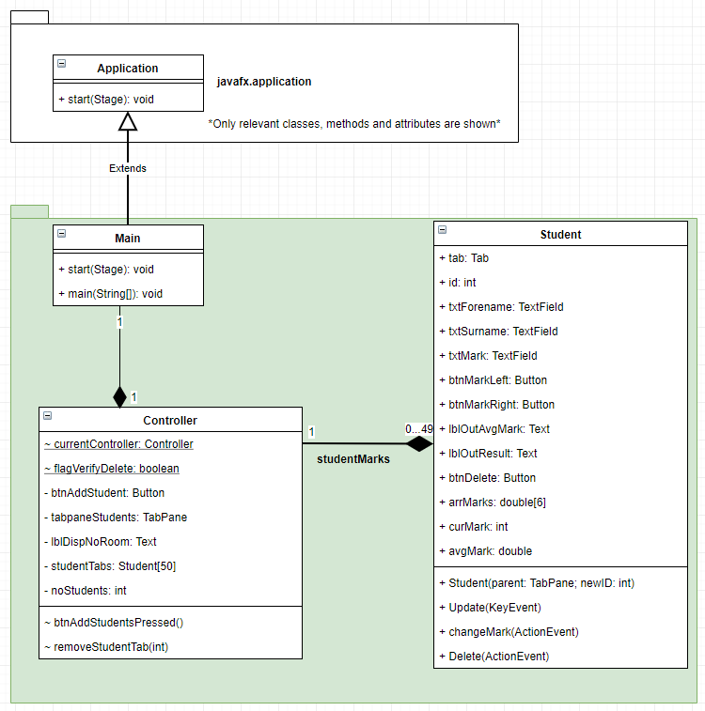

Code

Main Class

package moduleMarks;  
  
import javafx.application.Application;  
import javafx.fxml.FXMLLoader;  
import javafx.scene.Parent;  
import javafx.scene.Scene;  
import javafx.scene.image.Image;  
import javafx.stage.Stage;  
  
public class Main extends Application {  
  
 @Override  
 public void start(Stage primaryStage) throws Exception  
 {  
 //variables for having a single point to change width and height.  
 int width = 305;  
 int height = 350;  
  
 //set the icon for the stage. The icon is from http://www.famfamfam.com/lab/icons/silk/  
 primaryStage.getIcons().add(new Image(getClass().getResourceAsStream("img/user.png")));  
  
 //Create an FXMLLoader to load Main.fxml, and load it.  
 FXMLLoader loader = new FXMLLoader(getClass().getResource("Main.fxml"));  
 Parent root = loader.load();  
 primaryStage.setTitle("5.12 Module Marks");  
 Scene sceneMain = new Scene(root, width, height);  
  
 //Add the scene to the stage, and show it. Sets min width and height to defaults.  
 primaryStage.setScene(sceneMain);  
 primaryStage.setMinWidth(width);  
 primaryStage.setMinHeight(height);  
 primaryStage.show();  
  
 /*Store the reference of the FXMLLoader's controller (the controller which the FXMLLoader is using defined by  
 the FXML) statically in the Controller. Only exists so Student class instances can call an instance of Controller  
 to call the method removeStudentTab*/  
 Controller.*currentController* = loader.getController();  
  
 }  
  
  
 public static void main(String[] args)  
 {  
 *launch*(args);  
 }  
}

Controller Class

package moduleMarks;  
  
import javafx.fxml.FXML;  
import javafx.scene.control.Button;  
import javafx.scene.control.TabPane;  
import javafx.scene.text.Text;  
  
public class Controller  
{  
 /* static variable stores the instance of this class that is being used by FXML. Set when loading the FXML in Main  
 class, used by Student class to invoke the method removeStudentTab*/  
 static Controller *currentController*;  
 static boolean *flagVerifyDelete* = true; //flag for enabling and disabling the deletion verification dialogue.  
  
 //Instances of FXML elements, that we are going to manipulate in some way.  
 @FXML private Button btnAddStudent;  
 @FXML private TabPane tabpaneStudents; //Tabs stored in here, we can add new students which generates a tab added into the pane.  
 @FXML private Text lblDispNoRoom; //Only shown when noStudents == studentTabs.length  
  
 //Array stores instances of class Student. Array size can be changed and all code will work normally.  
 private Student[] studentTabs = new Student[50];  
  
 //Stores number of students. If adding, the value is used as next student id. e.g. 0 students, the next id is 0.  
 private int noStudents = 0;  
  
 //Method called when btnAddStudent is pressed, event managed by class FXMLLoader  
 public void btnAddStudentPressed()  
 {  
 //Add a new instance of the Student class to the next free array position. Requires the tabpane and new ID.  
 studentTabs[noStudents] = new Student(tabpaneStudents, noStudents);  
  
 //increment number of students as new student has been added.  
 noStudents++;  
  
 //if we have hit the tab limit, disable input button so can't create more students, show message why.  
 if (noStudents == studentTabs.length)  
 {  
 lblDispNoRoom.setVisible(true);  
 btnAddStudent.setDisable(true);  
 }  
 }  
  
 //method invoked when the delete button for a student has been pressed. Called from the student  
 public void removeStudentTab(int id)  
 {  
 //check the student we are trying to remove exists.  
 if (studentTabs[id] != null)  
 {  
 /*if id is 0 and is the only element, we can't shift the next element down, so manually delete the student  
 and set noStudents to 0 (no students exist). id 0 should be the only one that exists at 1 student according  
 to this method*/  
 if (id == 0 && noStudents == 1)  
 {  
 studentTabs[0] = null;  
 noStudents = 0;  
 return;  
 }  
 else if (id > -1 && id < studentTabs.length) //if we are between the valid ranges (and noStudents is > 1)  
 {  
 //delete the current student.  
 studentTabs[id] = null;  
  
 //start at the next ID, work down.  
 for (int i = id+1; i < studentTabs.length; i++)  
 {  
 //if we have not hit the end of array  
 if (studentTabs[i] != null)  
 {  
 /*shift the current element down by 1, decrease its id to the new id based on array position,  
 call update method to fix the name.*/  
 studentTabs[i-1] = studentTabs[i];  
 studentTabs[i-1].id--;  
 studentTabs[i-1].Update(null);//null provided as we are not updating from an ActionEvent.  
  
 /*set the current element to null as we have finished with it. If the end of elements in array  
 it allows for detecting end on other deletions.*/  
 studentTabs[i] = null;  
 }  
 else  
 {  
 /*if the next element is null then assume we have hit the current end of array, decrement number  
 of students and return as we have removed specific ID from array. Ends loop early. Enable button  
 and remove end of array text as array is not full*/  
  
 lblDispNoRoom.setVisible(false);  
 btnAddStudent.setDisable(false);  
  
 noStudents--;  
 return;  
 }  
 }  
 /*once we have gone through every element decrement number of students as we have been able to remove  
 the element at specific ID. enable button and hide text as array is not full.*/  
  
 lblDispNoRoom.setVisible(false);  
 btnAddStudent.setDisable(false);  
  
 noStudents--;  
 }  
 else  
 {  
 //id is not in valid range. Throw an exception.  
 throw new IllegalArgumentException("Value of 'ID' was invalid. Value was " + id + ", it should have been between 0 and " + (studentTabs.length-1) + ".");  
 }  
 }  
 else  
 {  
 //Could not remove id because it did not exist, throw an exception.  
 throw new IllegalArgumentException("Value of 'ID' was invalid. Element at position " + id + " did not exist (was null), so cannot be deleted.");  
 }  
 }  
}

Student Class

package moduleMarks;  
  
import javafx.event.ActionEvent;  
import javafx.geometry.Insets;  
import javafx.scene.control.*;  
import javafx.scene.image.Image;  
import javafx.scene.image.ImageView;  
import javafx.scene.input.KeyEvent;  
import javafx.scene.layout.HBox;  
import javafx.scene.layout.VBox;  
import javafx.scene.text.Text;  
import javafx.stage.StageStyle;  
  
import java.text.DecimalFormat;  
import java.util.Optional;  
  
import static javafx.geometry.Pos.*CENTER*;  
import static javafx.geometry.Pos.*CENTER_RIGHT*;  
  
public class Student  
{  
 //Student's tab attributes  
 public Tab tab;  
 public int id;  
 public TextField txtForename;  
 public TextField txtSurname;  
 public TextField txtMark;  
 public Button btnMarkLeft;  
 public Button btnMarkRight;  
 public Text lblOutAvgMark;  
 public Text lblOutResult;  
 public Button btnDelete;  
 public double[] arrMarks = new double[6];  
 public int curMark;  
 public double avgMark;  
  
 //method invoked on creating new instance of Student. Generates a tab with controls and event handling.  
 public Student(TabPane parent, int newID)  
 {  
 /*create a tab, store it as the student's tab attribute, set the ID from the ID provided in the creation and set  
 a title for new students.*/  
 this.tab = new Tab();  
 this.id = newID;  
 this.tab.setText("S" + newID + ": New Student");  
  
 /*create elements that will become nested in the tab, and nested in this nested element. Second and Third are  
 arbitrary names as their only point is to structure the scene objects. We need to reference them to append  
 children. Center objects to everything appears in the middle of the tab.*/  
 HBox hbSecond = new HBox();  
 VBox vbThird = new VBox();  
 hbSecond.setAlignment(*CENTER*);  
 vbThird.setAlignment(*CENTER*);  
  
 //creates image objects from png files. Images are from http://www.famfamfam.com/lab/icons/silk/  
 Image imgArrowLeft = new Image(getClass().getResourceAsStream("img/arrow_left.png"));  
 Image imgArrowRight = new Image(getClass().getResourceAsStream("img/arrow_right.png"));  
  
 //create javafx scene objects and assign them to this classes attributes. Set up attributes for the scene objects.  
 this.txtForename = new TextField();  
 this.txtSurname = new TextField();  
 this.txtMark = new TextField();  
 this.txtMark.setText("0");  
 this.btnMarkLeft = new Button();  
 this.btnMarkLeft.setGraphic(new ImageView(imgArrowLeft));  
 this.btnMarkLeft.setDisable(true);  
 this.btnMarkRight = new Button();  
 this.btnMarkRight.setGraphic(new ImageView(imgArrowRight));  
 this.lblOutAvgMark = new Text();  
 this.lblOutResult = new Text();  
 this.lblOutResult.setVisible(false);  
 this.btnDelete = new Button("Delete Current Student");  
  
 /*Events handled by existing method. Compiler deals with how we get to the method. Method must implement the event  
 type.*/  
 this.txtForename.setOnKeyReleased(this::Update);  
 this.txtSurname.setOnKeyReleased(this::Update);  
 this.txtMark.setOnKeyReleased(this::Update);  
 this.btnMarkLeft.setOnAction(this::changeMark);  
 this.btnMarkRight.setOnAction(this::changeMark);  
 this.btnDelete.setOnAction(this::Delete);  
  
 //Display 0 in txtMark by default as all elements in arrMarks start as 0.  
 this.txtMark.setText("0");  
  
 /*encapsulate the text entries within a hbox, and have a text label before them. alignment so text fields match  
 in alignment.*/  
 HBox hbForename = new HBox();  
 hbForename.getChildren().add(new Text("Forename: "));  
 hbForename.getChildren().add(this.txtForename);  
 hbForename.setAlignment(*CENTER*);  
  
 HBox hbSurname = new HBox();  
 hbSurname.getChildren().add(new Text("Surname: "));  
 hbSurname.getChildren().add(this.txtSurname);  
 hbSurname.setAlignment(*CENTER*);  
  
 HBox hbMark = new HBox();  
 hbMark.getChildren().add(new Text("Marks: "));  
 hbMark.getChildren().add(this.btnMarkLeft);  
 hbMark.getChildren().add(this.txtMark);  
 hbMark.getChildren().add(this.btnMarkRight);  
 hbMark.setAlignment(*CENTER*);  
  
  
 /*add the scene objects (and scene objects through their encapsulating hboxes) to their root. Create and add  
 spacing so there is space between scene objects.*/  
 vbThird.setSpacing(5);  
 vbThird.getChildren().add(hbForename);  
 vbThird.getChildren().add(hbSurname);  
 vbThird.getChildren().add(hbMark);  
 vbThird.getChildren().add(this.lblOutAvgMark);  
 vbThird.getChildren().add(this.lblOutResult);  
 vbThird.getChildren().add(this.btnDelete);  
  
 //sets margins to prettify the application.  
 vbThird.*setMargin*(hbForename, new Insets(10, 0, 0, 0));  
 vbThird.*setMargin*(hbMark, new Insets(15, 0, 0, 0));  
 vbThird.*setMargin*(this.lblOutResult, new Insets(10, 0, 0, 0));  
 vbThird.*setMargin*(this.btnDelete, new Insets(10, 0, 0, 0));  
  
 //Add the child to tabRoot (that contains all control objects) to tabRoot  
 hbSecond.getChildren().add(vbThird);  
  
 //add the tab root to the current tab. Add the current tab to the parent, the tabpane.  
 this.tab.setContent(hbSecond);  
 parent.getTabs().add(this.tab);  
 }  
  
 public void Update(KeyEvent e)  
 {  
 if (this.txtForename.getText().equals(""))  
 {  
 //set the text of the tab (what is displayed) to show the student id and "New Student" if no forename exists.  
 this.tab.setText("S" + this.id + ": New Student");  
 }  
 else  
 {  
 //set the text of the tab (what is displayed) to show the student id and name. if a forename exists.  
 //e.g. S0: Smith, M  
 this.tab.setText("S" + id + ": " + this.txtSurname.getText() + ", " + this.txtForename.getText().charAt(0));  
 }  
  
  
  
 try  
 {  
 //convert the text of the TextField to an int, throws NumberFormatException if not a valid int.  
 double mark = Double.*parseDouble*(this.txtMark.getText());  
  
 if (mark < 0 || mark > 100)  
 {  
 //set mark to -1 if it is invalid  
 arrMarks[curMark] = -1;  
 }  
 else  
 {  
 //set the current marks element to the converted value of mark if mark is valid.  
 arrMarks[curMark] = mark;  
 }  
 }  
 catch (NumberFormatException x)  
 {  
 /*On NumberFormatException we know mark is not a number, set the mark value in arrMarks to -1 so we know a  
 mark is invalid.*/  
 arrMarks[curMark] = -1;  
 }  
  
 //flag catches invalid marks.  
 boolean flagMarksValid = true;  
  
 //resets avgMark to recalculate the average  
 avgMark = 0;  
  
 for (int i = 0; i < arrMarks.length; i++)  
 {  
 //increment avgMark by the current element  
 avgMark += arrMarks[i];  
  
 //if the current mark (any in the array) is invalid, set the flag to false.  
 if (arrMarks[i] == -1)  
 {  
 flagMarksValid = false;  
 }  
 }  
  
 //if valid flag is true (no elements were invalid)  
 if (flagMarksValid)  
 {  
 //show the output labels.  
 lblOutResult.setVisible(true);  
 lblOutAvgMark.setVisible(true);  
  
 //divide avgMark by the number of elements in the array (calculate average from total)  
 avgMark /= arrMarks.length;  
  
 DecimalFormat df3DP = new DecimalFormat("##0.0#");  
  
 //display the average  
 lblOutAvgMark.setText("The average mark is " + df3DP.format(avgMark));  
  
 //check if the student is above or below grade threshold. pass if above, fail if below.  
 if (avgMark < 40)  
 {  
 this.lblOutResult.setText("This student has failed.");  
 }  
 else if (avgMark >= 40)  
 {  
 this.lblOutResult.setText("This student has passed.");  
 }  
 }  
 else  
 {  
 //if invalid hide output labels and clear avgMark.  
 lblOutResult.setVisible(false);  
 lblOutAvgMark.setVisible(false);  
 avgMark = 0;  
 }  
 }  
  
 public void changeMark(ActionEvent ev)  
 {  
  
 if (ev.getSource() == this.btnMarkLeft)  
 {  
 //if left button decrement the current mark by 1  
 curMark--;  
 }  
 else if (ev.getSource() == this.btnMarkRight)  
 {  
 //if right button increment the current mark by 1  
 curMark++;  
 }  
  
  
  
 //<1 = 0 or less, > 4 = 5 or more, else = between 1 and 5.  
 if (curMark < 1)  
 {  
 //if we are at the lowest value or less prevent going too low.  
 btnMarkLeft.setDisable(true);  
 }  
 else if (curMark > arrMarks.length-2)  
 {  
 //if we are at the highest value or more prevent going too high.  
 btnMarkRight.setDisable(true);  
 }  
 else  
 {  
 //if our values are between highest and lowest, override previous conditions.  
 btnMarkLeft.setDisable(false);  
 btnMarkRight.setDisable(false);  
 }  
  
  
  
 if (arrMarks[curMark] == -1)  
 {  
 //if invalid set the current mark value to 0 (Only if shifting up or down to current position).  
 arrMarks[curMark] = 0;  
 }  
  
 //set the text of txtMark to the current mark selected.  
 txtMark.setText(String.*valueOf*(arrMarks[curMark]));  
 }  
  
 public void Delete(ActionEvent e)  
 {  
 //if we want to verify that the user wants to delete the current student  
 if (Controller.*flagVerifyDelete*)  
 {  
 /*crate a new alert of type warning, with a title and content text, which informs the user the implications  
 of clicking yes. StageStyle.utility means it has no icon.*/  
 Alert verifyDeletion = new Alert(Alert.AlertType.*WARNING*);  
 verifyDeletion.setTitle("Verify Action");  
 verifyDeletion.setHeaderText(null);  
 verifyDeletion.setContentText("Are you sure you want to delete the current student? This action cannot be undone.");  
 verifyDeletion.initStyle(StageStyle.*UTILITY*);  
  
 //button for yes, allows us to detect if the user clicks yes.  
 ButtonType verifyDeletionBtnYes = new ButtonType("Yes");  
  
 /*adds button types to the dialogue. Adds the yes button, and creates a no and cancel button (which we don't  
 need to store in memory because they will not be used for testing what was pressed).*/  
 verifyDeletion.getButtonTypes().setAll(verifyDeletionBtnYes, new ButtonType("No"), new ButtonType("Cancel", ButtonBar.ButtonData.*CANCEL_CLOSE*));  
  
 /*Create an object called result of type optional, meaning that it can have no value. show and wait for a  
 result of the dialogue. The result is used to determine what the user clicked on the dialogue.*/  
 Optional<ButtonType> result = verifyDeletion.showAndWait();  
  
 /*If the user clicked anything other than yes, return, skipping the deletion part in this method. If the user  
 did click yes then it will skip the return, completing the scope of the current if, and then completing the  
 deletion portion of this method.*/  
 if (result.get() != verifyDeletionBtnYes)  
 {  
 return;  
 }  
 }  
  
 //Remove the tab from the tabpane  
 this.tab.getTabPane().getTabs().remove(this.tab);  
  
 /*Call Controller.removeStudentTab to remove the current student from the array studentTabs (and kill this  
 instance). Have to get a statically defined variable from Controller that stores the instance of Controller used  
 by the FXMLLoader, as that is the instance of the class that stores the studentTabs array and instance of this  
 class*/  
 Controller.*currentController*.removeStudentTab(this.id);  
 }  
}

FXML File

<?xml version="1.0" encoding="UTF-8"?>  
  
<?import javafx.scene.control.Button?>  
<?import javafx.scene.control.TabPane?>  
<?import javafx.scene.layout.HBox?>  
<?import javafx.scene.layout.VBox?>  
<?import javafx.scene.text.Text?>  
  
<VBox maxHeight="-Infinity" maxWidth="-Infinity" minHeight="-Infinity" minWidth="-Infinity" prefHeight="400.0" prefWidth="600.0" xmlns="http://javafx.com/javafx/9.0.1" xmlns:fx="http://javafx.com/fxml/1" fx:controller="moduleMarks.Controller">  
 <children>  
 <HBox alignment="CENTER" prefHeight="119.0" prefWidth="600.0">  
 <children>  
 <VBox alignment="CENTER" prefHeight="47.0" prefWidth="100.0">  
 <children>  
 <Button id="btnAddStudent" fx:id="btnAddStudent" alignment="CENTER" mnemonicParsing="false" onAction="#btnAddStudentPressed" prefHeight="25.0" prefWidth="140.0" text="Add New Student" />  
 <Text fx:id="lblDispNoRoom" strokeType="OUTSIDE" strokeWidth="0.0" text="Maximum Number of students reached,." visible="false" />  
 </children>  
 </VBox>  
 </children>  
 </HBox>  
 <TabPane id="tabpaneStudents" fx:id="tabpaneStudents" prefHeight="274.0" prefWidth="600.0" tabClosingPolicy="UNAVAILABLE" />  
 </children>  
</VBox>

Output

(windows)

Adding

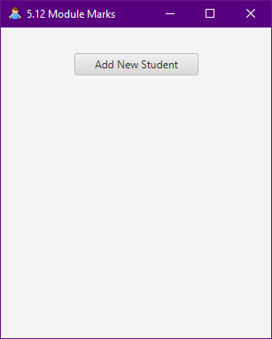

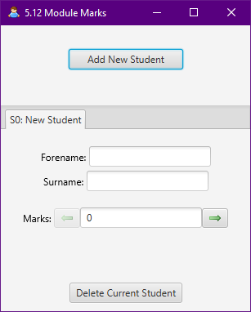

Deleting

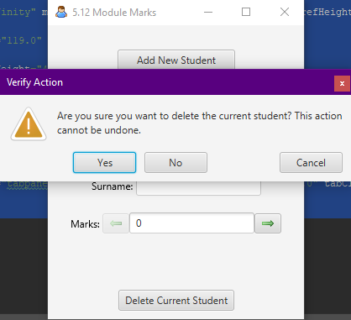

(pressing no, cancel or the cross)

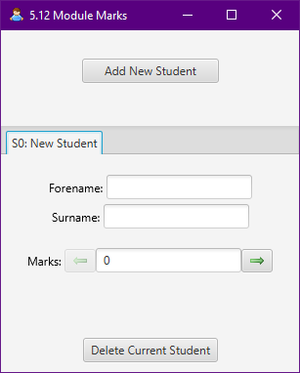

(pressing yes)

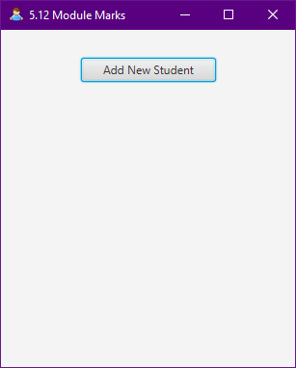

Upper student Range and changing student

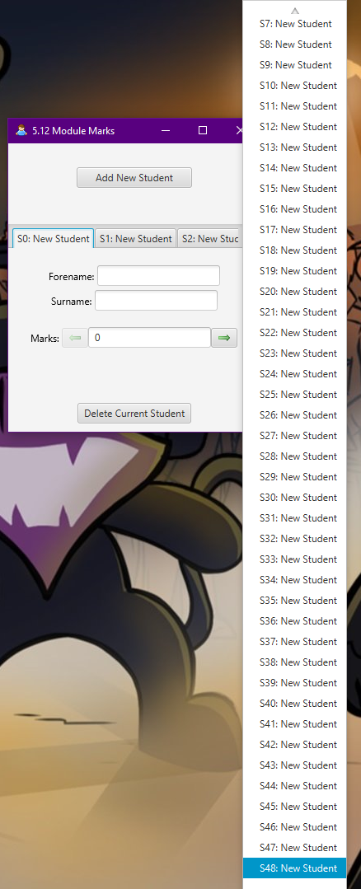

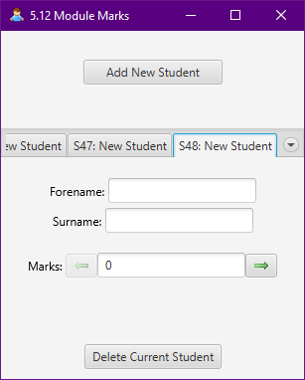

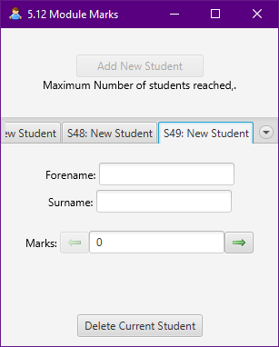

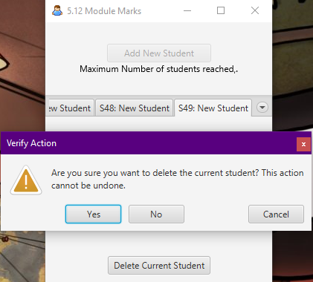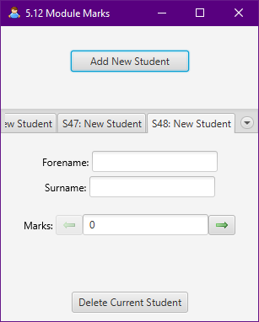

Testing Editing

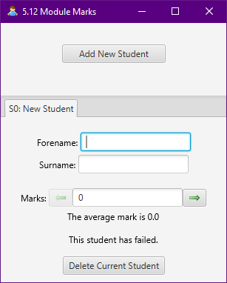

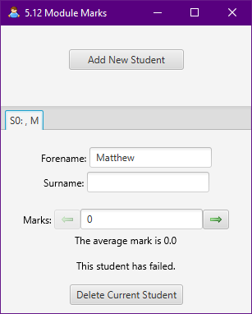

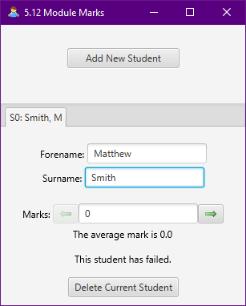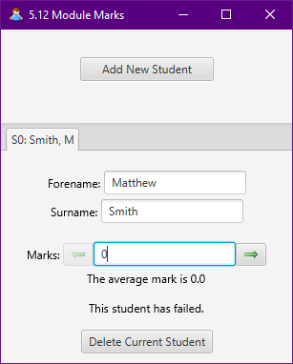

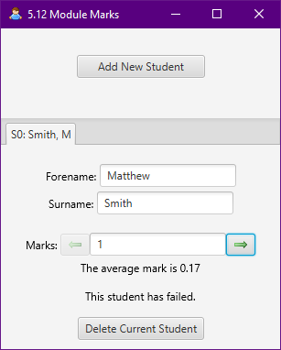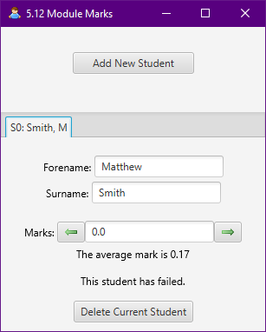

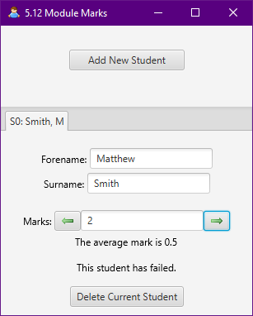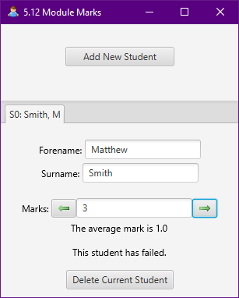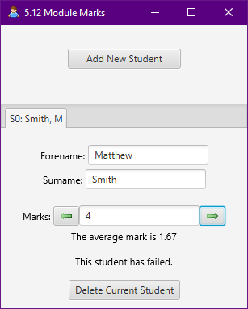

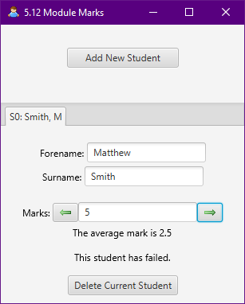

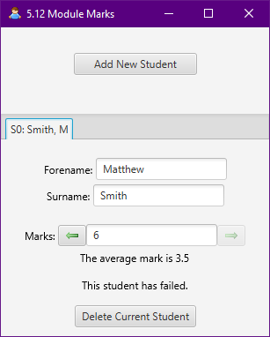

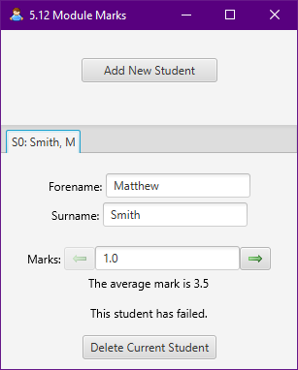

|  |  |  |  |  |  |  |  |  |  |  |
| --- | --- | --- | --- | --- | --- | --- | --- | --- | --- | --- |
| Test No. | Mark 0 | Mark 1 | Mark 2 | Mark 3 | Mark 4 | Mark 5 | Predicted Average | Average Mark | Passed or Failed? | Expected? |
| 0 | 0 | 0 | 0 | 0 | 0 | 0 | 0 | 0 | Failed | Yes |
| 1 | 40 | 0 | 0 | 0 | 0 | 0 | 6.66666* | 6.67 | Failed | Yes |
| 2 | 40 | 40 | 0 | 0 | 0 | 0 | 13.3333* | 13.33 | Failed | Yes |
| 4 | 40 | 40 | 40 | 0 | 0 | 0 | 20 | 20 | Failed | Yes |
| 5 | 40 | 40 | 40 | 40 | 0 | 0 | 26.6666* | 26.67 | Failed | Yes |
| 6 | 40 | 40 | 40 | 40 | 40 | 0 | 33.3333* | 33.33 | Failed | Yes |
| 7 | 40 | 40 | 40 | 40 | 40 | 40 | 40 | 40 | Passed | Yes |
| 8 | 40 | 40 | 40 | 40 | 40 | 39 | 39.8333* | 39.83 | Failed | Yes |
| 9 | 40 | 40 | 40 | 40 | 40 |  | Invalid |  |  | Yes |
| 10 | 40 | 40 | 40 | 40 | 40 | Apple | Invalid |  |  | Yes |
| 11 | 73 | 39 | 56 | 22 | 54.7 | 62 | 51.11666* | 51.12 | Passed | Yes |

Test 7

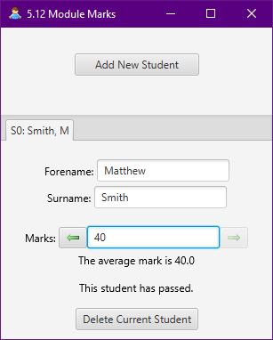

Test 8

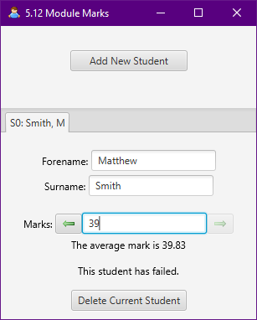

Test 9

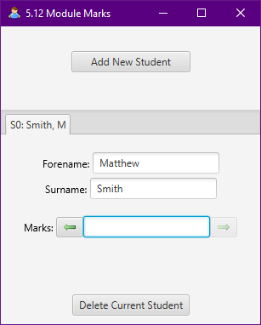

Test 10

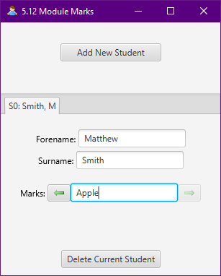

Test 11

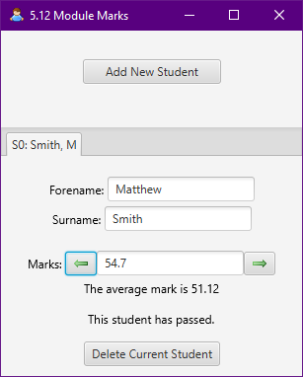

### Exercise 6.1. Hello again

* Design, build and test a program that asks the user to input a number, and output the message "Hello world" that number of times. Your program must have a separate method which outputs the set of messages.

While this application is very simple in nature I will still program it into a GUI, even though it is clearly a beginner’s exercise. I will use 6.1 to learn ListViews (List Boxes) to store many values in a single node of a fixed size. The method to print will store the for loop that adds that number of hello world to the ListView.

Design

GUI Design

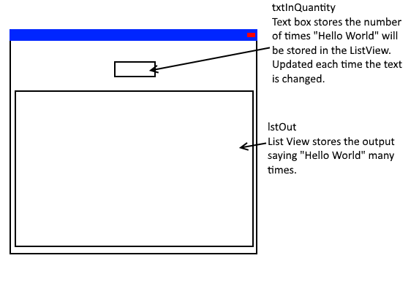

Class Diagram

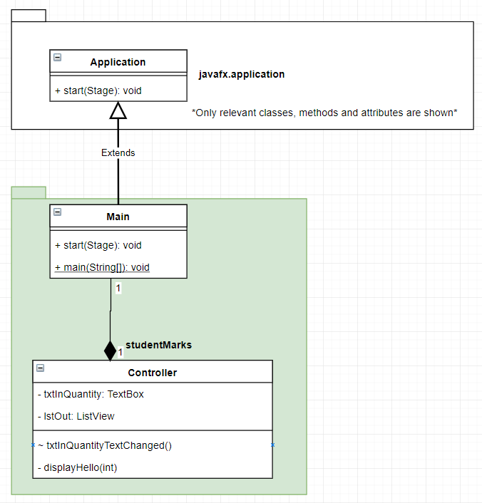

Code

Main Class

package helloAgain;  
  
import javafx.application.Application;  
import javafx.fxml.FXMLLoader;  
import javafx.scene.Parent;  
import javafx.scene.Scene;  
import javafx.scene.image.Image;  
import javafx.stage.Stage;  
  
public class Main extends Application {  
  
 @Override  
 public void start(Stage primaryStage) throws Exception{  
 Parent root = FXMLLoader.*load*(getClass().getResource("hello.fxml"));  
 primaryStage.setTitle("6.1 Hello Again");  
 primaryStage.setScene(new Scene(root, 300, 275));  
 primaryStage.getIcons().add(new Image(getClass().getResourceAsStream("img/comments.png")));  
 primaryStage.show();  
 }  
  
  
 public static void main(String[] args) {  
 *launch*(args);  
 }  
}

Controller Class

package helloAgain;  
  
import javafx.fxml.FXML;  
import javafx.scene.control.ListView;  
import javafx.scene.control.TextField;  
  
public class controllerHello  
{  
 @FXML TextField txtInQuantity;  
 @FXML ListView<String> lstOut;  
  
 @FXML  
 void txtInQuantityTextChanged()  
 {  
 int quantity;  
 try  
 {  
 quantity = Integer.*parseInt*(txtInQuantity.getText());  
  
 }  
 catch (NumberFormatException ex)  
 {  
 quantity = -1;  
 }  
  
 if (quantity == -1)  
 {  
 //if invalid clear the list and tell the user.  
 lstOut.getItems().clear();  
 lstOut.getItems().add("Quantity value is not a number.");  
  
 }  
 else if (quantity > 0 && quantity < 10000001)  
 {  
 display(quantity);  
 }  
 else  
 {  
 lstOut.getItems().clear();  
 lstOut.getItems().add("Quantity value must be between 1 and 10000000 (Ten Million).");  
 }  
 }  
  
 private void display(int x)  
 {  
 lstOut.getItems().clear();  
 for (int i = 0; i < x; i++)  
 {  
 lstOut.getItems().add("Hello World");  
 }  
 }  
}

FXML

<?xml version="1.0" encoding="UTF-8"?>  
  
<?import javafx.geometry.Insets?>  
<?import javafx.scene.control.ListView?>  
<?import javafx.scene.control.TextField?>  
<?import javafx.scene.layout.VBox?>  
  
<VBox alignment="CENTER" prefHeight="200.0" prefWidth="100.0" xmlns="http://javafx.com/javafx/9.0.1" xmlns:fx="http://javafx.com/fxml/1" fx:controller="helloAgain.controllerHello">  
 <children>  
 <TextField fx:id="txtInQuantity" alignment="CENTER" maxWidth="150.0" minWidth="150.0" onKeyTyped="#txtInQuantityTextChanged" prefWidth="150.0" promptText="Quantity">  
 <VBox.margin>  
 <Insets top="10.0" />  
 </VBox.margin></TextField>  
 <ListView fx:id="lstOut" minWidth="150.0" VBox.vgrow="ALWAYS">  
 <VBox.margin>  
 <Insets bottom="10.0" left="10.0" right="10.0" top="10.0" />  
 </VBox.margin></ListView>  
 </children>  
</VBox>

Output

(windows)

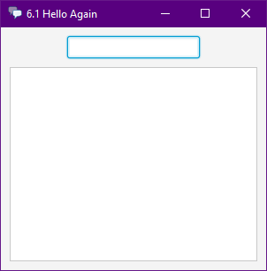 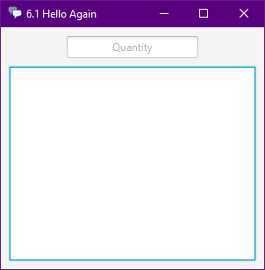 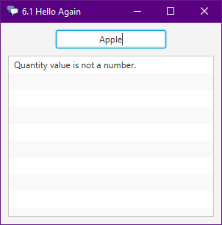 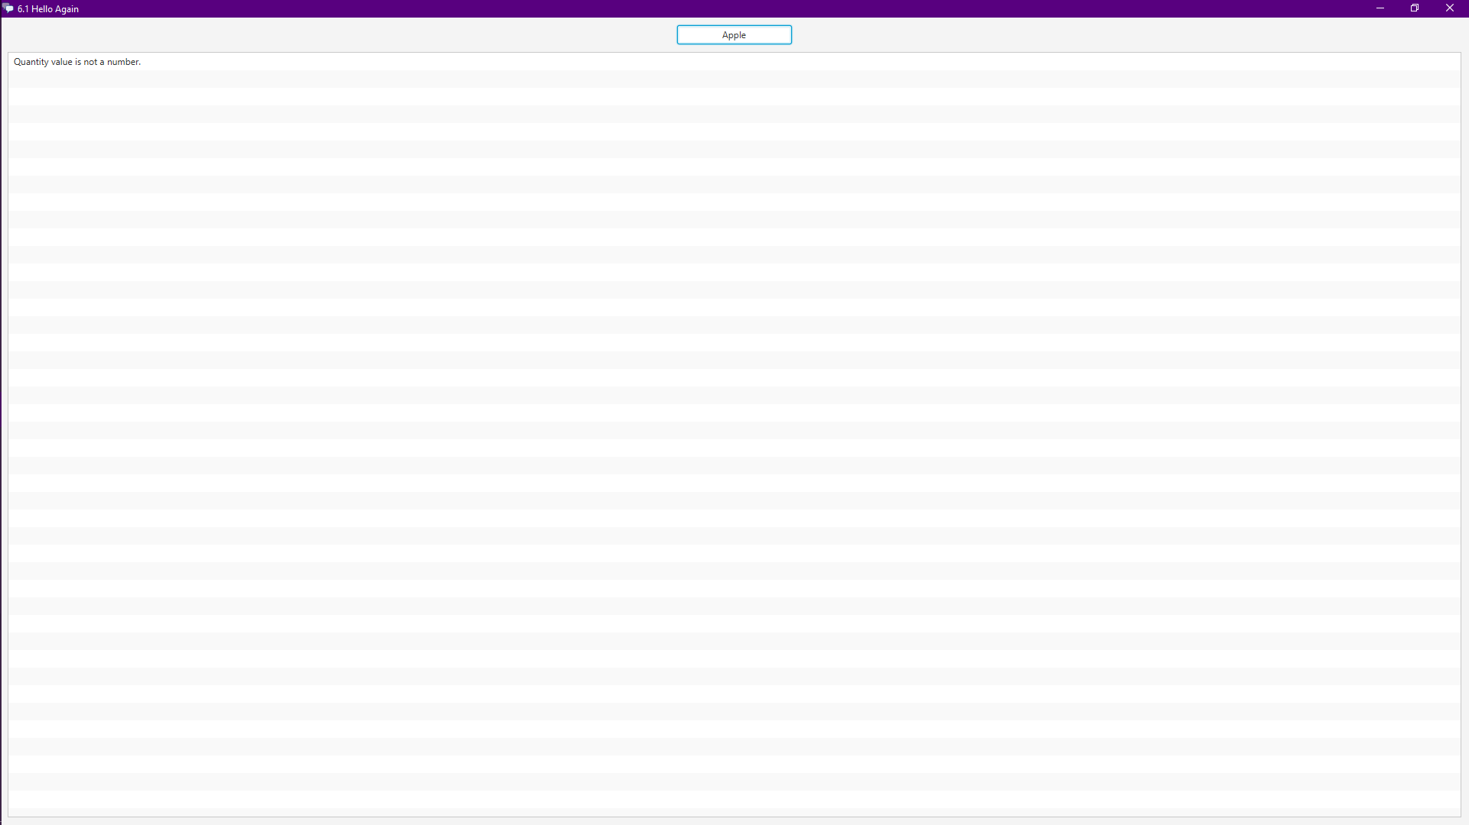 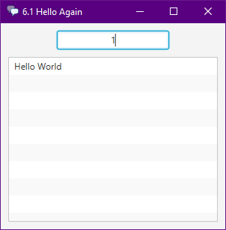 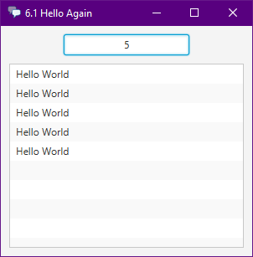

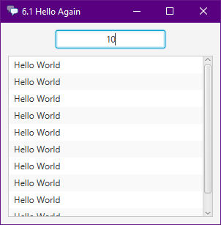

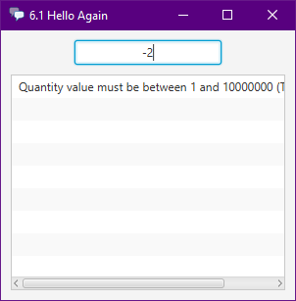

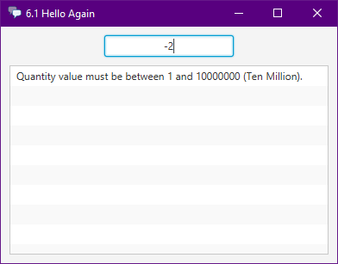

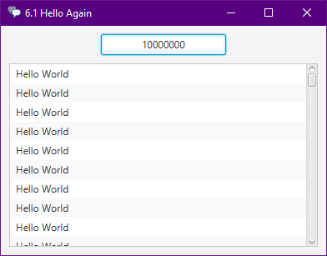

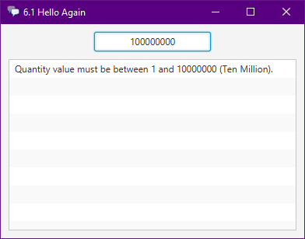

### Exercise 6.2. Circle area

* Design, build, and test a program that calculates the area of a circle, based on the user inputting its radius. You must write a separate method to calculate the formula: Area = πr2

The application will be simple to make, just inputting values from the user. I will also try to draw the circle with the javafx circle library. It uses a radius to draw a circle, but I will display the area inside the circle I draw.

Design

GUI Design

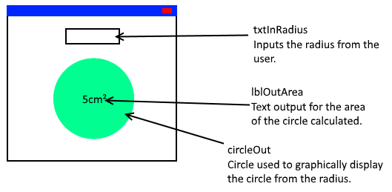

Class Diagram

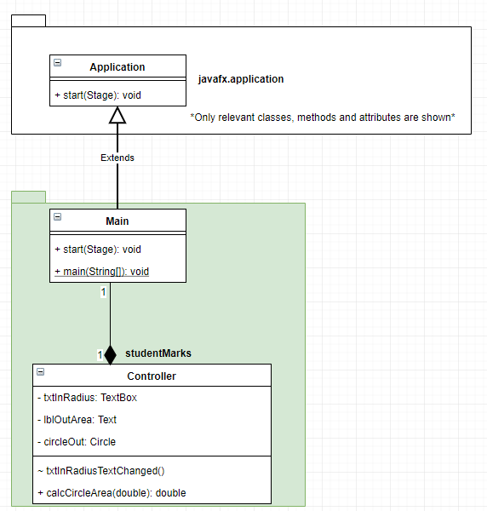

Code

Main Class

package circleArea;  
  
import javafx.fxml.FXML;  
import javafx.scene.control.TextField;  
import javafx.scene.layout.StackPane;  
import javafx.scene.layout.VBox;  
import javafx.scene.shape.Circle;  
import javafx.scene.text.Text;  
  
import java.text.DecimalFormat;  
  
public class controllerMain  
{  
 @FXML VBox root;//Used for positioning lblOutArea.  
 @FXML TextField txtInRadius;//Input of radius  
 @FXML Text lblOutStatus;//Status messages telling the user their errors.  
 @FXML StackPane stackpaneCircle;//used for positioning lblOutArea  
 @FXML Circle circleOut;//Circle display  
 @FXML Text lblOutArea;//Displaying area  
  
 @FXML  
 void txtInRadiusTextChanged()  
 {  
 //define the radius and a flag to determine if we could get a radius or if it was invalid.  
 double radius = 0.0;  
 boolean flagRadiusValid = true;  
  
 try  
 {  
 //try to convert the text of txtInRadius to a Double.  
 radius = Double.*parseDouble*(txtInRadius.getText());  
 }  
 catch (NumberFormatException ex)  
 {  
 //if NumberFormatException is thrown (thrown when Double.parseDouble cannot parse), set invalid flag to false.  
 flagRadiusValid = false;  
 }  
  
 //in case the text is empty override the radius to 0 and the flag to true. Effectively changes the status message.  
 if (txtInRadius.getText().equals(""))  
 {  
 radius = 0;  
 flagRadiusValid = true;  
 }  
  
 if (flagRadiusValid)  
 {  
 //if values are between the range.  
 if (radius > 0 && radius < 100001)  
 {  
 //calculate the area  
 double area = calcCircleArea(radius);  
  
 //Decimal format for formatting decimals to 2 decimal places.  
 DecimalFormat df2DP = new DecimalFormat("##########0.0#");  
  
 //removes lblOutArea from all possible parent nodes, so we can reassign where it should go.  
 stackpaneCircle.getChildren().remove(lblOutArea);  
 root.getChildren().remove(lblOutArea);  
  
 /*Based on testing, if below this arbitrary number the text is too large for the circle, so put it below  
 the circle otherwise it will fit so put it inside the circle. Only tested on windows. so could  
 be different for a different OS, or even a different resolution.*/  
 if (radius < 30)  
 {  
 root.getChildren().add(lblOutArea);  
 }  
 else  
 {  
 stackpaneCircle.getChildren().add(lblOutArea);  
 }  
  
 /*Hide the status as we can display the area, set the area as a formatted decimal of the area + units.  
 Set the circle radius to the new radius and make sure lblOutArea is visible.*/  
 lblOutStatus.setVisible(false);  
 lblOutArea.setText(String.*valueOf*(df2DP.format(area) + "M²"));  
 circleOut.setRadius(radius);  
 lblOutArea.setVisible(true);  
 }  
 else  
 {  
 /*if values are not between the ranges, tell the user what they did wrong, and hide the area displays.  
 Setting circle radius rather than visible will make so when the last area was very large, lblOutStatus  
 and txtInRadius will be visible on screen.*/  
  
 lblOutArea.setVisible(false);  
 circleOut.setRadius(0);//  
 lblOutStatus.setText("The radius must be between\n1 and 100000.");  
 lblOutStatus.setVisible(true);  
 }  
 }  
 else  
 {  
 /*if the radius was invalid, tell the user what they did wrong and hide the area displays.  
 Setting circle radius rather than visible will make so when the last area was very large, lblOutStatus  
 and txtInRadius will be visible on screen.*/  
 lblOutArea.setVisible(false);  
 circleOut.setRadius(0);  
 lblOutStatus.setText("The radius is invalid.\nIt must be a positive decimal number.");  
 lblOutStatus.setVisible(true);  
 }  
 }  
  
 public double calcCircleArea(double radius)  
 {  
 //calculate the area of any circle. Return.  
 return Math.*PI*\*(Math.*pow*(radius, 2));  
 }  
}

Controller Class

package circleArea;  
  
import javafx.fxml.FXML;  
import javafx.scene.control.TextField;  
import javafx.scene.layout.StackPane;  
import javafx.scene.layout.VBox;  
import javafx.scene.shape.Circle;  
import javafx.scene.text.Text;  
  
import java.text.DecimalFormat;  
  
public class controllerMain  
{  
 @FXML VBox root;//Used for positioning lblOutArea.  
 @FXML TextField txtInRadius;//Input of radius  
 @FXML Text lblOutStatus;//Status messages telling the user their errors.  
 @FXML StackPane stackpaneCircle;//used for positioning lblOutArea  
 @FXML Circle circleOut;//Circle display  
 @FXML Text lblOutArea;//Displaying area  
  
 @FXML  
 void txtInRadiusTextChanged()  
 {  
 //define the radius and a flag to determine if we could get a radius or if it was invalid.  
 double radius = 0.0;  
 boolean flagRadiusValid = true;  
  
 try  
 {  
 //try to convert the text of txtInRadius to a Double.  
 radius = Double.*parseDouble*(txtInRadius.getText());  
 }  
 catch (NumberFormatException ex)  
 {  
 //if NumberFormatException is thrown (thrown when Double.parseDouble cannot parse), set invalid flag to false.  
 flagRadiusValid = false;  
 }  
  
 //in case the text is empty override the radius to 0 and the flag to true. Effectively changes the status message.  
 if (txtInRadius.getText().equals(""))  
 {  
 radius = 0;  
 flagRadiusValid = true;  
 }  
  
 if (flagRadiusValid)  
 {  
 //if values are between the range.  
 if (radius > 0 && radius < 501)  
 {  
 //calculate the area  
 double area = calcCircleArea(radius);  
  
 //Decimal format for formatting decimals to 2 decimal places.  
 DecimalFormat df2DP = new DecimalFormat("##########0.0#");  
  
 //removes lblOutArea from all possible parent nodes, so we can reassign where it should go.  
 stackpaneCircle.getChildren().remove(lblOutArea);  
 root.getChildren().remove(lblOutArea);  
  
 /*Based on testing, if below this arbitrary number the text is too large for the circle, so put it below  
 the circle otherwise it will fit so put it inside the circle. Only tested on windows. so could  
 be different for a different OS, or even a different resolution.*/  
 if (radius < 30)  
 {  
 root.getChildren().add(lblOutArea);  
 }  
 else  
 {  
 stackpaneCircle.getChildren().add(lblOutArea);  
 }  
  
 /*Hide the status as we can display the area, set the area as a formatted decimal of the area + units.  
 Set the circle radius to the new radius and make sure lblOutArea is visible.*/  
 lblOutStatus.setVisible(false);  
 lblOutArea.setText(String.*valueOf*(df2DP.format(area) + "M²"));  
 circleOut.setRadius(radius);  
 lblOutArea.setVisible(true);  
 }  
 else  
 {  
 /*if values are not between the ranges, tell the user what they did wrong, and hide the area displays.  
 Setting circle radius rather than visible will make so when the last area was very large, lblOutStatus  
 and txtInRadius will be visible on screen.*/  
  
 lblOutArea.setVisible(false);  
 circleOut.setRadius(0);//  
 lblOutStatus.setText("The radius must be between\n1 and 500.");  
 lblOutStatus.setVisible(true);  
 }  
 }  
 else  
 {  
 /*if the radius was invalid, tell the user what they did wrong and hide the area displays.  
 Setting circle radius rather than visible will make so when the last area was very large, lblOutStatus  
 and txtInRadius will be visible on screen.*/  
 lblOutArea.setVisible(false);  
 circleOut.setRadius(0);  
 lblOutStatus.setText("The radius is invalid.\nIt must be a positive decimal number.");  
 lblOutStatus.setVisible(true);  
 }  
 }  
  
 public double calcCircleArea(double radius)  
 {  
 //calculate the area of any circle. Return.  
 return Math.*PI*\*(Math.*pow*(radius, 2));  
 }  
}

FXML

<?xml version="1.0" encoding="UTF-8"?>  
  
<?import javafx.geometry.Insets?>  
<?import javafx.scene.control.TextField?>  
<?import javafx.scene.layout.HBox?>  
<?import javafx.scene.layout.StackPane?>  
<?import javafx.scene.layout.VBox?>  
<?import javafx.scene.shape.Circle?>  
<?import javafx.scene.text.Text?>  
  
<HBox alignment="CENTER" maxHeight="-Infinity" maxWidth="-Infinity" minHeight="-Infinity" minWidth="-Infinity" prefHeight="400.0" prefWidth="600.0" xmlns="http://javafx.com/javafx/8.0.121" xmlns:fx="http://javafx.com/fxml/1" fx:controller="circleArea.controllerMain">  
 <children>  
 <VBox fx:id="root" alignment="CENTER" prefHeight="200.0" prefWidth="100.0">  
 <children>  
 <TextField fx:id="txtInRadius" alignment="TOP_CENTER" maxHeight="25.0" maxWidth="200.0" minHeight="25.0" minWidth="200.0" onKeyTyped="#txtInRadiusTextChanged" prefHeight="25.0" prefWidth="200.0" promptText="Radius" />  
 <Text fx:id="lblOutStatus" strokeType="OUTSIDE" strokeWidth="0.0" text="Text" visible="false" />  
 <StackPane fx:id="stackpaneCircle" prefHeight="150.0" prefWidth="200.0">  
 <children>  
 <Circle fx:id="circleOut" fill="#1fffa14e" stroke="BLACK" strokeType="INSIDE" />  
 <Text fx:id="lblOutArea" strokeType="OUTSIDE" strokeWidth="0.0" text="Text" visible="false" />  
 </children>  
 <VBox.margin>  
 <Insets top="15.0" />  
 </VBox.margin>  
 </StackPane>  
 </children>  
 </VBox>  
 </children>  
</HBox>

Output

(windows)

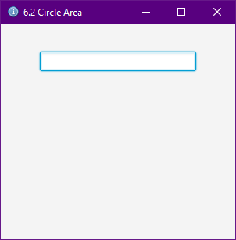

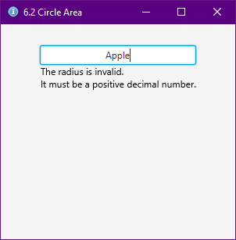

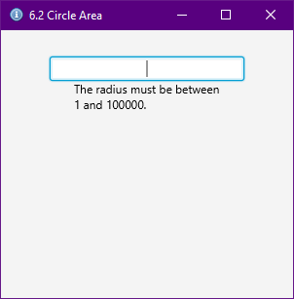

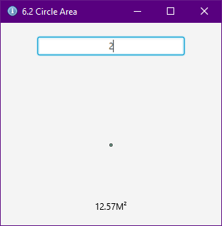

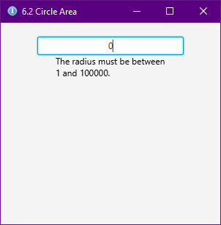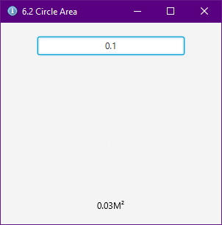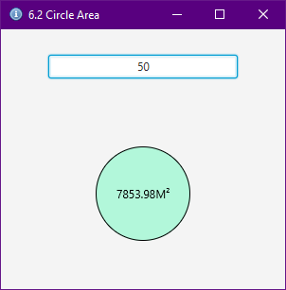

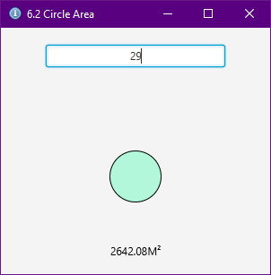

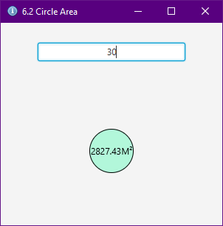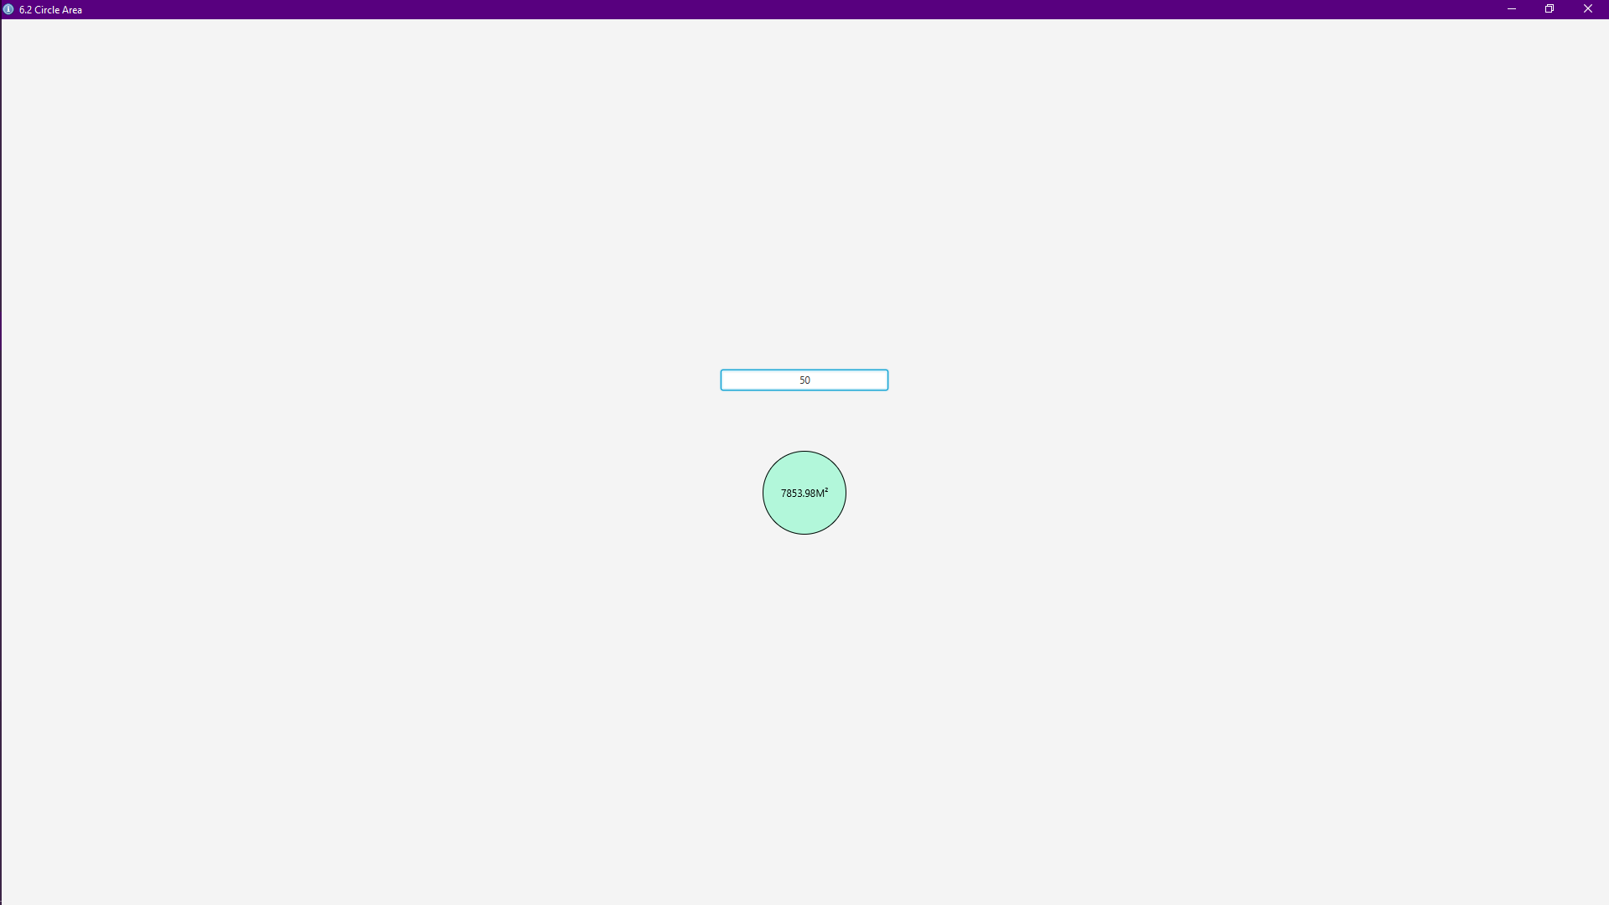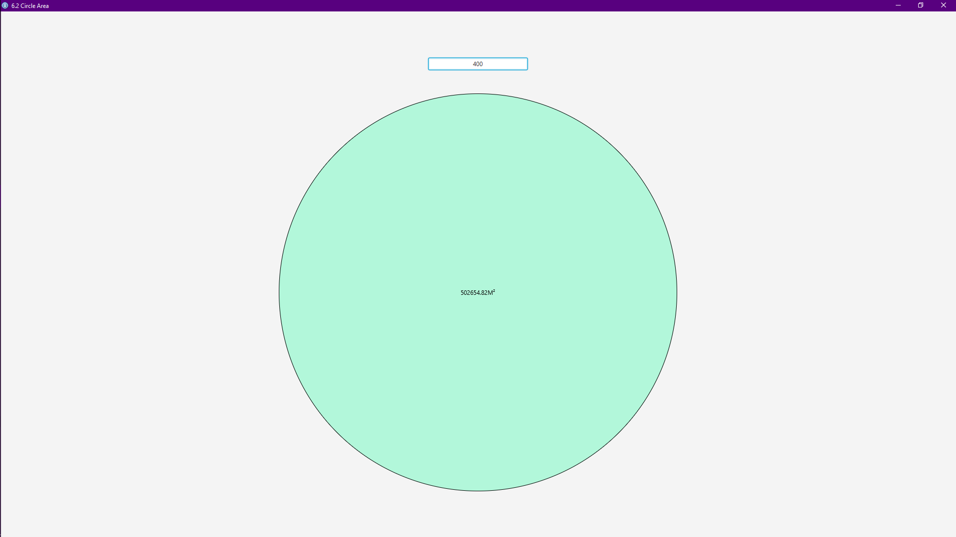

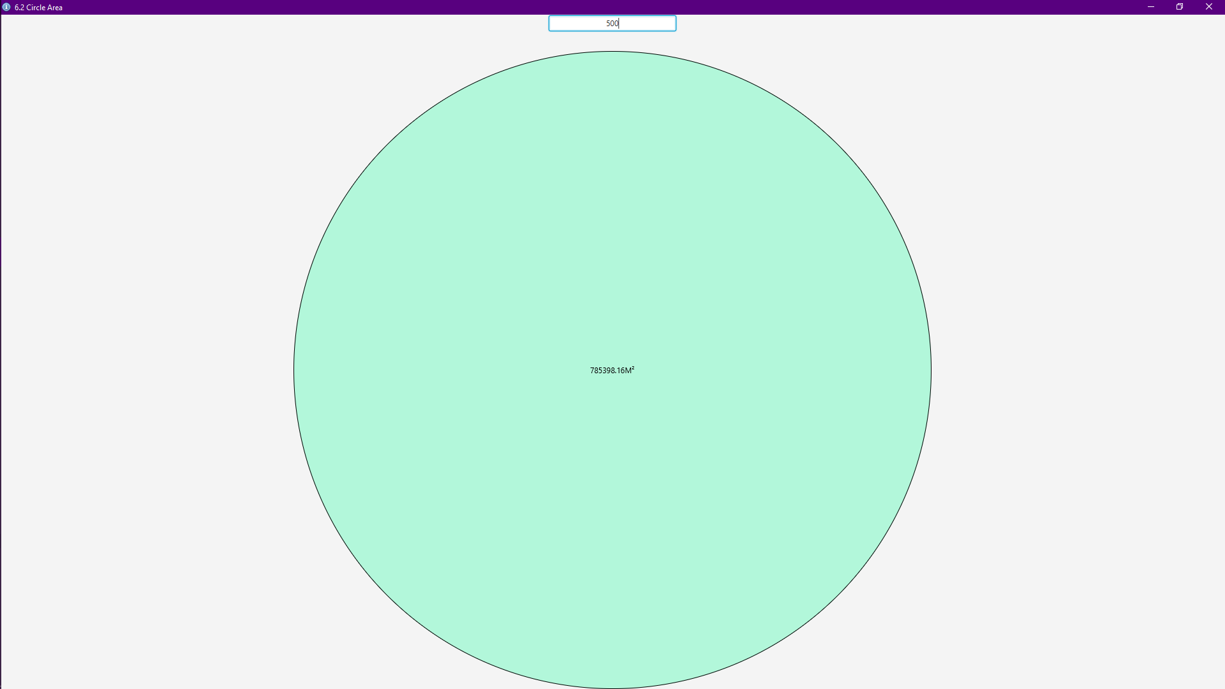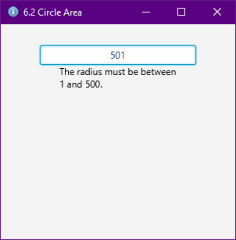

There are limitations to this application, mainly in the sense that increasing the circle size pushes txtInRadius off the screen. I tried to limit this for my PC by limiting radius to be less than 501, but this would only work on a screen similar to mine (27” 1920p x 1080p). Different operating systems might also have different ways of drawing circles which might mean that the sizes I have gotten from my testing and experience, such as radius 30, could be incorrect and look wrong. The main point of the application has been covered and reguardless of setup, the area will always be shown, and txtInRadius should always be focused as there are no other controls on the scene. This has, however, also ment that the prompt text is never visible unless the stage is not focused.

### Exercise 6.3. Volume

* Add a new method to your circle area calculation program which calculates the volume of a cylinder with the same base area as the circle. Use the formula: Volume = area * height. Hint: there are lots of ways to solve this problem, but the best way is to use the result returned from the area calculation method as an input to the calculate volume method!

P

Design

GUI Design

Pseudocode

Code

Output

(windows)

### Exercise 6.4. More pay

* Design, build and test a program to input the number of workers followed by their name, hours worked, hourly rate of pay, overtime rate of pay, status (married or single) for each. The main program must use separate methods and appropriate parameters. Suggested methods include:
  + Calculate the gross pay (overtime rate is paid for any number of hours above 40);
  + Calculate the amount of tax paid (25% if Married and 30% if Single);
  + Display all the details as a payslip on the computer screen. Hint: you can pass **String** parameters too!

P

Design

GUI Design

Pseudocode

Code

Output

(windows)

### Exercise 7.1. Ice skaters

* Design and build a program to enable a user to input an array of six integers, which represent the scores allocated by judges in an ice skating competition. Once all scores have been entered into the array, use it to calculate and output the average score.
* Modify your program to omit the lowest and highest score allocated, taking the middle four marks as the basis on which to calculate the average.

### Exercise 7.2. Initialise a list

* Modify the **NameList** program so that no user input is required to enter the list of names. Instead of the user entering ten names, initialise a new list of names in the String declaration statement.

### Exercise 7.3. Saver bonus

* Finally, you will show how you can use arrays to manipulate grouped information. Every Christmas, the Famously Good Building Society awards a bonus to all its savers, expressed as a percentage of the balance of each account. Design, code and test a program to enable a user to type in four savers’ balances and the percentage bonus (which is the same for everyone). The program should then output the new balances for each saver.

### Exercise 7.4. Savers with methods

* Modify the Famously Good Building Society program to use methods. Use separate methods for the following functions:
  + enable a user to type in four savers’ balances
  + update the balances by applying the percentage bonus
  + output the new balances for each saver.

### Exercise 8.1. Author

* Add a new attribute to the **Book** class called **author**. In your main method, after comparing dates, write another test to establish if the author of the two books is the same person.

### Exercise 8.2. Music

* Draw a class diagram which describes what you know about three musical instruments. The instruments are piano, guitar, and violin. All of them have strings and all of them make a sound. Pianos have keys and violins have bows. You can strum a guitar and a violin, but you can't strum a piano - you have to hit the keys. Show some other properties and actions that can be performed with the instruments. To structure your class model, use a super class, called **Instrument**.

### Exercise 8.3. Museum

* Draw a class diagram and write the Java code to represent a vehicle museum. Vehicles have a licence plate, a year of manufacture, a value, and a colour. The museum has cars, which have a number of doors, seats, engine type (petrol or diesel), and engine size in litres. The museum also has motorbikes, which have a bike type (sports, tourer, or trails), and engine size in cubic centimetres (cc). Note that you are not expected to run the program – all you need to do is show how the class structures can be coded in Java.

### Exercise 8.4. Museum inventory

* Here's a reminder of an exercise from earlier in this chapter: *draw a class diagram and write the Java code to represent a vehicle museum. Vehicles have a licence plate, a year of manufacture, a value, and a colour. The museum has cars, which have a number of doors, seats, engine type (petrol or diesel), and engine size in litres. The museum also has motorbikes, which have a bike type (sports, tourer, or trails), and engine size in cubic centimetres (cc).*
* Using the knowledge you have gained since tackling this exercise, add the following features to the program in the form of a menu:
  + add new vehicles (bikes or cars)
  + list all vehicles manufactured in a given year
  + list all vehicles of 1 litre or more (1 litre = 1000cc)
  + list all cars
  + list all bikes
    - HINT: for the above two options, you can get a string representation of an object's class by calling the following method **getClass().toString()**, so to print object x's class, you would do this:   
      **System.out.print( x.getClass().toString() );**